Prepared by: Conrad deBarros

For the

Lake Ontario Nutrient Task Team

April 26, 2016

**Lake Ontario - State of Nutrient ScIEnce**

# Executive Summary

Annex 4 Subcommittee established a Lake Ontario Nutrients Task Team (LONTT) to initiate steps required to develop Lake Ontario nutrient targets. Specifically, the LONTT will develop a binational monitoring and modeling plan to support the establishment of nutrient targets for Lake Ontario. The LONTT is charged with assessing the current state of the science in Lake Ontario with respect to nutrients in order to prepare a proposal that outlines specific research, monitoring and modeling necessary to assess the Lake Ecosystem Objectives and phosphorus targets for Lake Ontario. This report provides an overview of the state of nutrients in Lake Ontario, as well as recommendations to the Lake Ontario Target Task Team (LONTTT) to assist with the development of nutrient targets and management of Lake Ontario phosphorus loading. The LONTTT has reviewed and revised the conclusions and recommendations. These are contained in a separate document.

There are two distinct periods of change in Lake Ontario total phosphorus trends. The first saw the declines in phosphorus in the 1970s and 1980s in response to the implementation of controls on municipal and industrial point sources within the lower Great Lakes and the enactment of regulations to reduce the phosphate content in detergents. A brief stable period followed during the early 1990s and a subsequent decline in TP concentrations began in the mid-1990s and it is suggested that this latter decline was due to the colonization of dreissenid mussels in Lake Ontario. Offshore spring TP concentrations within Lake Ontario have been below the GLWQA objective of 10 ug/l since 1991 and have declined further to between 5-6 ug/l. Phosphorus loading to Lake Ontario has been declining since 1980 to 1989 however, after that period loading trend is unclear. A recent analysis of the long-term Niagara River monitoring data provided a revised annual load of 5550 metric tons over the period of 2000-2015, which is 4 times greater than the estimate provided by Dolan and Chapra (2012). This revised assessment of upstream loadings suggests the Niagara River load accounts for 60% the total phosphorus loading to Lake Ontario, double previous estimates. The revised loading figures also show that six out of the 26 years from 1990-2015 the Niagara River load exceeded the GLWQA target load of 7000 metric tons per year. No data for phosphorus loading from groundwater exists and this information gap needs to be addressed.

Mass balance modeling of total phosphorus suggests the expected offshore TP concentrations are below values based on the loading to Lake Ontario. This is especially more puzzling based on recent analysis of Niagara River loadings which suggests the proportion annual loading to the lake from upstream is double the previous estimate of approximately 30%. Dolan and Chapra (2012) and Chapra et al. (in press) indicate there is an unexplained sink of total phosphorus that is required to account for the observed total phosphorus decline in Lake Ontario. This phosphorus sink represents a major unknown in the Lake Ontario phosphorus budget, especially with the recent updated Niagara River loading.

Spring nutrient levels (TP, SRP) within the nearshore of both the north and south shores have decreased however, the lack of a continued decrease within parts of the south coast may indicate either the loading to this area has not decreased over the past 20 years or the elevated levels are due to the influence by the Niagara River plume which is carried along the south coast by the lake-wide circulation pattern. This highlights the continued need to track the Niagara River loading to Lake Ontario. Spring TP along the south coastal area routinely exceeds the 10 ug/l GLWQA objective and high SRP values >19 ug/l also define this area. The nearshore of both the north and south coast receives tributary, direct point source and direct urban runoff (stormwater and combined sewer overflow). Nearshore water quality is variable due to inputs from sources of varying magnitude, flow pattern and wind direction. The spatial patterning of water quality across the lake is; very low hyper-oligotrophic conditions within the northeast; oligotrophy in the offshore; mesotrophy in some nearshore areas along the south coast and in the vicinity of Hamilton and Toronto.

Dreissenid mussels are well established within Lake Ontario with quagga mussels (*Dreissena bugensis*) dominating the mussel population. Both the amount of substrate colonized and density of dreissenids appears to be greater on the north verses the south shore. This may be due to the greater availability of suitable hard substrate along the north shore coastal area. The re-engineered environment caused by invasive mussels, which is described by the *Nearshore Shunt* (i.e. increased water transparency, retention of phosphorus within the nearshore, and conversion of particulate phosphorus to soluble reactive phosphorus more easily used by *Cladophora*) has led to the reemergence of *Cladophora* at nuisance levels reminiscent of the 1960s and 1970s. Specific locations of reported problems of shoreline fouling by *Cladophora* include St. Catherines, Oakville, Ajax, Newcastle, Presqu’ile and Kingston, Ontario and Rochester, Kendall and Hamlin, New York. In these areas, complaints of shoreline fouling, beach closures and intake clogging have increased since the establishment of dreissenid mussels within Lake Ontario. Most concerning is this reemergence of *Cladophora* during a time when phosphorus loading has declined and is below the GLWQA target, the offshore is hyperoligotrophic and nearshore nutrient concentrations are lower than in the past. The results of studies reviewed provide differing conclusions as to whether anthropogenic sources of nutrients are driving localized nuisance growth of *Cladophora*. It would appear that *Cladophora* growth is exacerbated under conditions of land-based phosphorus enrichment in some nearshore areas however, under optimum conditions (e.g. high mussel density, low light attenuation, large quantity of available hard substrate, quiescent or protected areas) dreissenid mediated environments also support dense *Cladophora* growth at low ambient background phosphorus concentrations. This raises the question whether nuisance growth of *Cladophora* can be eliminated through local control of land-based phosphorus loads or whether a whole-lake approach is required.

Due to the hyperoligotrophic conditions and concerns regarding the stressed state of productivity within Lake Ontario’s offshore waters a balance will be needed between management of *Cladophora* growth through controls on phosphorus loading and protection of offshore productivity. Two modeling frameworks that address the phosphorus-mussel-*Cladophora* relationship are currently under development for Lake Ontario. These models will help lake managers evaluate options for *Cladophora* control however, additional research and development will be required to build a food web model that will predict bottom up and top down food web response under various phosphorus management scenarios. The development of the modeling frameworks and the development of a linked Lake Ontario food web model is critical to balancing decisions for nearshore management of *Cladophora* growth with protection of offshore productivity.

**Recommendations**

1. Lake Ontario agencies should work together to establish consistent binational practices and methodology for estimating loads. Consistency in approach will allow for accurate tracking and reporting of loading, and will assist lake managers in making sound management decisions.
2. Lake Ontario agencies should consider the development of unit area inputs from watersheds as a means of identifying problem watersheds (and sub-watersheds) and sewer-sheds with high unit area nutrient loading. This type of approach will assist in focusing resources as needed and will also provide a metric upon which to track the effectiveness of any required abatement actions in both rural and urban landscapes.
3. Although not heavily focused on as part of this report, projected urban growth within the Lake Ontario watershed was identified by Lake Ontario Algae Action Advisory Committee (LOSAAAC, 2008) as a risk to increasing future nutrient loading in the Halton area. Population growth throughout the northwestern shore (Greater Toronto Area) is expected to increase by 3 million over the next 25 years and poses a risk of increased phosphorus loading to the Lake from direct discharge and runoff. It is recommended that the tracking of nutrient loads form rapidly urbanizing landscapes be considered by the Lake Ontario agencies.
4. A considerable percent (~30% to 60%) of Lake Ontario’s phosphorus load originates in Lake Erie and is delivered through the Niagara River and Welland Canal. However, the Welland Canal is not included in the calculations of upstream loading to Lake Ontario. It is recommended that Niagara River and Welland Canal loading to Lake Ontario continue to be monitored for the long-term, especially since future decisions for phosphorus load reductions in Lake Erie will have management implications for Lake Ontario. As well, to assess compliance with the GLWQA phosphorus target of 7,000 metric tons per year, the portion of the Lake Erie load delivered through the Welland Canal must be considered as part of the upstream load.
5. Lake Ontario agencies consider development of a strategy to address the four priority science needs related to groundwater nutrient contributions identified in the report “Groundwater science relevant to the Great Lakes Water Quality Agreement: A Status Report” (Grannemaman and Van Stemvoort. Eds. Draft. 2015). Through support for these science needs the significance of the nutrient contribution from groundwater to the Lake will be addressed.
6. The monitoring of offshore and nearshore waters has provided valuable information to track temporal and spatial changes in the nutrient status of these regions in Lake Ontario. This information has provided a means to monitor compliance with the Great Lakes Water Quality Agreement’s ecosystem objective for phosphorus and has also provided information that is critical for the effective management of Lake Ontario. It is recommended that current U.S., Canadian, state and provincial monitoring programs for Lake Ontario be maintained at current levels and expanded where and when needed to support specific initiatives (e.g. development of modeling frameworks, research on significance of nutrient sources for *Cladophora* growth). The current monitoring programs not only deliver on the two countries’ GLWQA commitment to monitor the Great Lakes ecosystem, they also provide a basis for tracking the effectiveness of management actions and are an important component of an adaptive management framework.
7. The overabundance of *Cladophora* is a key feature of the nearshore nutrient question within Lake Ontario. Currently there are no ongoing monitoring programs to track *Cladophora* abundance over time. Monitoring of Cladophora tissue phosphorus (Qp) would provide insight into the overall growing conditions and allow for expert interpretation on nutrient exposure. This information is useful for determining temporal trends, response in *Cladophora* abundance to year-to-year variability in environmental conditions and for use in current and future *Cladophora* growth modeling. It is highly recommended that the Lake Ontario agencies develop and implement a *Cladophora* monitoring strategy.
8. A number of studies have documented the increased light environment caused by dreissenid filtering of particulate matter from the water column. This additional increase in water clarity has led to production of *Cladophora* at much greater depths than in the pre-dreissenid period. Although the cause of nuisance growth of *Cladophora* appears to be related to dreissenid mussels and the changes they have caused in the light environment and the cycling of nutrients, there are still questions regarding the significance of dreissenid driven SRP, anthropogenic sources of phosphorus and lake-wide ambient concentrations in the production of *Cladophora*. For this reason, it is recommended that continued research into the causal factors of luxuriant growth of *Cladophora* be supported.
9. Modeling is a useful tool for understanding the interplay of man-made and environmental variables (e.g. light attenuation/turbidity, temperature, nutrient loads, dreissenid mussels, phytoplankton, *Cladophora*, hydrodynamics) in the promotion and constraint of *Cladophora* growth. Development of modeling frameworks that assist in understanding the complex dynamic relationships among environmental and anthropogenic variables and assist in making management decisions to control nuisance *Cladophora* growth should be supported.

Key to the success of model development efforts is the availability of accurate environmental information needed to calibrate, validate and drive the models. It is recommended that consideration be given to apportion monitoring efforts to the acquisition of data needed by model development teams. This will require collaboration between monitoring and modelling experts, and lake managers.

1. Low phosphorus concentrations in Lake Ontario’s offshore has raised concern regarding the sustainability of productivity within this region of the Lake. The ability to predict the response of the offshore food web to phosphorus loading options for the control of *Cladophora* in the nearshore is needed to make sound management decisions. A food web model that can be linked to hydrodynamic-ecological-*Cladophora* type model frameworks would allow for a balance between management actions to control nuisance *Cladophora* growth and protection of offshore productivity. It is therefore paramount that the development and operation of a sound Lake Ontario food web model be completed prior to the establishment of phosphorus targets or enacting management actions to reduce phosphorus loads.

Development of a Lake Ontario food web model that is linked or coupled to a hydrodynamic-ecological-Cladophora modeling framework will require collaboration between experts from multiple disciplines: water quality/hydrodynamic modeling, aquatic food web modeling, fisheries management, water quality monitoring and lake managers.

# Table of Contents

Executive Summary i

Table of Contents vi

List of Figures viii

List of Tables xi

Background 1

Overview of Lake Ontario 1

Great Lakes (Lake Ontario) Monitoring Programs 2

Environment and Climate Change Canada 3

U.S. Environmental Protection Agency Great Lakes Limnology Program 4

United States Geologic Survey 5

New York State and Province of Ontario Monitoring Programs 5

Municipal and Industrial Point Source Monitoring 6

Summary of Lake Ontario Monitoring and Studies 6

Lake Circulation 7

Nutrient Loading to Lake Ontario 8

Niagara Riv**er** Total Phosphorus Loadings 20

Phosphorus Loading from Groundwater 22

Conclusions 23

Nutrient Status of Lake Ontario 24

Introduction 24

Lake Ontario Offshore Nutrient Status 24

Conclusions 31

Nearshore Nutrient Status 32

Long-term Nearshore Nutrient Trends and Spatial Patterns 32

Variability within Nearshore Waters 36

Nearshore Seasonal Patterns 41

Impact on Water Quality by Lake Circulation Patterns 44

Conclusions 46

Role of Dreissenids on *Cladophora* Abundance 47

Distribution of Dreissenid Mussels in the Nearshore of Lake Ontario 48

Dreissenid Effects on Water Clarity 49

SRP Flux by Dreissenid Mussels 54

Conclusions 59

*Cladophora* in Lake Ontario 60

*Cladophora* Distribution and Abundance in Lake Ontario 60

*Cladophora* Then and Now 61

Landscape Influences on *Cladophora* Production/Abundance 63

Thermal Bar and *Cladophora* Production 70

Conclusions 72

Lake Ontario Embayments 73

U.S. Embayments 76

Canadian Embayments 85

Model Development in Lake Ontario 92

Summary of Model Applications Within Lake Ontario 96

Rural Watershed Models 96

Soil and Water Assessment Tool (SWAT) 96

Stormwater Management Model (SWMM) 97

HSPF 97

*Cladophora* Growth Model (CGM) 98

Lake Hydrodynamic Models 99

Princeton Ocean Model 100

ELCD-CGM Nested 3D Hydrodynamic Model 100

MIKE – 3 Model 101

Recommendations 102

Bibliography 105

Appendix 1 – Summary of Lake Ontario Monitoring 112

# List of Figures

Figure 1: Lake Ontario sampling sites, Environment and Climate Change Canada, Great Lakes Surveillance Program …………………………….....................................................3

Figure 2: U.S. Environmental Protection Agency’s Great Lakes Limnology Program Lake Ontario Stations…………………………………………………………..……………………...5

Figure 3: Lake Ontario observed currents…………....………………………..……………..8

Figure 4: Modeled depth-averaged currents during summer 2006…………………….…..8

Figure 5: Time series of Lake Ontario total phosphorus loading (MTA)….………………17

Figure 6: Total phosphorus load (in metric tonnes per annum) at Niagara-on-the-Lake, 1975-2015 …….…………………………………………………………20

Figure 7: Spring (Apr.-May) epilimnetic total phosphorus concentrations in Lake Ontario, 1970-2013……………………………………………………………………………………….25

Figure 8: Lake Ontario Offshore spring total phosphorus fit since 1998 ………………...26

Figure 9: Lake Ontario offshore SRP trend.………………………………….……………...26

Figure 10: Lake Ontario offshore spring mean Nitrite+Nitrate trend………………………26

Figure 11: Lake Ontario spring and summer silica concentrations..……………………...27

Figure 12: Lake Ontario offshore summer (Jul-Aug) Chl a trend….………………………28

Figure 13: Open Lake Ontario spring and summer secchi disc depth trend………………………………………………………………………………………28

Figure 14: Correlation of offshore summer Chl a vs. TP for the Great Lakes..…...……..30

Figure 15: Correlation of offshore summer SD vs. Chl a for the Great Lakes...…………30

Figure 16: Near surface total phosphorus (TP), soluble reactive phosphorus (SRP), Chlorophyll a (Chl a), Secchi Depth (SD) in the North Coast, Offhshore, South Coast, Halton and Durham. ……………..…………………………………………………………….331

Figure 17: Spring, surface total phosphorus (ug/l) in 2013………………………………...34

Figure 18: Annual average concentrations for TP, Chl a,and Algal Cell Densities in untreated water form 4 water treatment plants along the Canadian shore of Lake Ontario…...………………………………………………………………………………………34

Figure 19: Annual average concentrations for silicate, Nitrate+Nitrite and Chloride in untreated water form 4 water treatment plants along the Canadian shore of Lake Ontario……..……………………………………...…………………………………………….35

Figure 20: Comparison of north coastline littoral zone spring total phosphorus, SRP and Chl a in 2 to 12 meter depth….……………………………………………………………….36

Figure 21: Variability in Chloride, TP, DIN, E. coli concentrations and counts with distance from shore in the Grimsby, Cobourg, GTA West, Ajax, GTA Centre and GTA East Study Polygons........................................................................................................38

Figure 22: Mean soluble reactive phosphorus (SRP) concentration grouped by conductivity percentile for each of the 5 surveys in 2008…………………………..……...40

Figure 23: Box plots of TP (ug/l), Chl a (ug/l) and algal cell densities (areal standard units, A.S.U./ml) measured each month of the year in untreated water from 4 water treatment plants along the Canadian shore of Lake Ontario……………………….……...41

Figure 24: Outer nearshore concentrations of Ca, DIN, silicate, and TP at lake surface and above bed………………………………………………………………………..…..…….42

Figure 25: Box plots of Si, NO2+NO3 and Cl concentrations measured each month of the year in untreated water from 4 water treatment plants along the Canadian shore of Lake Ontario. Grimsby, South Peel, R.L. Clark, Cobourg………………………………….43

Figure 26: Dreissenid mussel mean percent cover as observed by divers......................................................................................................................48

Figure 27: Mean dreissenid seasonal valve length (mm), density (no./m2) and shell-free mass (SFDM) (g/m2) at different depths in Lake Ontario’s nearshore, 2008……………49

Figure 28: Average CZCS nLw550 for the period 1979-1985, WiFS nLw550 for the period 1998-2005 and difference between two images………………………..…..50

Figure 29: Monthly lake-wide average nLw550 from CZCS and the SeaWIFS for Lake Ontario…………………………………………………………………………………….……..52

Figure 30: Photograph from the International Space Station highlights a late-summer whitening event visible across much of Lake Ontario on August 24, 2013..……………..52

Figure 31: Timeline of change in SAV area at the five focus areas, annotated with relevant events. …..…………...51

Figure 32: Average SRP profile above dreissenid/Cladophora beds………………….......54

Figure 33: Mean SRP profile above dreissenid mussel beds at a shallow 5m station in 2009................................................................................................................................ 53

Figure 34: Mean SRP (A) profile above dreissenid mussel beds at a deep 17m station 2009……………………………………………………………………………………55

Figure 35: SRP (ug/l) at the start of the 2-hour incubations and following the 2-hour incubation over mussel encrusted rock , mussel free rock and chambers containing only water ..……………………………..56

Figure 36: Modeled (CGM) P uptake by Cladophora during peak period (open circles and dashed lines) an P excretion rate by dreissenids……..56

Figure 37: SRP profiles above dreissenid beds confirming build-up of SRP in benthic boundary layer with increasing quiescent duration..………………………………………..57

Figure 38: Nearbed nutrient concentrations compared with surface concentrations at four Northshore study sites…………………………………………………………………...…….58

Figure 39: Satellite-derived Lake Ontario Submerged Aquatic Vegetation (SAV) map...61

Figure 40: Map of Lake Ontario with study site locations. ………………………………………………….64

Figure 41: The relationship between chemical tracers of land use (conductivity) and tissue P concentration, Cladophora biomass and depth integrated biomass..............65

Figure 42: Depth distribution of Cladophora biomass, tissue P concentration (Qp), and cumulative biomass at seven sites in Lake Ontario..………………………...........65

Figure 43: Cladophora growth model (CGM) simulations vs measured data in Lake Ontario during 2008…………………………………………….………………………………66

Figure 44: Gradients of P concentration away from point sources…………………..……67

Figure 45: Map of Cladophora study locations…………………………………………...…67

Figure 46: Conceptualized model of phosphorus profiles reflecting mussel density on concentration boundary layer (4.5a) and observed phosphorus profiles reflecting mussel density on concentration boundary layer (4.5b)…………………………………………….69

Figure 47: Scatterplot and linear trend line for percent of beach closed days due to accumulated algae each year versus the corresponding cumulative temperature contrast between nearshore and offshore waters.……………………………………………………70

Figure 48: Map - Lake Ontario Embayments……………………………….……………….84

Figure 49: Generalized Conceptual Graphic of the Modeling Framework for Lake Ontario…………………………………………………………………………………………...94

Figure 50: Conceptual diagram for Lake Ontario ecosystem model.................................................................................…..95

Figure 51: Model grids applied to the spill scenarios along the north coast of Lake Ontario……………………………..……………………………………………………………101

# List of Tables

Table 1: Annual Tributary total phosphorus (TP) loading to Lake Ontario from New York watersheds……………………………………….……………………………………………..12

Table 2: Annual tributary loadings of total phosphorus (TP) to Lake Ontario from Ontario watersheds…………………………….………………………………………………………..12

Table 3: Annual total phosphorus (TP) load to Lake Ontario from New York municipal wastewater treatment plants ...……………………………………………………….……....13

Table 4: Annual total phosphorus (TP) load to Lake Ontario from Ontario wastewater treatment plants ……………………………………………….………………….…………....13

Table 5: Great Lakes Total phosphorus municipal point sources 1994-2008 …...……...15

Table 6: Great Lakes total phosphorus tributary loads 1994-2008 (MTA)……..….……..16

Table 7: Great Lakes total phosphorus load estimates 1994-2008……………………….16

Table 8: Estimated annual loadings from urban and rural drainage areas in Halton Region………………………………………………………………………………………...…19

Table 9: Priority science needs related to groundwater and nutrients.............................22

Table 10: Mean spring nutrient concentrations and summer response variables for offshore waters of Lake Ontario ...…..………………………………………………..……...29

Table 11: Ranges defining trophic classes applicable to offshore waters of the Great Lakes ...…………………………………………………………………………………....…....30

Table 12: Mean concentrations (±S.E.) of total phosphorus (TP), soluble reactive phosphorus (SRP), nitrate, total suspended solids (TSS), total Kjeldahl nitrogen (TKN), sodium chloride, Chlorophyll *a* (Chl *a*) ………………………………………..……….…....37

Table 13: Mean concentrations and standard deviation of water quality parameters in surface samples among habitats by study polygon in 2008. Phosphorus…………………………………………………………………………………......40

Table 14: U.S. Embayments……………………………………………………….………....76

Table 15: Canadian Embayments…………………………..……………………….…….....85

# Background

Annex 4 of the Great Lakes Water Quality Agreement requires that the US and Canada manage nutrient levels in the Great Lakes by establishing phosphorus concentrations and loading targets needed to meet a series of Lake Ecosystem Objectives for each Lake. While much work remains to be done on Lake Erie, the Annex 4 Subcommittee established a Lake Ontario Nutrients Task Team (LONTT) to initiate steps required to develop Lake Ontario nutrient targets. Specifically, the LONTT will develop a binational monitoring and modeling plan to support the establishment of nutrient targets for Lake Ontario.

The LONTT is charged with assessing the current state of the science in Lake Ontario with respect to nutrients in order to prepare a proposal that outlines specific research, monitoring and modeling necessary to assess the Lake Ecosystem Objectives and phosphorus targets for Lake Ontario. A state of science report on nutrients in Lake Ontario will provide the basis for and recommendations to address the following questions:

1. Briefly summarize historic trends in phosphorus concentrations and loads to the Lake, in both nearshore and offshore environments, and eutrophication indicators (Cladophora biomass, bloom frequency, TP/SRP, Secchi Disc, Dissolved Oxygen). Are current nutrient objectives/targets being met? Are algal issues lakewide or localized?
2. What are current data gaps and monitoring needs for tributary, in-lake and nearshore related to TP/SRP loadings, frequency or timing of monitoring, locations in need of monitoring, and role of aquatic invasive mussels?
3. What ecosystem models exist or are under development that could be used to evaluate phosphorus targets? What information is needed to support these models (see #2)?
4. Identify specific priorities for research, monitoring and modeling that must be accomplished in order to establish P targets for Lake Ontario.

To address the GLWQA Annex 4 Subcommittee task the LONTT has prepared this state of Nutrient Science for Lake Ontario report which contains conclusions on nutrient-dreissenid-*Cladophora* science and provides recommendations on monitoring of ambient water quality, data gaps, model development and monitoring support.

## Overview of Lake Ontario

Lake Ontario is last in the chain of Great Lakes that straddle the Canada/United States of America border. Its shoreline is bordered by the Province of Ontario on the Canadian side and New York State on the U.S. side. Lake Ontario is the smallest of the Great Lakes, with a surface area of 18,960 km2 (7,340 square miles), but it has the highest ratio of watershed area to lake surface area. It is relatively deep, with an average depth of 86 meters (283 feet) and a maximum depth of 244 meters (802 feet), second only to Lake Superior. Approximately 80 per cent of the water flowing into Lake Ontario comes from Lake Erie through the Niagara River and Welland Canal (Lake Ontario LAMP, 1998). The remaining flow comes from Lake Ontario basin tributaries (14 per cent) and precipitation (7 per cent). About 93 per cent of the water in Lake Ontario flows out through the St. Lawrence River and the remaining 7 per cent leaves through evaporation. Since Lake Ontario is the farthest downstream Great Lake, it is impacted by human activities occurring throughout Lakes Superior, Michigan, Huron, and Erie, and within its watershed.

Lake Ontario is important to the U.S. and Canadian residents who live on or near to this beautiful lake. It is the primary source of drinking water for the many communities along its shoreline, it is an excellent supply of water for industrial and commercial uses and cooling water for nuclear power plants, and it provides assimilation for treated industrial and municipal wastewater. Its numerous beaches and parks provide recreational opportunities such as swimming and camping for local residents and tourists. It fishery supports recreational, charter and commercial fishing.

The Canadian north shore is much more urbanized and densely populated than the U.S. south shore. The estimated population living in the area of Ontario known as the Golden Horseshoe (area from the Niagara River north and eastward to Oshawa) was 8.7 million in 2011, a 6% increase since 2000 (Statistics Canada 2103). According to a 2010 U.S. census, the population within New York State’s 7 counties adjacent to Lake Ontario was 1.4 million people and the number is projected to remain fairly stable over the next couple of years (pers. Comm., Donald Zelazny, New York Department of Environmental Conservation). Due to the dense population along the northwestern shore, water quality is impacted by an urbanized landscape versus the more rural influences on water quality along the New York shore.

## Great Lakes (Lake Ontario) Monitoring Programs

Monitoring Great Lakes water quality and ecosystem health is a commitment made by both Canada and the United States within the Great Lakes Water Quality Agreement (GLWQA) of 2012. This commitment includes implementation of monitoring and research for each of the Great Lakes on a five-year rotational basis. Under Annex 10 (E), the parties are to focus monitoring and science on the priorities identified by the Lake Management Process and coordinate activities across government and non-government organizations. Annex 10 of the 2012 GLWQA Protocol also commits the countries to: a) maintain comprehensive, science-based ecosystem indicators to anticipate emerging threats; and, b) to measure and report on progress. This latter action is currently undertaken through the State of the Lakes Ecosystem Conference (SOLEC).

Lake Ontario is intensively monitored every five years and these 5-year intensive, multi-agency and partner monitoring initiatives are coordinated through the binational Cooperative Science and Monitoring Initiative (CSMI). The CSMI is a planning process that coordinates the resources and actions of the many U.S. and Canadian agencies, academia and no-governmental organizations that are involved in Great Lakes monitoring and research. For more information on the CSMI and how it was applied to the 2008 Lake Ontario binational intensive monitoring year, see Richardson et al. (2012).

Federal, provincial and state governments in both Canada and the United States share in the monitoring of Lake Ontario’s ecosystem health. In addition to the CSMI coordinated effort, routine monitoring of the Lake and its watersheds is conducted on an ongoing basis by the various governments and other partners (e.g. Conservation Authorities, Academia, municipalities). The following are brief descriptions of some of the major monitoring programs that contribute to the state of knowledge on nutrients in Lake Ontario and that deliver on both countries’ commitment to monitor Great Lakes water quality and ecosystem health.

### Environment and Climate Change Canada

Under the National Freshwater Quality and Ecosystem Health Monitoring Program, Environment and Climate Change Canada (ECCC) monitors Great Lakes water, precipitation, sediments, benthic and aquatic biota under its various monitoring projects. The projects with greatest relevance to nutrients in Lake Ontario are described briefly below.

Ship-based cruises are conducted under **Great Lakes Surveillance** (GLS) to ensure compliance with water quality objectives, evaluate trends in Great Lakes water quality and to identify emerging issues. Approximately 100 stations (Figure 1) are monitored on Lake Ontario, with approximately 23 of these designated as priority stations where more in-depth information is collected. Monitoring started in Lake Ontario in the late 1960s and is currently conducted approximately every two years, with a spring and summer cruise conducted during that year. The monitoring is also coordinated to support the CSMI intensive monitoring year. GLS is conducted throughout the lake on Lakes Superior, Huron, Erie and Ontario (no monitoring is conducted in Lake Michigan, which is located entirely within the United States). The monitored parameters include nutrients, major ions, metals, organic contaminants and compounds of new and emerging concern. GLS is delivered as part of Canada’s commitment to the Canada-United States Great Lakes Water Quality Agreement and in support of its Annexes, including the Lakewide Management Annex, the Nutrients Annex, the Chemicals of Mutual Concern Annex and the Science Annex.

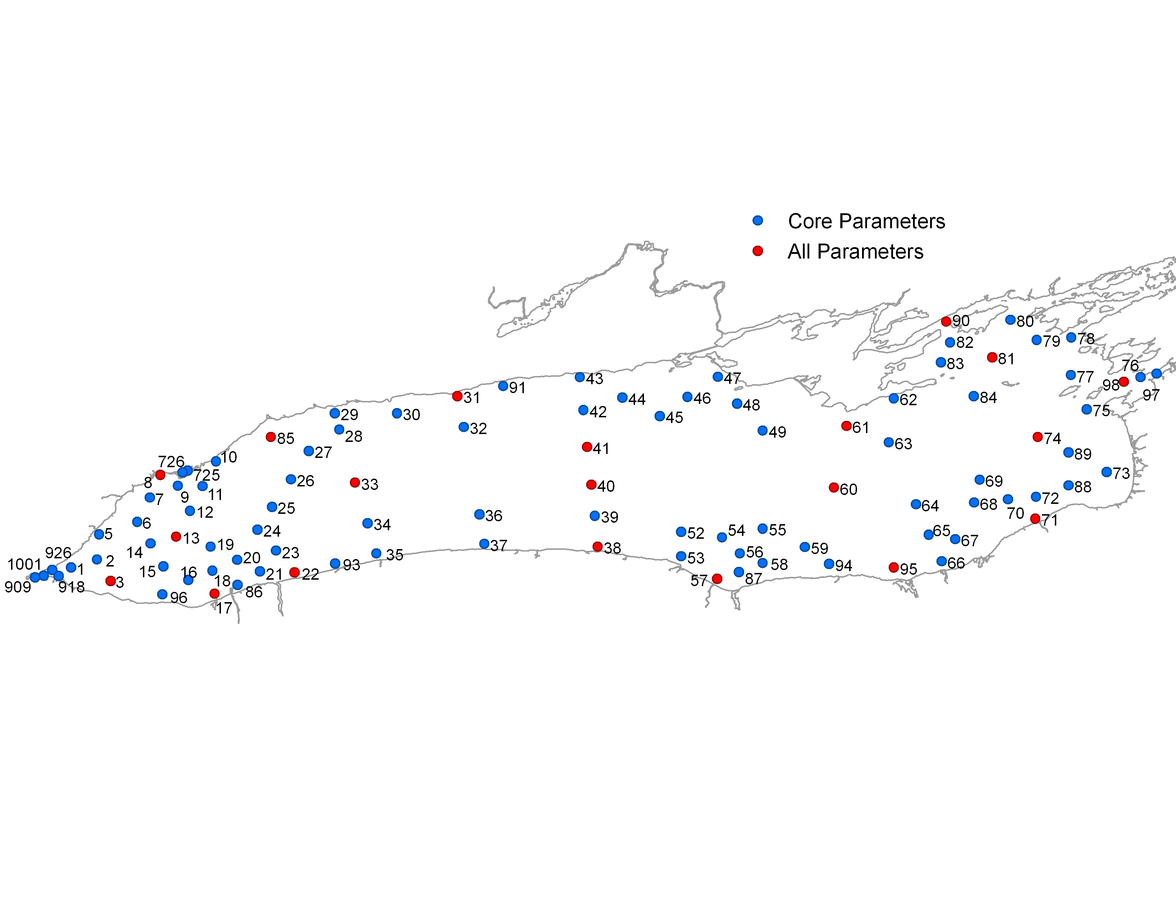

Figure 1: Lake Ontario sampling sites, Environment and Climate Change, Great Lakes Surveillance Program

The **Great Lakes Connecting Channels** project has focused on the assessment of organic contaminants as a requirement for the Niagara River Toxics Management Plan but its scope also includes nutrients in the River. The project monitors water quality in the Niagara River at both Fort Erie (upstream) and Niagara-on-the-Lake (downstream) and in the St. Lawrence River at Wolfe Island. These stations provide information about the concentrations and loadings of nutrients in the major inflow and the outflow of Lake Ontario. Nutrient data have been collected weekly since 1975 at Niagara-on-the-Lake, since 1983 at Fort Erie and since 1986 at Wolfe Island. These stations provide information about the concentrations and loadings of nutrients in the major inflow and the outflow of Lake Ontario. Nutrient data have been collected since 1975 at Niagara-on-the-Lake, since 1983 at Fort Erie and since 1986 at Wolfe Island; samples are currently collected weekly. Additionally the USGS through EPA R2 and GLRI(GLNPO) is monitoring both upstream and downstream on the Niagara River and upstream on the St. Lawrence River 12 times a year. This monitoring started in fall, 2015 for the Niagara River, and in the spring 2016 for the St. Lawrence.

The **Great Lakes Precipitation Network** (GLPN) is mandated within the GLWQA and its Annexes. Monitoring of nutrients in precipitation is used to determine loadings and trends (spatial and temporal). Presently the GLPN consists of eight active sampling sites, with two located on the shores of Lake Ontario (Burlington in the west and Point Petre in the north-east). Monthly composite samples have been collected for nutrients at each of these two locations since 1994.

### U.S. Environmental Protection Agency Great Lakes Limnology Program

The U.S. Environmental Protection Agency’s Great Lakes Limnology Program began in 1983 for Lakes Michigan, Huron, and Erie; 1986 for Lake Ontario; and 1992 for Lake Superior. The limnology program provides information on key environmental factors that influence the food webs in the Great Lakes. The sampling strategy is to collect water and biota samples at specific water depths from a limited number of locations in each lake (Figure 2: Lake Ontario Station Locations). This occurs twice every year in order to meet the objectives of the program, which are:

1. Assess the state of water quality in the open lake basins (water greater than 30 meters in depth, or greater than 3 miles from shore.)
2. Provide data to detect and evaluate trends and annual changes in chloride, nitrate nitrogen, silica, phytoplankton, total phosphorus, chlorophyll *a*, and secchi disc depth.
3. Provide data sufficient to verify or modify water quality models.
4. Provide data to calculate the Trophic Index of each lake.

For more on the U.S. EPA’s Great Lakes Limnology Program see: <https://www3.epa.gov/greatlakes/monitoring/limnology/index.html>

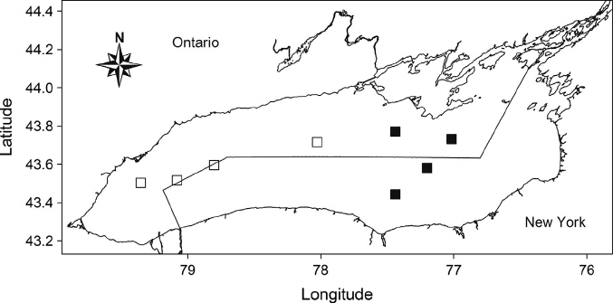

**Figure 2**: U.S. Environmental Protection Agency’s Great Lakes Limnology Program Lake Ontario Stations.

### United State Geologic Service

In 2015, the U.S. EPA and United States Geologic Survey (USGS) initiated connecting channel monitoring of the Niagara River in support of the Lake Ontario LAMP information needs. In March of 2016 monitoring of the St. Lawrence River was added at a location downstream from Wolfe Island and upstream from Ogdensburg, New York. Sampling of both the Niagara and St. Lawrence Rivers is conducted on a monthly basis with a focus on nutrients and sediment. This monitoring is planned to continue to at least 2018, the next Lake Ontario CSMI year. The USGS Great Lakes Science Center has additional data and monitors the lakes for certain constituents.

### New York State and Province of Ontario Monitoring Programs

The New York State Department of Environmental Conservation (NYSDEC) undertakes a variety of programs to monitor Lake Ontario’s prey fish and fish community and to sample water quality parameters that are indicative of trophic status. Some of this work is conducted in coordination with the U.S. Fish and Wildlife Service and the Ontario Ministry of Natural Resources and Forestry.

The NYSDEC Biomonitoring focuses on providing trend-through-time data for nutrient and primary production dynamics in the nearshore and offshore waters of Lake Ontario. Nearshore water and zooplankton samples are taken biweekly from May through October. Similar collections are made offshore at approximately 35 sites during August and October. The sample efforts include secchi disk transparency, total phosphorus, nitrate-nitrogen, chlorophyll a, and replicate zooplankton tows. Samples are processed and data are summarized by Cornell University staff at Shackelton Point. NYSDEC also monitors water quality within its inland lakes and Lake Ontario tributaries through its Rotating Integrated Basin Studies (RIBS), a program designed so that all major drainage basins in the state are monitored every five years.

In Ontario, tributary water quality monitoring is provided through the Ministry of the Environment and Climate Change’s (MOECC) Provincial Water Quality Monitoring Network (PWQMN). Complementing the PWQMN, is the additional monitoring of tributaries conducted by Conservation Authorities who manage Lake Ontario watersheds. MOECC also conducts monitoring of the nearshore waters of Lake Ontario and maintains 18 Index Stations within the Lake that are generally sampled every 3 years for of physical, chemical and biological variables, which includes nutrient sampling.

The Ontario Ministry of Natural Resources and Forestry monitors Lake Ontario fish communities in many of the embayments, nearshore and offshore waters. The offshore monitoring of fish communities is coordinated with the NYSDEC.

### Municipal and Industrial Point Source Monitoring

In both Canada and the United States, federal, state and provincial legislation governs the operation and management of industrial and municipal wastewater treatment plants (WWTP). Various legislations require operators of these facilities to monitor the quality and quantity of treated effluent and to report this information to the federal, state and provincial regulatory bodies. Inspections and auditing of these facilities is undertaken to ensure the compliance with regulations and the accuracy of operator monitoring reports.[1]

### Summary of Lake Ontario Monitoring and Studies

In the preparation of this report, a number of scientific papers, government reports and gray literature have been reviewed. The material covered contains valuable information related to Lake Ontario’s nutrients, *Cladophora* and dreissenid mussels. A brief description of each scientific paper or report, variables measured, lead author/contact and contact information is provided in tabular format in Appendix 1. The purpose of Appendix 1 is to provide a quick reference or “road-map” to pertinent information that may be required in future development of Lake Ontario nutrient targets and management options or needed to provide the background information for further research.

# Lake Circulation

Knowledge of water circulation and mixing within the offshore and nearshore of Lake Ontario is important to understanding the dispersal and transport of nutrients from tributaries and point sources, and the interaction of nearshore and offshore waters. Due to its size, water circulation within Lake Ontario is affected by the earth’s rotation (i.e. Coriolis effect), which causes a large anti-cyclonic flow direction. Lake currents are also affected by lake bathymetry, meteorological forcing factors (wind speed and direction, temperature, humidity, etc.) and tributary flows. In Lake Ontario, the currents generally move in a large anti-cyclonic direction with a smaller anti-cyclonic gyre in the northwest portion of the lake as depicted in Figure 3 (Pickett 1976) and in Figure 4 (Huang et al. 2010).

As the Niagara River enters Lake Ontario, it initially mixes and the plume extends 6-7 km into the lake before responding to the prevailing general circulation of the Lake. Although the plume can be pushed towards the west by wind, the general flow pattern is eastward along the south coast and then north and into the large central gyre that dominates the Lake. The current direction along the north shore is a little more complicated. In the summer (during lake stratification), the eastern two-thirds of the north shore experiences a westerly flow and in the northwestern one-third of the Lake the flow direction is eastward. Where these two flow patterns meet, they turn southwest. With more variable winds in the winter and little thermal current the northwestern gyre is erratic and can build, retract or disappear depending on the wind direction, speed and duration (Pickett 1976). Nearer to shore the currents can be changed by wind direction in fairly short time spans measured in hours (Blanton 1974). Variability in nearshore current direction can also be influenced by the shoreline shape and morphology. Within the nearshore faster currents in the shallower waters are encountered due to the wind-blown water being confined to smaller cross sectional area (Pickett 1974).

In the nearshore, upward and downward water movement can occur under certain wind conditions. Relatively strong offshore winds will cause the surface waters to move away from the shore resulting an upwelling of water. As water moves away from the shore during upwelling conditions, the lost water is replaced by deeper and colder hypolimnetic waters. While onshore winds will direct surface waters to move towards the shore causing a downwelling event. During downwellings, wind driven warm surface water piles up on shore and then is forced down to the bottom of the lake. Water up to 10km from the shoreline can be involved in these events. The predominant winds over Lake Ontario are from the northwest to the southeast and are ideal for creating frequent upwellings that are experienced on north west shore. For the south shore, strong winds moving offshore to the north are ideal for upwellings along this shoreline. Casanady 1971 (as cited in Blanton 1974) found on the north shore that eastward flow direction correlated with upwelling and westward flows with downwellings.

The spring thermal bar is another process that affects the movement of water within the nearshore. During spring the shallower nearshore waters warm more quickly and stratify while the deeper waters offshore remain colder and isothermal. The point at which these two water masses meet is called the thermal front. Due to the density differences between the warm and cold masses of water there is little to no mixing and the flow of warmer water remains in the nearshore, trapping nutrients (and other pollutants) within this narrow band. As the offshore warms the thermal front progresses further offshore and eventually disappears when the lake becomes fully stratified, usually in June to early July.

# Nutrient Loading to Lake Ontario

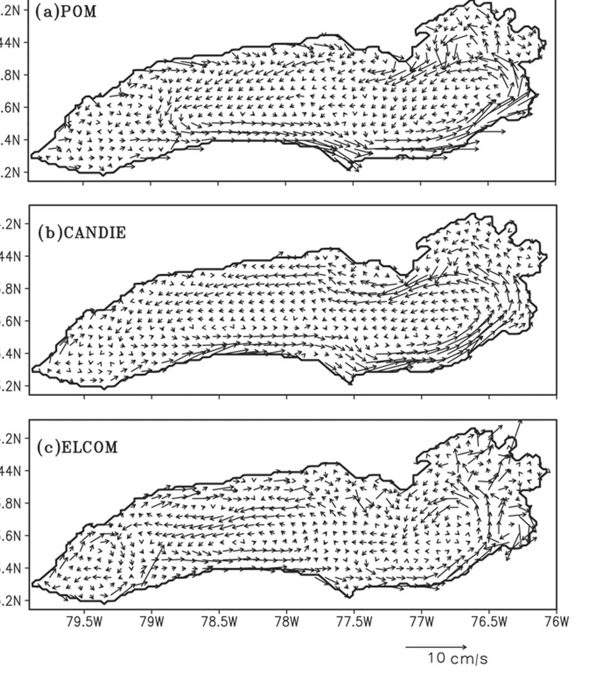

**Figure 4**: Modeled depth-averaged currents during summer 2006.

*From Huang et al., 2010*

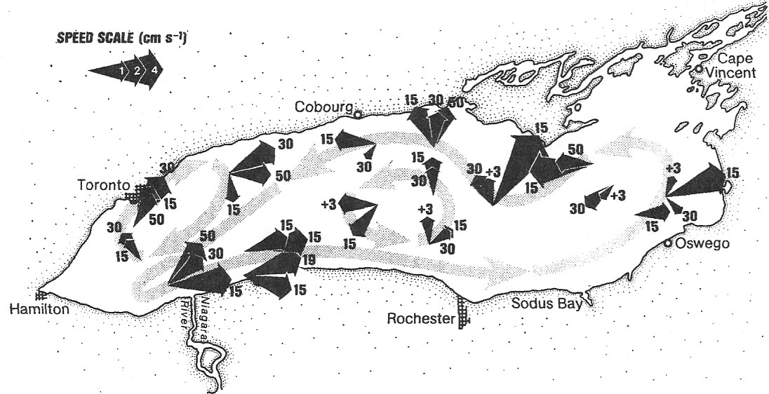

*(depths in meters at arrow tips; +3 indicates 3 meters off bottom) vector averaged from June to October 1972. From Pickett 1976.*

*(depths in meters at arrow tips; +3 indicates 3 meters off bottom) vector averaged from June to October 1972. From Pickett 1976.*

*(depths in meters at arrow tips; +3 indicates 3 meters off bottom)*

*(depths in meters at arrow tips; +3 indicates 3 meters off bottom)*

**Figure 3**: Lake Ontario observed currents

Due to the swell of public concern during the 1960s and early 1970s about the poor state of water quality in the Great Lakes, the governments of Canada and the United States signed the 1972 Great Lakes Water Quality Agreement. The main focus of the 1972 agreement was to reduce the loadings of phosphorus to the lower Great Lakes. The 1978 amendment to the GLWQA included phosphorus-loading targets for each of the Lakes. For Lake Ontario, 7000 metric tons per year (mT/year) was set as the loading target and 10 μg/l as the ambient spring open water quality objective. Both the loading target and water quality objective have been incorporated into Annex 4 of the Great Lakes Water Quality Protocol of 2012 as interim ecosystem objectives.

Tracking of phosphorus loading to Lake Ontario is critical to monitoring compliance with the phosphorus-loading target. Traditionally, tracking of phosphorus loads has focused on five main source classifications that include: direct industrial and municipal point sources; non-point or tributary sources; atmospheric deposition; and, upstream Great Lakes inputs. The recent re-emergence of *Cladophora* in Lake Ontario at nuisance levels has focused the need to understand the role and significance of anthropogenic phosphorus in exacerbating this problem. In order to make sound management decisions, source identification and accurate estimates of phosphorus loading are needed. Two journal articles that address the estimation of total phosphorus loading to Lake Ontario were reviewed. The first, Makarewicz et al., (2012a), focused on estimating tributary loading to Lake Ontario and included loading estimates for municipal and industrial direct dischargers and upstream (Niagara River) sources as part of the 2008 binational Cooperative Science and Monitoring year for Lake Ontario. The second article, by and Dolan and Chapra (2012), developed TP loading estimates for all of the five Great Lakes from direct industrial and municipal point sources; non-point or tributary sources; atmospheric deposition; and, upstream. Findings from a third source, a report by the Lake Ontario Shoreline Algae Action Committee (LOSAAC), 2008 is provided to highlight the importance of understanding loadings to the lake on a much finer spatial scale.

The main focus of Makarewicz et al., (2012a) was to estimate the phosphorus loads from the 145 U.S. and Canadian tributaries that empty into Lake Ontario. The approaches for estimating tributary loading differed between the Canadian and U.S. tributaries. On the Canadian side the Event Mean Concentration (EMC)[2] method developed by the U.S. EPA was applied to 101 tributaries, which represent 69% of the Ontario portion of Lake Ontario’s watershed. To obtain total phosphorus and suspended solids (SS) EMCs for tributaries along the north shore, 25 event-based flow-weighted composite samples were collected from 13 tributaries[3] between 2008 and 2010. The tributaries represented a range of watersheds (urban to rural) and allowed for prorating of EMCs to nearby unmonitored streams.[4] The total phosphorus EMC for the Trent River was based on water quality data collected as part of Project Quinte. Tributary discharge was obtained from Environment Canada, Water Survey of Canada’s Hydrometric Data (HYDAT), which can be accessed at https://ec.gc.ca/rhc-wsc/default.asp?lang=En&n=9018B5EC-1. Since the stream gauges are located upstream from the tributary mouths, a correction factor was applied to represent the flow for the entire drainage area of each watershed. Dry weather EMCs for each tributary was estimated using the previous 5 years of water quality data from the Ontario Ministry of the Environment and Climate Change’s Provincial Water Quality Monitoring Network (PWQMN). For streams with monitored flow but no water quality data, annual loads were calculated by applying the EMCs determined for the nearest monitored tributary in the area. For tributaries that had no flow or water quality monitoring, loads were estimated by areal prorating of flows and adopting the EMCs from the nearest tributary for which flows and water quality were measured.

On the U.S. side of the lake, annual total phosphorus loading was estimated for 44 tributaries representing 79% of the New York state portion of the Lake Ontario watershed. TP concentrations for some tributaries were obtained from 12 individual, 1 to 2 year, sampling studies that occurred over an 18-year period (Makarewicz et al., 2012a). Sampling of tributaries over the 18-year period included weekly and event based sampling over the 1 or 2 year (all seasons) period of study of each tributary. The Genesee River was the only New York tributary that had flow proportional sampling data. Available water quality data for the Salmon and Oswego Rivers cover the period of May to October over a 6-year period and the average total phosphorus monthly concentration for May to October was applied to calculate the monthly loadings for the November to April period. For several other tributaries, loadings were based on a minimum of a monthly sample with stream flows measured on the date of sampling and extrapolation of these data to a year. For Blind Sodus Bay and Little Sodus Bay the loadings were modeled using ArcView Generalized Watershed Loading Function. Continuous stream flow information was obtained whenever possible from U.S. Geological Survey gauges. The loading for the unmonitored watershed was estimated by multiplying the remaining watershed (21%) by the average loading (0.69 kg P/ha/year).

Only municipal and industrial wastewater treatment plants (WWTPs) that discharged directly into the lake were included in the point source loading calculations. WWTPs that discharged to tributaries were excluded since their loads are accounted for in the tributary loading to the Lake. Industrial once-through cooling water systems were excluded since there is no net loading from these facilities. Data on the loading from both municipal and industrial wastewater treatment plants for New York State and Ontario were obtained from the New York Department of Environmental Conservation and the Ontario Ministry of the Environment. The Monroe County Environmental Lab provided unpublished 2008 and 2009 data for the Northwest Quadrant and the Van Lare WWTP.

Based on the U.S. and Canadian approaches described above, a total annual phosphorus load of 2606 mT/year was estimated for all 145 Lake Ontario tributaries. The breakdown in the total annual load between U.S. and Canadian tributaries was 1411 mT/year for New York State watersheds and 1195mT/year from Ontario rivers and streams (see Tables 1 and 2 for breakdown). On the U.S. side the Genesee was identified as largest tributary source with an estimated TP loading of 417 mT/year, followed by the Oswego River and Black River with annual loading of 336 mT/year and 135 mT/year, respectively. On the Canadian side the Trent River was the highest tributary source of TP with an annual load of 200 mT/year followed by the Humber River at 93.0 mT/year and the Welland Canal at 80.8 mT/year.

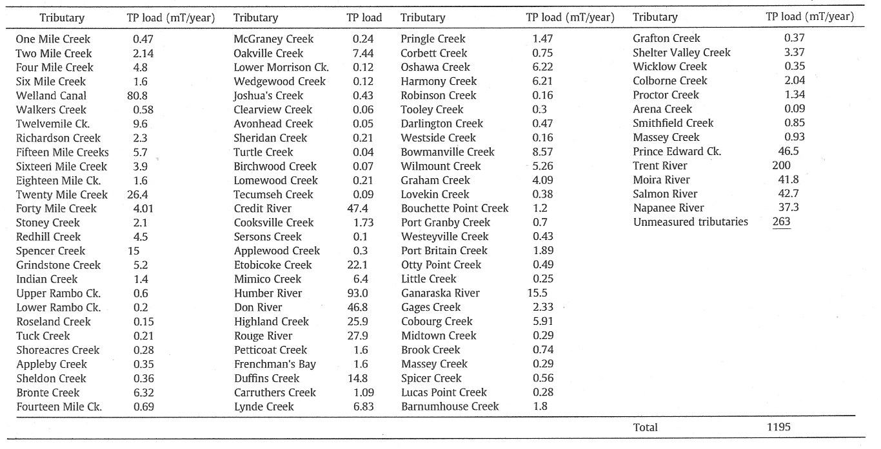

***Table 2****: Annual tributary loadings of total phosphorus (TP) to Lake Ontario from Ontario watersheds. Loadings in metric tons/year (mT/year) are estimates for 2008. Ck=Creek. From Makarewicz et al., (2012a).*

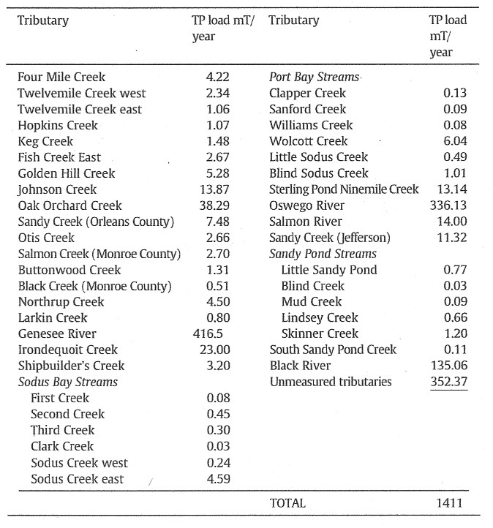

***Table 1****: Annual Tributary total phosphorus (TP) loading to Lake Ontario from New York watersheds. All units are in metric tons/year (mT/year). American data was collected over a 20-year period from 1998-2008. From Makarewicz et al., (2012a).*

Niagara River phosphorus loads were not available during the preparation of this study so comparison of tributary loads to Niagara River loads for 1982 from Neilson et al., (1995) and 1999-2004 from Environment Canada, (2009) were used. For the period of 1999-2004 Environment Canada reported the Niagara River load ranged from a low of 3642 (2004) to a high of 5182 mT/year (2001). The estimated Lake Ontario 2008 tributary load was 67.5% of the 1982 (~3860) Niagara River load reported by Neilson et al., (1995) and 71% and 50.2% of the 2004 (5182 mT) and 2001 (4564 mT) Niagara River loads reported by Environment Canada (2009).

No breakdown of phosphorus load by industry is provided in Markarawecz et al., (2012a). However, the total annual TP load was 0.3 mT/year for New York industries and 16.3 mT for Ontario industries. The total TP load from the 11 New York municipal WWTPs directly discharging to Lake Ontario was 137 mT with the Van Lare plant contributing the largest load at 108 mT/year. Table 3 provides a breakdown of the 2008 and 2009 average TP load for each of these New York State municipal WWTPs. The total Ontario municipal loading from 38 WWTPs was 644 mT/year, which was 6 times greater than the New York municipal load reflecting the greater population on the Canadian side of Lake Ontario. The breakdown of Ontario municipal WWTPs loads is provided in Table 4. At 153.6 mT/year, the Ashbridges Bay WWTP located in Toronto had the highest municipal TP loading on the Canadian side of the lake. Five other municipal WWTPs (Lakeview South Peel, Clarkson South Peel, Highland Creek, Humber and Duffin) located in Toronto or within the Greater Toronto Area also contributed significant annual TP loads that ranged from 41.5 to 90.8 mT/year. With its large population of around 6 million, the Greater Toronto Area stands out as an area of high point source phosphorus loading to the Lake.

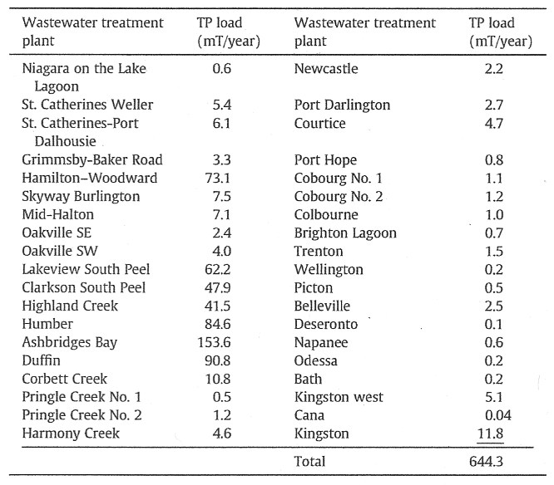

***Table 4****: Annual total phosphorus (TP) load to Lake Ontario from Ontario wastewater treatment plants. Values are for 2008. From Makarewicz 2012a.*

***Table 4****: Annual total phosphorus (TP) load to Lake Ontario from Ontario wastewater treatment plants. Values are for 2008. From Makarewicz 2012a.*

***Table 3****: Annual total phosphorus (TP) load to Lake Ontario from New York municipal wastewater treatment plants. Values are ave. 2008 and 2009. From Makarewicz 2012a*.

***Table 3****: Annual total phosphorus (TP) load to Lake Ontario from New York municipal wastewater treatment plants. Values are ave. 2008 and 2009. From Makarewicz 2012a*.

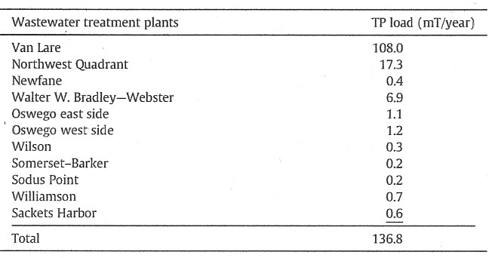

The combined annual U.S. and Canadian industrial and municipal direct discharge load of 797.7 mT/year was a little less than 1/3 (30.6%) of the combined U.S. and Canadian tributary load. Comparison of historic point source data suggests that the total phosphorus loading from U.S. and Canadian municipal point sources has declined substantially over the period 1976 to 2008 from 2047 to 781 mT/year and the industrial loading over the same period also shows a loading decrease from 80 to16.3 mT/year. Total tributary loading has also decreased from 3581 in 1976 to 2606 mT/year in 2008.

Dolan and Chapra (2012) estimated annual total phosphorus, chloride, nitrate and dissolved phosphorus loadings for all Great Lakes over the period of 1994 to 2008. All data used to estimate municipal total phosphorus loads came from U.S. and Canadian state and provincial governments. U.S. point source data (monthly average effluent flow and total phosphorus concentration) were retrieved from the Permit Compliance System (PCS). The PCS is a national database maintained by the U.S. EPA and updated by the States. U.S. flows for gauged tributaries were provided by the National Water Information System (NWIS) which is maintained by the Water Resources Division of the U.S. Geological Survey. Available TP concentrations for monitored Lake Ontario tributaries were retrieved from the U.S. EPA water quality STORET and NYSDEC water quality monitoring network information databases.

Canadian point source discharge data were provided by the Ontario Ministry of the Environment and Climate Change’s Municipal Industrial Strategy for Abatement (MISA) database. Tributary flows for gauged tributaries were retrieved from Environment Canada’s Water Survey of Canada’s Hydrometric Data (HYDAT) database. The Ontario Ministry of the Environment and Climate Change’s Provincial Water Quality Monitoring Network (PWQMN) provided the tributary TP concentrations. TP concentrations in atmospheric deposition (in rainfall) were provided by Environment Canada.

TP loads estimation methods varied by source type and the availability of data but generally followed the basic calculation by taking the product of discharge concentration and flow rate. Upstream loading was derived from modeled estimates based on measured flow between Lake Erie and Lake Ontario and observed in-lake TP concentrations. Direct municipal and industrial discharges had the most complete and consistent dataset for calculating loading. Not all Lake Ontario tributaries are monitored annually for flow and water quality, and for some tributaries this information is lacking. In addition, PWQMN provides only monthly sampling for a limited period of the year (e.g. 8 months). Due to these discrepancies in data availability, prorating of flows, TP concentration and loads were required to calculate estimated loadings for all tributaries.

Atmospheric loading was also a challenge as only TP in wet precipitation (rainfall) is available and no monitoring of TP in dry deposition is undertaken as part of the Integrated Atmospheric Deposition Network (IADN) monitoring. Using an International Joint Commissions convention, atmospheric deposition loading was calculated by assuming the dry deposition TP concentration is equal to the wet deposition TP concentration. Dolan and Chapra (2012) noted that dry deposition can represent up to 75% of the total atmospheric deposition load and therefore, their estimated atmospheric deposition TP loadings were conservative.

Dolan and Chapra (2012) defined a direct point source as a wastewater treatment facility that discharges directly into the Lake. Indirect point sources are those that discharge into a tributary. The indirect point sources were not included in the estimated municipal loads unless in a given year the tributary, which received the indirect municipal effluent, was notmonitored. In these cases, all indirect point sources to the un-monitored tributary were included in the total municipal load estimate. **Table 5** provides the loading estimates for municipal point sources from 1994 to 2008. An average annual municipal total phosphorus load of 1174 mT/year was calculated for the 15-year period (1994 – 2008).

Industrial direct and indirect annual TP loading ranged from 120 mT/year in 1994 and declined by 50% to 59mT/year in 2008. The TP loading from industrial point sources were considerably lower than the municipal point sources.

Tributary loads for monitored and unmonitored tributaries are provided in **Table 6** and the annual average load over the 15-year period from 1994 to 2008 was 1531 mT/year and 528 mT/year, respectively. The average annual load contributed by atmospheric deposition for the same time span was 243 mT/year. The estimated Lake Erie loads to Lake Ontario are still significant (**Table 7**) and based on a rolling 5-year average. Dolan and Chapra (2012) estimated the loads from Lake Erie to Lake Ontario represent about 27% of the overall load. Based on the analysis by Dolan et al., the Lake Ontario target load of 7000 mT/year has not been exceeded over the 15-year period of the study, however the authors’ note that the load estimates in 1996 and 1998 were not significantly different than the lake-wide TP load target. They attribute these two high years in part to the high inputs from Lake Erie.

By compiling previous loading data and the 15 years of data presented in the 2012 paper, Dolan and Chapra (2012) used a linear regression to fit the loading period from 1980 to 2008 for all of the Great Lakes. As a result of this analysis only Lakes Huron and Ontario loading data exhibited a statistically significant declining linear trend (Figure 5).

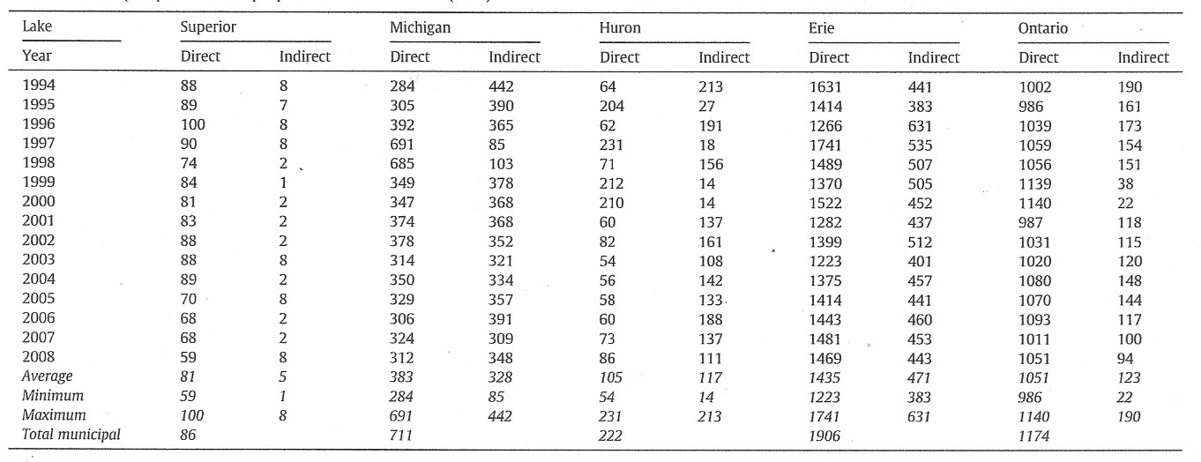

***Table 5****: Great Lakes total phosphorus municipal point sources 1994-2008 (MTA).*

*From Dolan et al., 2012*

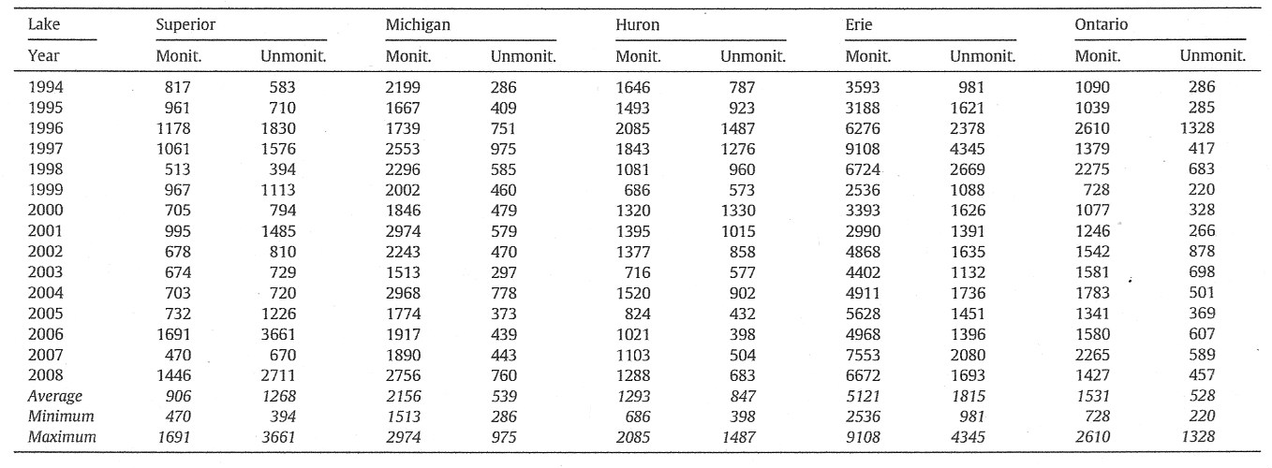

***Table 6****: Great Lakes total phosphorus tributary loads 1994-2008 (MTA). From Dolan et al., 2012.*

***Table 6****: Great Lakes total phosphorus tributary loads 1994-2008 (MTA). From Dolan et al., 2012.*

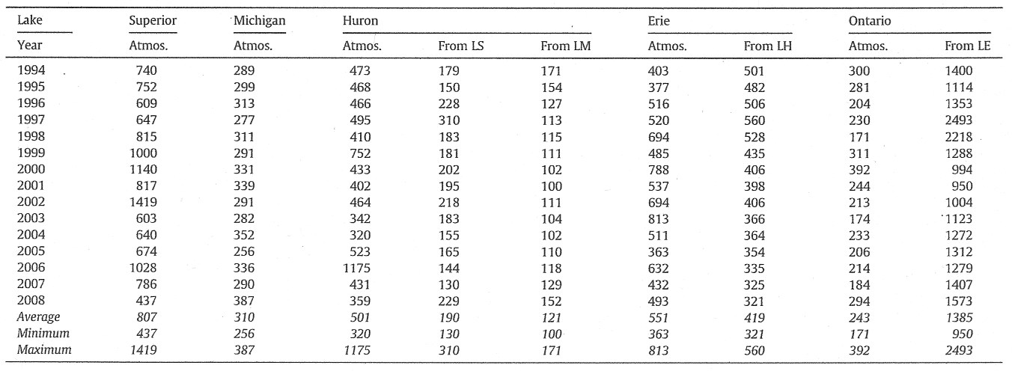

***Table 7****: Great Lakes total phosphorus load estimates 1994-2008 (MTA). Upstream contributions are identified as follows; LS (Lake Superior via St. Marys River), LM (Lake Michigan via straits of Mackinac), LH (Lake Huron via the St. Clair River), LE (Lake Erie via the Niagara River). From Dolan et al., 2012.*

***Table 7****: Great Lakes total phosphorus load estimates 1994-2008 (MTA). Upstream contributions are identified as follows; LS (Lake Superior via St. Marys River), LM (Lake Michigan via straits of Mackinac), LH (Lake Huron via the St. Clair River), LE (Lake Erie via the Niagara River). From Dolan et al., 2012.*

In an ongoing study of agricultural impacts on water quality in southwestern Ontario, the Ontario Ministry of the Environment and Climate Change assessed 5 years of data from 2004 to 2009 (Ontario Ministry of the Environment and Climate, Change unpublished). Of importance to the Lake Ontario nutrient loads is the finding that there were clear seasonal patterns in nutrient concentrations and loads, with a majority of annual loads of TP, NO2+NO3, and suspended solids delivered in winter and early spring

with low loading of these substances during summer. As much as 50% of the annual nutrient load from the studied agricultural streams occurred in the December to March period. Many of the Lake Ontario tributary load estimates were based on monitoring the stream quality for 8 months per year (April to November) and using the monthly concentration average to prorate the December to March concentrations. If Lake Ontario’s agricultural tributaries have similar seasonal loading and concentration patterns as southwestern Ontario, then many of the tributary estimates will have underestimated the actual loading.

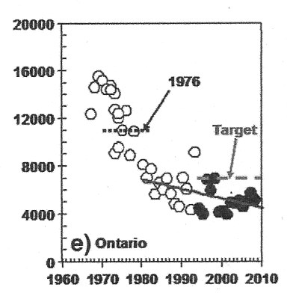

*Filled in points are new estimates, open points are previously compiled loading. Dotted line is 1976 IJC loadings; dashed line is the GLWQA target loading. Solid line is the trend for previously compiled data from 1980 to recent data through to 2008. Dolan et al., 2012.*

*Filled in points are new estimates, open points are previously compiled loading. Dotted line is 1976 IJC loadings; dashed line is the GLWQA target loading. Solid line is the trend for previously compiled data from 1980 to recent data through to 2008. Dolan et al., 2012.*

**Figure 5**: Time series of Lake Ontario total phosphorus loading (MTA).

In Lake Ontario, *Cladophora* grows, for the most part, close to shore at depths of >2 to 20 meters. Soluble reactive phosphorus (SRP) is the form of phosphorus that is most easily taken up by plants, microorganisms and is important for *Cladophora* growth. For this reason, knowing the sources and loading of total phosphorus and SRP to areas of dense *Cladophora* stands is important to better understand the land based influences that may contribute to nuisance growth of the benthic algae. In urban areas, anthropogenic sources of phosphorus are direct industrial and municipal point sources, tributaries and, stormwater and combined sewer outfalls. Direct loading from stormwater and combined sewer outfalls to the Lake were not addressed in either Markarewicz et al., (2012a) or Dolan and Chapra (2012), although stormwater and combined sewer outfalls to tributaries would have been captured as part of the tributary loading estimates. As well, neither of the two studies had the necessary information to address SRP loading. To highlight the importance of understanding the nutrient loading, especially SRP, within local nearshore settings the results of a loading study undertaken by the Lake Ontario Algae Action Advisory Committee (LOSAAAC, 2008) in Halton Region is summarized below.

This study took place along the shoreline of the municipality of Halton Region, an area along the north shore of Lake Ontario that has experienced numerous episodes of severe shoreline fouling by *Cladophora*. At the outset of the study (2004-2005) the research team found there was little known about the nearshore water chemistry in this area or what was flowing into the lake from the storm drains and streams. Only loading data for the four regulated municipal WWTP in the study area were available. As a result, a comprehensive analysis of local watersheds, and the loading of both total phosphorus and SRP to the lake from urban and rural sources were undertaken by the Halton Region. Measured flow and water quality were monitored to estimate the source-based loadings. The loadings from all the sources in the study area are presented in **Table 8** and based on these loadings the LOSAAAC concluded:

1. The combined total phosphorus (TP) load from urban and rural land drainage of 14,611 kg/year is very close to that from WWTPs (13,969 kg/year). However the SRP loading from the WWTPs at 7,277 kg was 4 times greater than from drainage at 1,722 kg (**Table 6**).
2. The urban TP per hectare loading is nearly 4 times greater from urban versus rural areas and SRP from the urban drainage is nearly 7 times greater than rural drainage.
3. The expected urban growth in Halton Region will significantly add to urban drainage load unless effective stormwater management systems are put in place.

These findings highlight the importance of not only understanding the nutrient loadings on a local scale but also understanding the sources of the different forms of phosphorus, especially SRP, and the importance of stormwater outfalls as significant local sources of nutrients. The findings also demonstrate how detailed understanding of sources and loads of both TP and SRP can provide valuable information to assist water quality managers in making sound decisions and plans for the future.

To help provide more current and accurate loading estimates for total phosphorous, orthophosphate (SRP), total suspended solids, and total dissolved solids, the United States Geological Survey (USGS) in cooperation with the U.S. Environmental Protection Agency (U.S. EPA) monitored stream flow and water quality parameters for nine tributaries on the U.S. side of the lake between 2012 to 2014. In addition to total tributary loads, watershed yields on load per unit area will be included as part of the analysis to assess relative tributary contribution and allow direct comparisons of loads among monitored basins. The data will also be used in the development of a hydrodynamic model for the southwestern shore of Lake Ontario from the Niagara River to the Genesee Embayment and assist the GLWQA Annex 4 and USEPA GLRI initiatives to determine future nutrient and sediment goals. Results of this tributary loading study are to be made available once published in the not too distant future as a USGS Scientific Information Report (personal communication, Ed Bugliosi, USGS March, 2016).

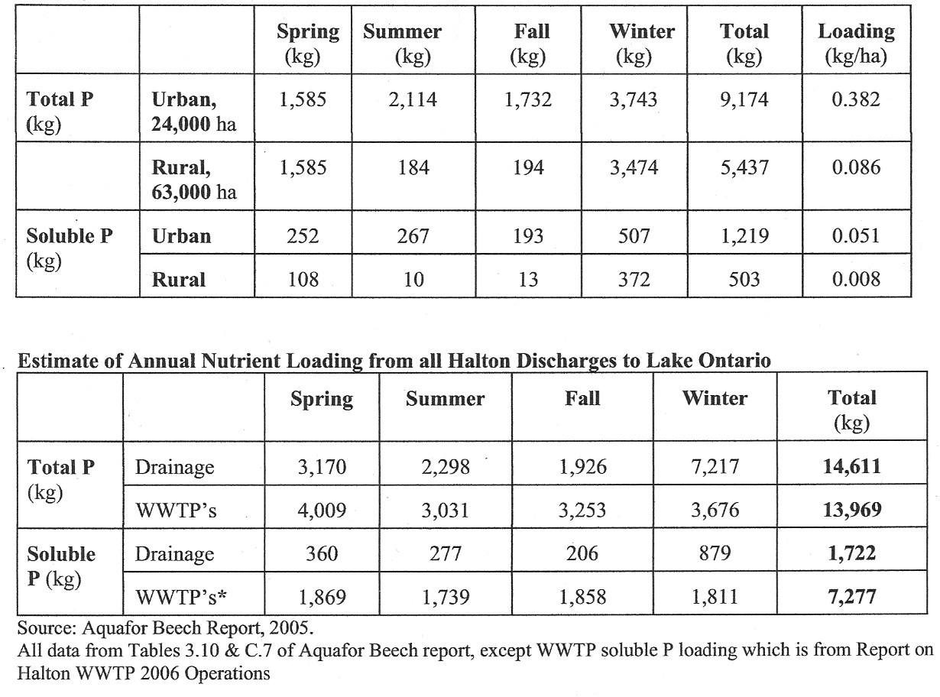

***Table 8****: Estimated annual loadings from urban and rural drainage areas in Halton Region. Soluble P refers to SRP. Data From LOSAAAC, 2008.*

***Table 8****: Estimated annual loadings from urban and rural drainage areas in Halton Region. Soluble P refers to SRP. From LOSAAAC, 2008.*

## Niagara RiverTotal Phosphorus Loadings

The Niagara River accounts for more than 80% of the total tributary inflow to Lake Ontario (Eadie and Robertson 1976) and about 50% of all incoming fine grained sediment (Kemp and Harper 1976). As a result, the Niagara River has a significant influence on the water quality of Lake Ontario. As noted in the section of this report, “Great Lakes (Lake Ontario) Monitoring Programs”, Environment and Climate Change Canada has been monitoring the Niagara River at the downstream Niagara-on-the-Lake station since 1975 and monitoring at the upstream Fort Erie station also began in 1983. The river is monitored weekly for a range of chemical contaminants, major ions – calcium, sodium, magnesium, potassium, sulfate and chloride - and nutrients. A recent assessment has been completed of the long-term data from the upstream/downstream (Hill et al., in prep.).

Four different methods of load computation have been performed for Niagara River total phosphorus concentrations and all provided similar results and indicate the loading of total phosphorus to Lake Ontario from upstream sources via the Niagara River has been approximately 5550 metric tonnes per year since the 2000 water year. During six of the 25 years since 1990, the load from the Niagara River alone has accounted for or exceeded the GLWQA total Lake Ontario loading target of 7000 metric tonnes per annum (MTA) **(Figure 6).** These results indicate that upstream loadings are significant and are much greater than the approximate 30% of the total loadings to Lake Ontario provided in Markarewicz et al., (2012a) and Dolan and Chapra, (2012). A comparison with tributary and point source (industrial and municipal provided in Makarewicz et al., (2012) suggests the Niagara River loadings are as much as 60% of the loading to the Lake.

**Figure 6**: Total phosphorus load (in metric tonne per annum) at Niagara-on-the-Lake, 1975-2015 (year is water year). The dashed horizontal line is the GLWQA target load for all sources to Lake Ontario.

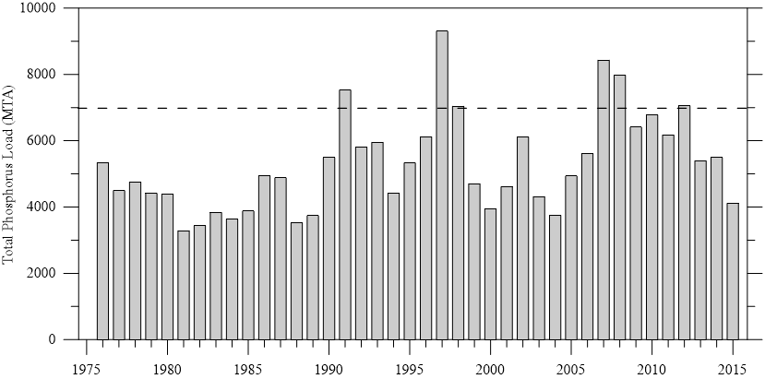

The modeling of Niagara River loading by Dolan and Chapra (2012) was based on measured TP concentrations in the eastern basin of Lake Erie during spring (April). ECCC monitoring cruises and, as Dolan and Chapra (2012) point out, the eastern Lake Erie concentrations, multiplied by the flow in the Niagara River, produce much lower estimates than the direct measurements in the river since 1990. A preliminary assessment by ECCC showed that the total phosphorus concentration differences between the River and the Lake appear to be greatest during the spring (A. Dove, ECCC, personal communication); therefore, it may not be appropriate to scale up eastern Lake Erie spring measurements to account for year-round loadings from the Niagara River to Lake Ontario.

## Phosphorus Loading from Groundwater

The traditional tracking of phosphorus loads to the Great Lakes has focused on five main source classifications that have not included groundwater: direct industrial and municipal point sources; non-point or tributary sources; atmospheric deposition; and, upstream sources. This is understandable since monitoring of groundwater flow and quality on a large areal basis is complex and expensive. In estimating nutrient loading to the Great Lakes, groundwater contributions to tributaries are accounted as part of the total tributary load. What is missed is the nutrient contribution through direct discharge of groundwater that can occur either near the shore from permeable aquifers or at discrete points offshore. Groundwater was estimated to be a small component in Great Lakes water balances. However, it may play a critical role in delivering nutrients to the lakes during the critical growing season when tributary flows are at or approaching their low-flow period. No evaluation of nutrient loading from groundwater to Lake Ontario was found and the report “Groundwater science relevant to the Great Lakes Water Quality Agreement: A Status Report” (Grannemaman and Van Stemvoort. Eds. Draft. 2015) acknowledges data gaps and research needs for understanding the effects of groundwater on nutrient enrichment of the Great Lakes surface waters. Four areas of priority science needs related to groundwater and nutrients are identified in the report and are listed in **Table 9** below. It would seem that until these data gaps and research needs are filled, attempts to estimate the groundwater loading of phosphorus to Lake Ontario on a lake-wide scale would be challenging.

|  |  |
| --- | --- |
| ***Table 9****: Priority science needs related to groundwater and nutrients (from Grannemaman and Van Stemvoort. Eds. Draft 2015.* | |
| **Priority Science Needs** | **Related needs and information gaps** |
| **A**. Linking land management and groundwater nutrient loading | * Acknowledgement that groundwater nutrient loading is linked to land management * Evaluation of the best management practices for reducing groundwater nutrient export to surface waters * Understanding the temporal lag between the implementation of best management practices and improvements in groundwater and surface water quality |
| **B**. Role of hot phenomena with respect to groundwater nutrient fluxes | * Groundwater sampling to evaluate the spatial and temporal variability associated with the hot phenomena * Research on the importance of the hot phenomena with respect to direct groundwater nutrient discharge to the Great Lakes |
| **C**. Upscaling of site specific knowledge | * Development of tools for scaling up local groundwater knowledge for application at the watershed and basin scales * Identify the landscape controls on groundwater nutrient fluxes * Identify priority watersheds in which to focus research efforts |
| **D**. Basin-wide assessment of groundwater | * Compile historical groundwater data * Augment monitoring networks to assess groundwater nutrient trends * Regular systematic assessment of groundwater nutrient trends in the Great Lakes Basin * Increase availability of hydrogeological mapping products |

### Conclusions

1. The Lake Ontario loading data presented by Dolan and Chapra (2012) exhibited statistically significant declining linear trend from 1980 to 2008 and has not exceeded its target load of 7,000 mT/year since the mid-1980s. However, recent analysis of total phosphorus loading to Lake Ontario from upstream sources via the Niagara River provides an annual estimate of approximately 5550 metric tonnes per year since the 2000 water year. This revised annual average is 4 times greater than the annual average (1385 mT/year) provided by Dolan and Chapra (2012). In addition, the recent analysis of upstream loads indicates that six out of 26 years from 1990 to 2015, the load from the Niagara River alone has accounted for or exceeded the GLWQA total Lake Ontario loading target of 7000 mT/year.
2. The total phosphorus loads from U.S. and Canadian tributaries, and municipal and industrial wastewater treatment plants to Lake Ontario have decreased from 1976 to 2008 by 77%, 61% and 65%, respectively.
3. Studies of nutrient loading from agricultural watersheds in southwestern Ontario have found that a considerable amount of the nutrient and suspended sediment loading occurs during the December to March period of the year. If Lake Ontario’s agricultural watershed have a similar seasonal pattern, current loading estimates from these tributaries may be low due to the lack of winter to early spring monitoring and the prorating of December to March nutrient concentrations based on data covering the April to November period.
4. No information is available for the estimation of nutrient contributions from direct groundwater discharge and this represents an information gap in the loading estimates for Lake Ontario.

# Nutrient Status of Lake Ontario

## Introduction

The following section provides a status assessment of nutrients within Lake Ontario. The discussion is organized into three coarse geographical classifications of the Lake; offshore, nearshore and embayments. For this report “embayments” are defined as bodies of water that are not part of the open lake where water exchange occurs freely. The shoreline within these embayments form part of the overall Lake Ontario coastline and they are generally included as part of the Lake’s nearshore. Due to the reduced exchange of water with the lake, water quality within the embayments is influenced more by their surrounding landscape rather than the main lake conditions. The Bay of Quinte, Hamilton Harbour on the north shore and Irondequoit Bay and Soddus Bay on the south shore are examples of bodies of water included as embayments in this report.

The status of the offshore and nearshore includes discussions on the temporal, seasonal and spatial nutrient patterns in these Lake Ontario zones. The embayments section provides a summary of conditions within each embayment and actions to address their nutrient problems. The assessment is based on a review of scientific literature, government reports and gray literature.

## Lake Ontario Offshore Nutrient Status

A number of researchers have analyzed and reported on long-term nutrient data sets for Lake Ontario. The primary source of data for these assessments have been obtained from Environment and Climate Change Canada’s Great Lakes Surveillance Program (1970 to present), U.S. EPA’s GLNPO Limnology Program (1986 to present), the Department of Fisheries and Oceans Canada’s ecological monitoring studies (1981 – 1992) and Bioindex Program (1981 – 1995) and other Lake Ontario datasets developed by various agencies within the basin. In addition, three binational intensive monitoring years have been completed for Lake Ontario in 2003, 2008 and 2013.

Among the various research papers, the concurrence is very strong on the nutrient trends and the Lake’s current trophic status.[5] Dove and Chapra (2015) report on nutrient trends in the Great Lakes using Environment and Climate Change Canada’s (ECCC) extensive Great Lakes Surveillance database. The paper is the third in a series documenting the long-term water quality trends in the Great Lakes. Holeck et al., (2015) combined several of the mentioned data sources in their assessment of long-term Lake Ontario nutrient trends and trophic status. To evaluate compliance with the GLWQA phosphorus targets, Johengen et al., (1994) evaluated 12 years (1981 to 1982) of nutrient data from single stations in Lakes Michigan and Ontario that are representative of the broader offshore conditions. The following discussion summarizes the findings from these studies. Findings by other researchers are provided where appropriate to support or provide an alternative interpretation to those of the primary papers mentioned. This section also provides a discussion on the long-term temporal and seasonal trends, spatial patterns and current status of nutrients within Lake Ontario’s offshore waters.

Over the length of time covered by the long-term data sets two key periods emerge: the initiation of phosphorus controls circa 1972 and the establishment of dreissenid mussels in the Great Lakes around 1992-1998[6]. Assessment of nutrient levels during the spring, un-stratified period (April to May) provides a perspective on annual maximum concentrations prior to the warmer algae growing season. The analysis of summer (July and August) and fall (September) trends of Chlorophyll *a* and secchi depth provide an indication of the biological response to the spring concentrations.

Most of the phosphorus load reductions within the lake to meet the GLWQA target for Lake Ontario were achieved prior to 1977 (Johengen et al., 1994). Since that time, spring mean offshore total phosphorus (TP) concentrations have dramatically decreased in Lake Ontario from 21 μg/L in 1970 to 6 μg/L in 2013 (**Figure 7 and Table 10**). The TP concentrations indicate a strong downward trend with the greatest decline during the 1970s to the 1980s followed by a more gradual decrease since that time. The mean spring offshore concentrations have been below the GLWQA ambient water TP objective of 10 μg/L since 1991. Since 1998, spring TP concentrations have demonstrated a downward trend and current concentrations are in the range of 5-6 μg/L (**Figure 8**). Spring Soluble Reactive Phosphorus (SRP) concentrations have mirrored the declining trend of TP (**Figure 9**) and in 2013 the mean was 2 μg/L..

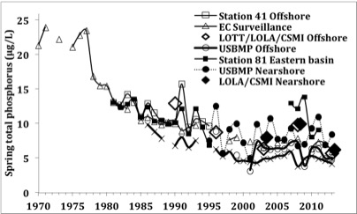

*Compilation of multi-agency data demonstrates a long-term decline that has slowed, with less discernible change over the past 15 years. Data sources include ECC’s Great Lakes Surveillance Program, (EC Surveillance) DFFO-Canada’s Bioindex Program (Station 41), U.S. Bimonitroing Program (USBMP), and several lake-wide assessments (LOTT, LOLA, CSMI). Nearshore and Eastern Basin data from DFO-Canada and OMNRF (Station 81) and the USBMP.*

**Figure 7**: Lake Ontario Offshore spring total phosphorus fit since 1998. Source – Environment and Climate Change Canada Great Lakes Surveillance Program unpublished.*Compilation of multi-agency data demonstrates a long-term decline that has slowed, with less discernible change over the past 15 years. Data sources include ECC’s Great Lakes Surveillance Program, (EC Surveillance) DFFO-Canada’s Bioindex Program (Station 41), U.S. Bimonitroing Program (USBMP), and several lake-wide assessments (LOTT, LOLA, CSMI). Nearshore and Eastern Basin data from DFO-Canada and OMNRF (Station 81) and the USBMP.*

**Figure 7:** Spring (Apr.-May) epilimnetic total phosphorus concentrations in Lake Ontario, 1970-2013.

Lake Ontario spring median SRP:TP ratios have declined from the ratio of 0.6 in 1970 to 0.2 in 2012 indicating a significant decline of SRP relative to TP in Lake Ontario’s offshore nutrient supply (Dove and Chapra 2015). The most recent 2013 mean springtime TP concentrations of 5-6 μg/L indicate that Lake Ontario’s offshore continues to be oligotrophic

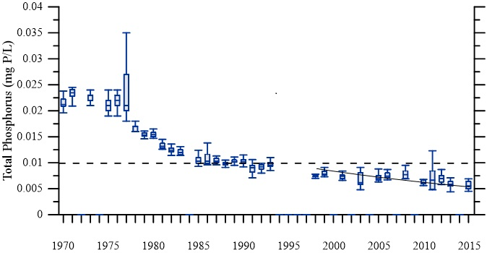

**Figure 8**: Lake Ontario Offshore spring total phosphorus fit since 1998. Source – Environment and Climate Change Canada Great Lakes Surveillance Program unpublished.

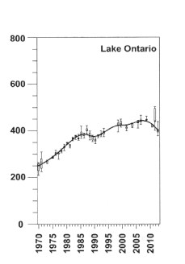

**Figure 10**: Lake Ontario offshore spring mean Nitrite+Nitrate trend.

**Figure 9**: Lake Ontario offshore spring mean Nitrite+Nitrate trend.

*From Dove and*

*From Dove and*

*Chapra 2015.*

**Figure 20**: Lake Ontario spring (blue) and summer (red) silica concentrations.*Chapra 2015.*

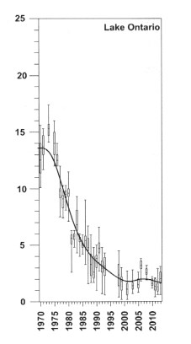

**Figure 9:** Lake Ontario offshore SRP trend

**Figure 8:** Lake Ontario offshore SRP trend

*From Dove and Chapra 2015.*

**Figure 9**: Lake Ontario offshore spring mean Nitrite+Nitrate trend.*From Dove and Chapra 2015.*

Mass balance modeling of Great Lakes total phosphorus, validated by offshore data, indicates that offshore Lake Ontario phosphorus concentrations have declined below values expected according to its loading. Dolan and Chapra (2012) and Chapra et al. (in press) indicate an unexplained sink of total phosphorus that is required to account for the observed total phosphorus decline in Lake Ontario. In other words, there is an apparent retention of total phosphorus in Lake Ontario that has been at play since about 1990.

Mean spring Nitrate plus Nitrite (NO3 + NO2)concentrations in Lake Ontario have increased substantially (>62%) from 1969 to 2013 to a spring mean concentration of 398.4 μg/L (**Figure 10**). A short-lived reversal of the increasing trend occurred in the late 1980s however, levels returned to the increasing trend from the 1990s until 2005. Another trend reversal in the NO3 + NO2 spring mean concentrationsmay have started in 2007 and has continued until 2013. Results of future monitoring will determine whether the ongoing trend is declining, stabilizing or increasing. With the long-term increase in nitrate (NO3) concentration and decrease in TP, the result is an abundance of nitrate, which supports P-limitation within the Lake Ontario offshore.

All offshore ammonia (NH3) values are low (1.12-4.86 μg/L) and no significant trend has occurred in Lake Ontario over the period of record (1973 – 2013) (Dove and Chapra, 2015). Dove and Chapra (2015) reported that spring silica (SiO2) concentrations have been increasing in the offshore since the early 1990’s (**Figure 11).** A similar trend was identified by Holeck et al., (2015) which showed mean spring silica concentrations have increased significantly from 1986 to 2010. A number of researchers have suggested that the rise in silica concentration has been caused by two factors: 1) the decrease in TP due to controls which reduced diatom production; and, 2) introduction of dreissenid mussels which have reduced diatom abundance which in turn has reduced silica utilization.



**Figure 11**: Lake Ontario spring (blue) and summer (red) silica concentrations.

**Figure 40**: Lake Ontario spring (blue) and summer (red) silica concentrations.

*Source Environment and Climate Change Canada Great Lakes Surveillance Program unpublished.*

**Figure 41**: Lake Ontario offshore summer (Jul-Aug) Chl a trend.*Source Environment and Climate Change Canada Great Lakes Surveillance Program unpublished.*

Despite the increasing trend in spring silica mean concentrations, there has been no associated increase in summer SiO2 concentrations indicating that although diatom abundance has declined summer diatom concentrations are still sufficient to utilize available silica. The silica to TP ratio has increased over time and suggests that phosphorus is now the strongly limiting nutrient.

The summer Chlorophyll *a* (*Chl a*) trend shows a steep decreasing trend until 1990 when concentrations leveled off (**Figure 12**). The post 1990 values suggest that concentrations may be increasing but the variability is so great that any trend is not statistically significant (Dove and Chapra, 2015).

With the decline in Chl a, offshore mean summer secchi depth in Lake Ontario demonstrated a doubling in water transparency from 3.1 meters to 5.92 over the time period 1966 to 2010 (Figure12: Offshore summer Chl a trend). No secchi depth data for Lake Ontario were presented for 2011-2012 however, the 2013 mean secchi depth was 4.45 m (Dove and Chapra 2015).

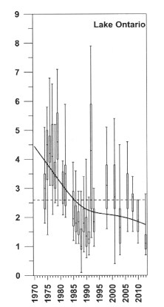

**Figure 12**: Lake Ontario offshore summer (Jul-Aug) Chl a trend.

**Figure 61**: Lake Ontario offshore summer (Jul-Aug) Chl a trend.

*From Dove et al., 2015*

**Figure 6**: Open Lake Ontario a) spring (April) and b) summer (July-August) secchi disc depth trend.*From Dove et al., 2015*

Holeck et al. (2015) analyzed both spring and summer secchi depth long-term datasets and found that water clarity has increased in the offshore of Lake Ontario (**Figure 13a and b).** Secchi depths in the 2000s are about double those measured in the 1980s. A break point in the spring secchi depth and summer secchi depth trends occurs in 1998 and 2001, respectively. Spring secchi depth values show a marginally significant increase between 1998 to 2011, but the summer secchi depth indicates no increase from 2001 to 2011.

Plots between trophic-status variables are used to investigate whether correlations between these variables exist. The correlations can provide insight into the cause and effect relationship between lake trophic status and phosphorus concentrations in phosphorus-limited lakes like Lake Ontario. **Figure 14** shows a correlation between the logarithms of summer Chl concentration and spring TP concentration for offshore waters from for all the Great Lakes, including Lake Ontario (Dove and Chapra 2015). For Lake Ontario, the plot suggests a good correlation between the two variables that indicates extreme P limitation, that is, “low phosphorus is limiting the lower food webs to an unprecedented level” in Lake Ontario (Dove and Chapra 2015).

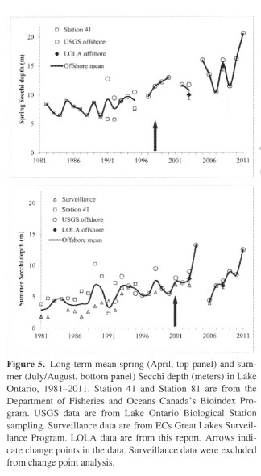

**Figure 13**: Open Lake Ontario a) spring (April) and b) summer (July-August) secchi disc depth trend.

**Figure 7**: Open Lake Ontario a) spring (April) and b) summer (July-August) secchi disc depth trend.

*Arrows indicated change point. From Holeck et al., 2015.*

*Arrows indicated change point. From Holeck et al., 2015.*

Dove and Chapra (2015) provide a log-log plot to confirm the relationship between Chl *a* and secchi depth (**Figure 15**). The high secchi depth in Lake Ontario indicates the extremely low levels of productivity in the offshore waters.

To help in the interpretation of their results Dove and Chapra (2015) presented a modified trophic classification system that includes 2 additional classifications of Ultraoligotrophy and Hypereutrophy that definea significant lack of nutrients and high clarity due to lwo productivity (Table 11). Based on the current spring TP (6 μg/L) and summer Chl *a* (1.28 μg/L) concentrations, and summer secchi depth (4.45 m) the trophic status of the offshore waters of Lake Ontario is oligotrophic. The Chl *a* : TP and secchi depth : Chl *a* correlations (Figures 14 and 15) confirm that the productivity is low and is limited by the low levels of total phosphorus.

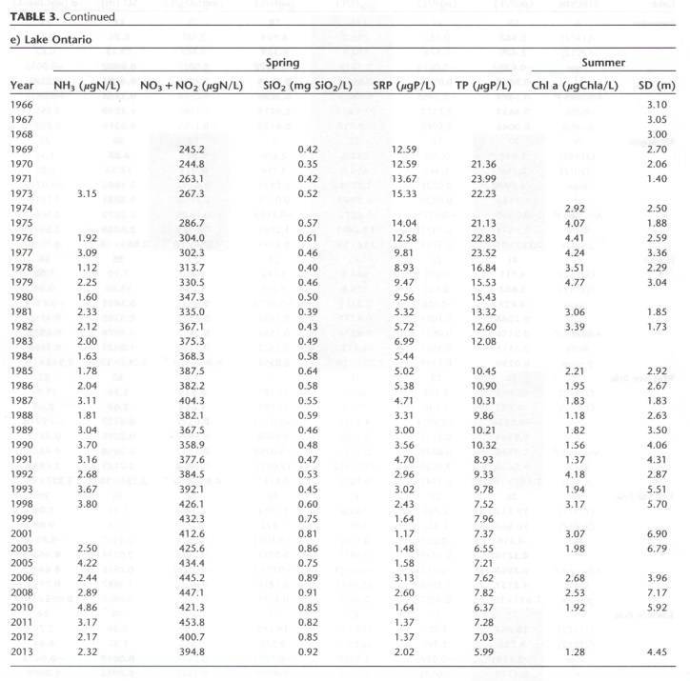

***Table 10****: Mean spring nutrient concentrations and summer response variables for offshore waters of Lake Ontario. From Dove et al., 2015.*

***Table 10****: Mean spring nutrient concentrations and summer response variables for offshore waters of Lake Ontario. From Dove et al., 2015.*

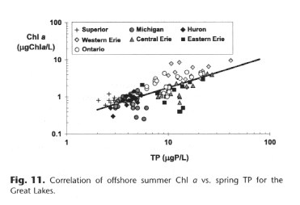

**Figure 14**: Correlation of offshore summer Chl a vs. TP for the Great Lakes.

**Figure 93**: Correlation of offshore summer Chl a vs. TP for the Great Lakes.

*From Dove et al., 2015.*

**Figure 94**: Correlation of offshore summer SD vs. Chl a for the Great Lakes.*From Dove et al., 2015.*

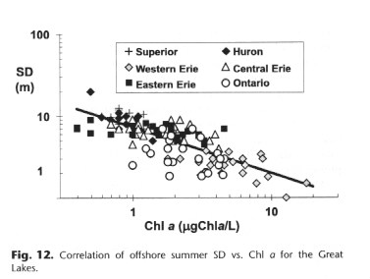

**Figure 15**: Correlation of offshore summer SD vs. Chl a for the Great Lakes.

**Figure 114**: Correlation of offshore summer SD vs. Chl a for the Great Lakes.

*From Dove et al., 2015*

**Figure 11**: Near surface total phosphorus (TP), soluble reactive phosphorus (SRP), Chlorophyll a (Chl a), Secchi Depth (SD) in the North Coast, Offshore, South Coast, Halton and Durham.*From Dove et al., 2015*

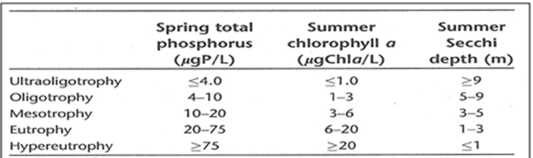

***Table 11:*** *Ranges defining trophic classes applicable to offshore waters of the Great Lakes. From Dove and Chapra, 2015.*

**Figure 123**: Correlation of offshore summer Chl a vs. TP for the Great Lakes.***Table 11:*** *Ranges defining trophic classes applicable to offshore waters of the Great Lakes. From Dove and Chapra, 2015.*

### Conclusions

1. The data indicate two distinct periods of change in Lake Ontario TP trends. The first decline in phosphorus occurred with the implementation of controls on municipal and industrial point sources within the lower Great Lakes and the enactment of regulations to reduce the phosphate content in detergents. A second period of decline in TP concentrations began in the mid-1990s and this latter decline was coincident with the colonization of dreissenid mussels in Lake Ontario.
2. The offshore spring TP concentrations within Lake Ontario have been below the GLWQA objective of 10 ug/l since 1991 and have declined since then to between 5-6 ug/l (Dove and Chapra, 2015). Mass balance modeling of total phosphorus suggests the expected offshore TP concentrations are below values based on the loading to Lake Ontario. This is especially more puzzling based on recent analysis of Niagara River loadings which suggests the proportion of the total annual loading to the lake from upstream is double the previous estimate of approximately 30%. Dolan and Chapra (2012) and Chapra et al. (in press) indicate there is an unexplained sink of total phosphorus that is required to account for the observed total phosphorus decline in Lake Ontario. This phosphorus sink represents a major unknown in the Lake Ontario phosphorus budget, especially with the recent update in Niagara River loading.
3. Recent mean spring TP concentration, mean summer Chl *a* concentration and mean summer secchi disc depth indicate the offshore trophic status for Lake Ontario is strongly oligotrophic and may indicate the reduced primary productivity of this region of the Lake is showing signs of its low nutrient status.
4. The strong correlation between the logarithms of summer Chl *a* concentration and spring TP concentration in the offshore waters indicates extreme P limitation, that is, “low phosphorus is limiting the lower food web to an unprecedented level” in Lake Ontario. Offshore secchi depth : Chl *a* correlation confirms productivity is low and the nitrate : TP, silica : TP ratios confirm that phosphorus is the limiting nutrient within Lake Ontario’s offshore waters.
5. Nitrate+nitrite and silica concentrations have both increased in Lake Ontario. Nitrate+Nitrite has increased since 1969 (earliest record in the Great Lake Surveillance Program Long-term dataset) while the increasing trend in silica concentrations started with the decline in phytoplankton, specifically, diatom abundance, in response to reductions in phosphorus. A further increase in silica concentrations is associated with the colonization of dreissenid mussels in Lake Ontario during the mid-1990s, which may have further reduced diatom abundance.

## Nearshore Nutrient Status

There are ranges in nomenclature used by researchers and others to describe the specific area or proximity to the shoreline or depth of water they are referring to within the more general term “nearshore. “Shoreside” has been used to define the area within the “nearshore” that is adjacent to the shore and is in “wadeable” depths between 0 to 1.2 or 1.5 meters. Howell et al., 2012a refer to the “nearshore” as the area from 3m depth extending to 5km offshore. Malkin et. al., (2010) use the term “coastal” to refer to a portion of the nearshore defined by sampling depths between 14 and 20 meters. Due to the trend of declining nutrient concentrations with distance from shore and land based discharges, and lower nutrient concentrations observed in greater depth, it is important for the reader to be aware of the area within the nearshore that is being referred to in the discussion on the nearshore nutrient status.

The nearshore of Lake Ontario comprises the part of the lake that receives tributary, industrial and municipal treated wastewater discharges, direct urban and rural run-off and direct groundwater inputs. It is also the area where municipal drinking water intakes are located. The nearshore is the area where most people come into contact either through viewing the Lake, fishing, walking or biking along lake-side walk ways and paths or by attending the many parks or beaches along Lake Ontario’s coast. It is through this interaction with the Lake that public perception about the health of the Lake Ontario is formed. Protection of water quality within the nearshore is important to maintain an excellent source of drinking water and its recreational and aesthetic value. The following discussion provides a perspective on the long-term nutrient trends in the nearshore and identifies spatial and temporal patterns within this area of Lake Ontario.

### Long-term Nearshore Nutrient Trends and Spatial Patterns

Using a subset of sampling stations from Environment Canada’s Great Lakes Surveillance Program for the period of 1975 to 2008, Malkin et al., (2010) conducted a comparison between trophic indicators (total phosphorus, SRP, Chl *a*, Secchi Disc, nitrate, ammonia) for the north coast, south coast and offshore zones in Lake Ontario. Station depths between 14-20 meters were used for this analysis and were classified as “coastal”. The 20-meter depth was chosen because it is considered the deepest autumnal thermocline extent and where it typically intersects with the lakebed. These criteria were used to identify six north coastal zone and five south coastal zone stations. Six stations of 50-meter depth or greater were identified to represent the offshore. Mean values were calculated by season for each station with the period of March-May considered as spring and July-September grouped as summer.

In another nearshore study, Winter et al., (2012) used raw water samples (1976-2008) from 5 drinking water intakes in the Canadian nearshore and analyzed trends in annual average concentrations of TP, silicate, nitrate, chloride, Chl *a*, and algal cell densities. The intake pipes ranged from 850 to 1950 meters in length and were situated in water from 10 to 15m depths and are comparable to the station depths used by Malkin et al., (2010).

Consistent with the offshore long-term total phosphorus (TP) trend in Lake Ontario, Malkin et al., (2010) found TP concentrations within the coastal zones have dramatically declined over the last 3 decades but there are spatial differences (**Figure 16 panels A and B**). Spring concentrations on the south coast have not declined to the same extent as the north coast. Offshore mean TP has remained below the 10 μg/L GLWQA water quality objective since 1991. The north coast spring TP has mirrored this offshore trend while the south coast spring TP has been more variable, exhibited by a greater range in TP concentrations and in recent years has exceeded the GLWQA objective of 10 μg/L in 1998, 2005, and 2008 (Malkin et al., 2010). South coast summer TP concentrations were significantly higher than offshore values, while offshore and north coast summer TP were similar.

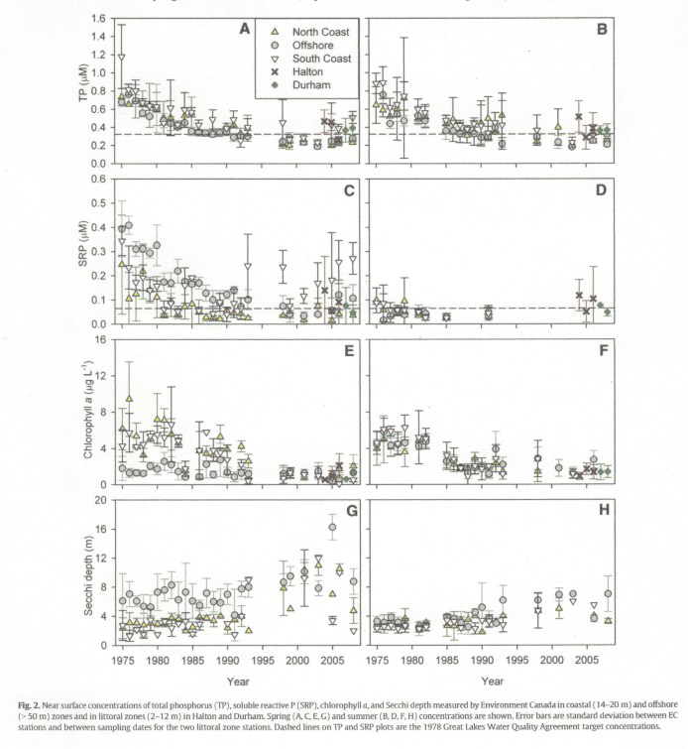

**Figure 16**: Near surface total phosphorus (TP), soluble reactive phosphorus (SRP), Chlorophyll a (Chl a), Secchi Depth (SD) in the North Coast, Offshore, South Coast, Halton and Durham.

**Figure 13**: Near surface total phosphorus (TP), soluble reactive phosphorus (SRP), Chlorophyll a (Chl a), Secchi Depth (SD) in the North Coast, Offshore, South Coast, Halton and Durham.

*Spring (ACEG) and Summer (BDFH) concentrations. Error bars are SD. From Malkin 2010*

*Spring (ACEG) and Summer (BDFH) concentrations. Error bars are SD. From Malkin 2010*

Winter et al., (2012) observed an urban to rural gradient in TP concentrations along the north coast, with higher TP detected in the densely populated Greater Toronto Area (GTA). Although the spatial pattern borne out from Environment and Climate Change Canada’s Great Lakes Surveillance Program monitoring of the Lake in 2013 may not be based on a dense number of sampling points, it does provide a general depiction of the geography of TP concentrations across the lake: very low hyper-oligotrophic conditions within the northeast (~ 4 ug/l); oligotrophy in the offshore (4 – 10 ug/l); mesotrophy in some nearshore areas along the south coast and in the vicinity of Hamilton and Toronto (Figure 17: Environment Canada Great Lakes Surveillance).

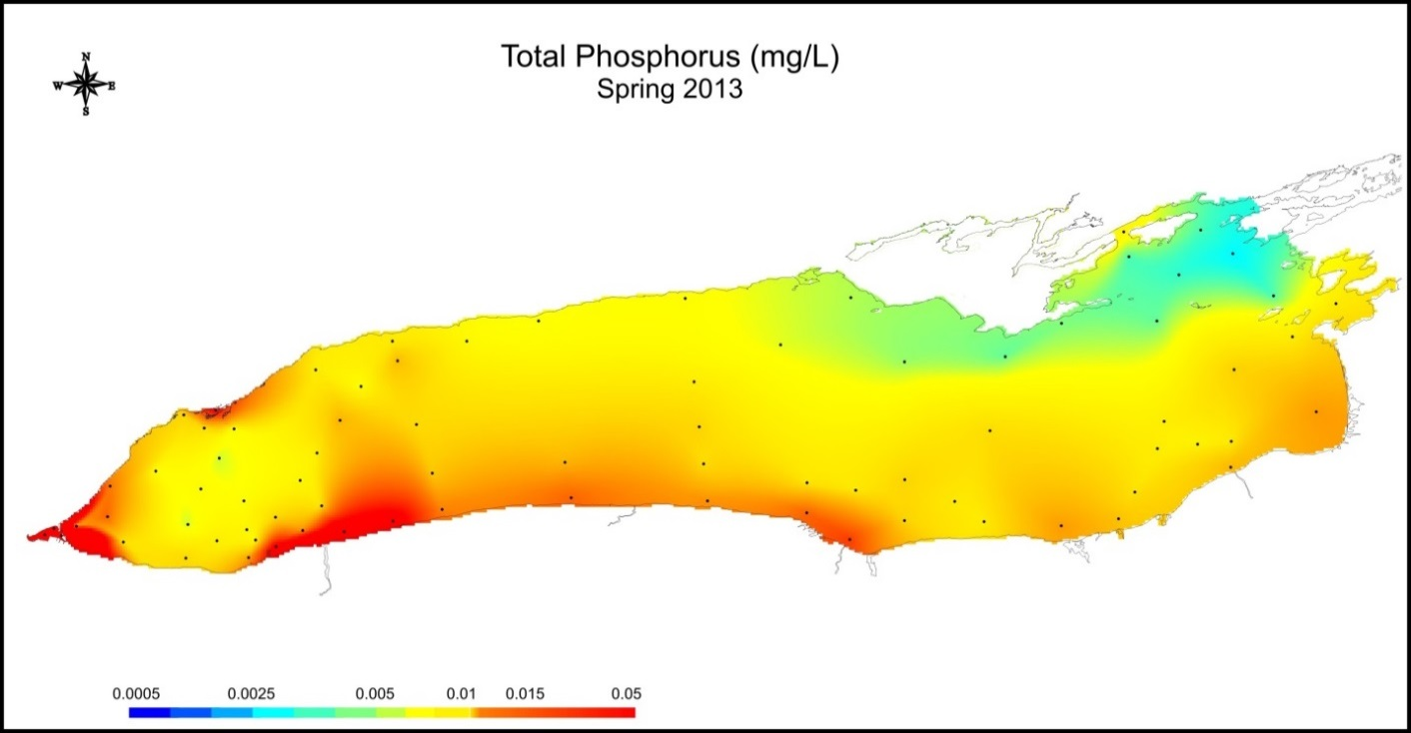

*and Climate Change Great Lakes Surveillance data. Unpublished.*

**Figure 166**: Spring, surface total phosphorus (ug/l) in 2013.*and Climate Change Great Lakes Surveillance data. Unpublished.*

**Figure 17**: Spring, surface total phosphorus (ug/l) in 2013.

**Figure 15**: Annual average concentrations for TP, Chl a,and Algal Cell Densities in untreated water form 4 water treatment plants along the Canadian shore of Lake Ontario.**Figure 166**: Spring, surface total phosphorus (ug/l) in 2013.

*Source – Environment Canada*

*Source – Environment Canada*

Spring soluble reactive phosphorus (SRP) values have also declined throughout Lake Ontario from the 1970s to the 1980s however, the changes have been spatially variable (**Figure 17 panels C and D spring and summer SRP concentrations**). The offshore and north coast SRP spring means have declined and remained low, especially over the last decade. In contrast high mean spring SRP concentrations have been frequently measured since 1993 along the south coast (Malkin et al., 2010).

**Figure 18:** Annual average concentrations for TP, Chl a and Algal Cell Densities in untreated water form 4 water treatment plants along the Canadian shore of Lake Ontario.

**Figure 18**: Annual average concentrations for TP, Chl a,and Algal Cell Densities in untreated water form 4 water treatment plants along the Canadian shore of Lake Ontario.

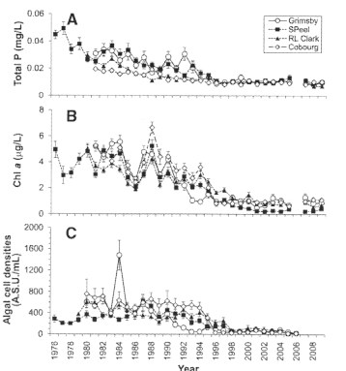

TP (panel A), Chl a (panel B) and Algal Cell Densities (panel C. From Winter et al., 20012.

**Figure 18**: Annual average concentrations for silicate, Nitrate+Nitrite and Chloride in untreated water form 4 water treatment plants along the Canadian shore of Lake Ontario.TP (panel A), Chl a (panel B) and Algal Cell Densities (panel C. From Winter et al., 20012.

Chlorophyll *a* (Chl *a*) concentrations within the north and south coastal areas were higher than the offshore during the 1970s however, coastal spring Chl *a* have declined and mean spring concentrations are now equal to offshore. Summer Chl *a* has declined from the 1980s to the 1990’s in the offshore and coastal zones and low lake-wide levels have been maintained (Malkin et al., 2010). Winter et al., (2012) reported that Chl *a* along with algal densities have decreased in the Canadian nearshore and noted that decreases began in 1991 at Grimsby, in 1996 at Cobourg and in 1997 at R.L. Clark and South Peel (Figure 18 B and C). These dates are consistent with those reported by Nichols (2001) for the progression of dreissenid establishment in Lake Ontario meaning that mussel establishment is associated with decreases in phytoplankton.. Chl *a* was also significantly correlated with TP at all drinking water intake sampling sites.

Along the north shore silicateconcentrations increased significantly at all stations except South Peel where levels did increase but the increase was not statistically significant (Figure 19 A). Silica concentrations during the 1970s were lower than during the 1980s, subsequently decreased and then began increasing steadily around 1994. Winter et al., (2012) noted a decline in the densities of several algal groups but by far the greatest rate of decrease observed was in diatom density which may explain the increase in spring silicate concentrations.

Offshore spring water clarity, as measured by Secchi Disc Depth (secchi depth), has generally been greater than in the coastal waters. The mean spring secchi depth in the open lake and the north coast increased rapidly in the 1990s **(Figure 16 panel G)** however, spring offshore mean secchi depth was significantly greater than the north cost and the north coast was significantly greater than the south coast mean spring secchi depth Malkin, et al., (2010). Secchi depth within the nearshore decreased from spring to summer (Figure 15 panelH).

Both Malkin et al., (2010) and Winter et al., (2012) documented a similar increasing trend of spring nitrate concentrations within the coastal waters as in the offshore waters. South coast stations have exhibited the highest concentrations and variability and Winter et al., (2012) reported that concentrations of NO**2** + NO3 were higher from the more densely populated R.L. Clark and S. Peel water intakes compared to the less densely populated rural sites (**Figure 19 B**).

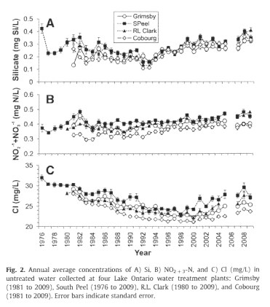

**Figure 19**: Annual average concentrations for silicate, Nitrate+Nitrite and Chloride in untreated water form 4 water treatment plants along the Canadian shore of Lake Ontario.

**Figure 19**: Annual average concentrations for silicate, Nitrate+Nitrite and Chloride in untreated water form 4 water treatment plants along the Canadian shore of Lake Ontario.

*Silicate (panel A), NO3+NO2 (panel B) and Cl (panel C) in untreated water from 4 water treatment plants along the Canadian shore of Lake Ontario. From Winter et al., 2012.*

*Silicate (panel A), NO3+NO2 (panel B) and Cl (panel C) in untreated water from 4 water treatment plants along the Canadian shore of Lake Ontario. From Winter et al., 2012.*

**Figure19**: Comparison of north coastline littoral zone spring total phosphorus, SRP and Chl a.in 2 to 12 meter depth

Mean spring ammonia (NH4+) concentrations along the south coast were found to be significantly higher than along the north coast and these in turn were significantly higher than levels in the offshore. NH4+ concentrations did not demonstrate any long-term trend for any of the three zones.

Malkin et al., (2010) also compared two monitored north shore littoral zone transects (2-12m) at Halton and Durham Regions from 2004 to 2008 to Ontario Ministry of the Environment 1976-1979 water quality data for locations near the Durham and Halton study sites and found Chl *a*,TP and SRP concentrations were significantly lower in recent years (2004-2008). For example, mean TP concentrations during 1976-1979 at Halton and Durham were approximately 48 μg/L (1.6 μM) and 24 μg/L (0.8 μM), respectively and the 2004 to 2008 mean TP concentrations for both locations were approximately 12 μg/L (**Figure 20 A**). More recent (2004-2008) SRP and Chl *a* concentrations at the Halton and Durham sites have also declined (**Figure 20 B and C**). Recent mean nitrate concentrations are higher but the difference is not significant; and, there were no differences in ammonia between the 2 time periods.

**Figure 20**: Comparison of north coastline littoral zone spring total phosphorus, SRP and Chl a.in 2 to 12 meter depth.

of north coastline littoral zone spring total phosphorus, SRP and Chl a.in 2 to 12 meter depth.

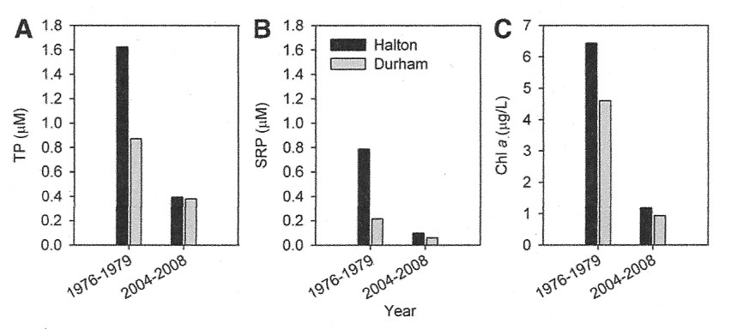

*(A) total phosphorus, (B) SRP, and (C) Chl a concentrations for periods 1976-1979 and 2004-2008. From Malkin et al., 2010.*

**Figure 20**: Variability in Chloride, TP, DIN, E. coli concentrations and counts with distance from shore in the Grimsby, Cobourg, GTA West, Ajax, GTA Centre and GTA East Study Polygons.*(A) total phosphorus, (B) SRP, and (C) Chl a concentrations for periods 1976-1979 and 2004-2008. From Malkin et al., 2010.*

### Variability within Nearshore Waters

Lake Ontario’s nearshore is dynamic and is influenced by the many tributaries and anthropogenic discharges (wastewater treatment plants, storm sewer outfalls, including combined sewer overflows and landscape run-off), as well as, the variation in lake bathymetry and circulation patterns. The magnitude of tributary and anthropogenic discharges varies with size of watershed and sewershed, land use and population. The magnitude of these discharges governs the size of the zone of influence within the nearshore. Lake circulation follows a general pattern (as described in the Lake Circulation section) however, current direction can vary in a matter of hours with changes in wind direction leading to changes in dispersion patterns, adding to the spatial and time bound heterogeneity in nutrient concentrations and effects observed within the nearshore.

Makarewicz et. al., (2012b; 2012c, 2013d) and Howell et al., (2012a, 2012b) have investigated and documented shoreside (0.5 to 1.5 m depth) nutrient conditions along the south and north shores of Lake Ontario. The shoreside area is important since it is the area in which people directly interact with the lake and where the highest nutrient values are observed. Both groups of researchers have defined this area of the lake as highly variable due to the influence of lake currents, wind driven erosional forces and the strong influence by adjacent land based discharges and associated nutrient loading (tributaries, stormwater outfalls, WWTPs, direct runoff). Along the south coast Makarewicz et al., (2012b) reported mean values of TP, SRP, Nitrate and TKN of 61.9 μg/L, 7 μg/L, 270 μg/L and 795 μg/:, respectively. The high variability of the shoreside is demonstrated by TP concentrations which ranged from 11 μg/L to 175.4 μg/L at all sampling sites (**Table 11**). TP was correlated with turbidity indicating wind/wave erosional forces, resuspension of sediment and tributary plumes are all factors leading to the high and variable shoreside TP concentrations.

In a study to evaluate the relative lake-wide, regional and location specific influences on water quality patterns in the Canadian nearshore in six areas (or study polygons) along the north shore Howell et al., (2012a) determined overall nearshore concentrations were similar to the open lake however, conditions closer to shore were more variable and, depending on location, reflected land based influences. At the shoreside sites mean nutrient concentration ranges were: TP 20-57μg/L; SRP 1.5-6.2 μg/L; dissolved inorganic nitrogen (DIN) 379-482 μg/L; and, silica 0.11-1.04 mg/L (**Table 11**). In contrast, ranges for mean nutrient concentrations in the nearshore (3m depth to 5km offshore) were lower over the six locations. Mean nearshore TP and SRP concentrations ranges were 6-22 μg/L and 1.2-9.5 μg/L, respectively. Patterns of suspended solids and TP (and E. coli) concentrations were better described by depth, indicating these parameters are affected by forces which are dependent on depth, while the patterns for dissolved variables (e.g. calcium, conductivity and dissolved organic carbon) were better explained by distance from the shoreline. Shoreside to nearshore concentrations of dissolved inorganic nitrogen (DIN) and silicate were less predictable than for other parameters and may be due to an interaction between the landscape loading and biological utilization. Landscape impacts on water quality within the nearshore are most evident at shoreside sites and within approximately 1km from shore (Howell et al., 2012a). Sharp declines in TP, SRP, conductivity, DOC (and chloride) occurred moving from the shore past wadeable depths with little decline beyond 1 to 3 km. Within the shoreside band water clarity was frequently reduced due to high suspended solids. The variability of particulate influenced parameters (e.g. SS, TP) and run-off-influenced parameters (e.g. Ca, conductivity and DOC) was significantly related to distance from shore and lake depth (**Figure 21**).

Due to difficulty characterizing nutrient levels within and between study locations polygons Howell et al., (2012a) used conductivity percentile ranges to organize water quality data into classifications representing the least land-influenced (sites falling below the 25th conductivity percentile) and the most land-influenced (sites falling above the 75th conductivity percentile). To provide a benchmark upon which to compare nearshore nutrient levels, “nearshore background” concentrations were developed for each study location as the aerial median concentration for a 1 kilometer band between 4 to 5 kilometers from shore. Mean area-weighted concentrations were also calculated for each of the six surveyed locations. Comparison of average nearshore and background concentrations identified subtle differences amongst the study polygons for all parameters except Chl *a*. Nearshore area-weighted mean concentrations for Chl *a* were higher and more variable over the GTA polygons than the Grimsby and Cobourg polygons. Using the conductivity classification to isolate the most land-influenced datasets yielded strong differences among the study areas. The GTA polygons were distinguished from the Grimsby and Cobourg polygons by higher average concentrations of TP, SRP, DIN, DOC and chloride. The high percentile conductivity datasets for Grimsby, Ajax and Cobourg had less variability and indicated that water quality within Cobourg was the least influenced by the adjacent watershed (**Figure 22**). The spatial pattern emerging from this study clearly shows the land-based influence on water quality was greatest in the urbanized Greater Toronto Area and the least over the less developed study site.

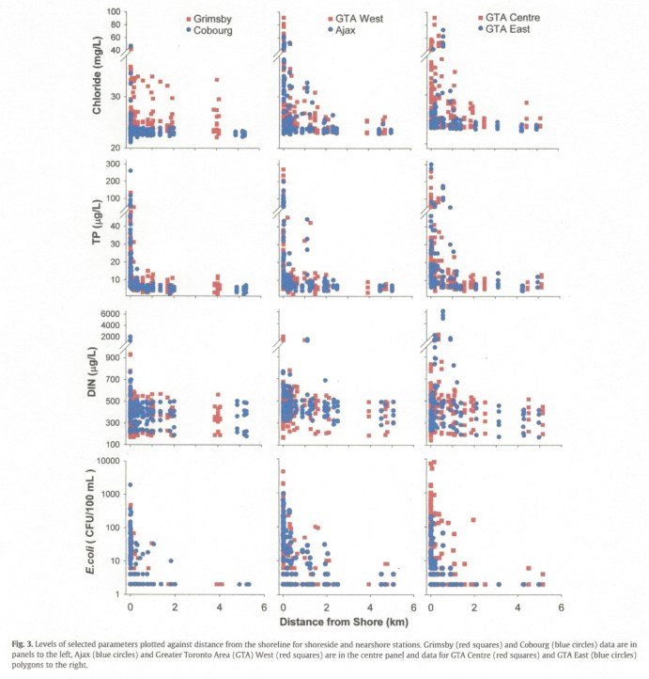

**Figure 21**: Variability in Chloride, TP, DIN, E. coli concentrations and counts with distance from shore in the Grimsby, Cobourg, GTA West, Ajax, GTA Centre and GTA East Study Polygons.

The view emerging from the north and south shore water quality studies is that tributary discharge strongly influenced the spatial patterns of nutrients within the shoreside and nearshore areas. The varying volumes of tributaries discharging to the south and north shores and the size of their mixing zones result in high variability, characterized by concentration gradients on scales of meters to kilometers as demonstrated in Figure 21.

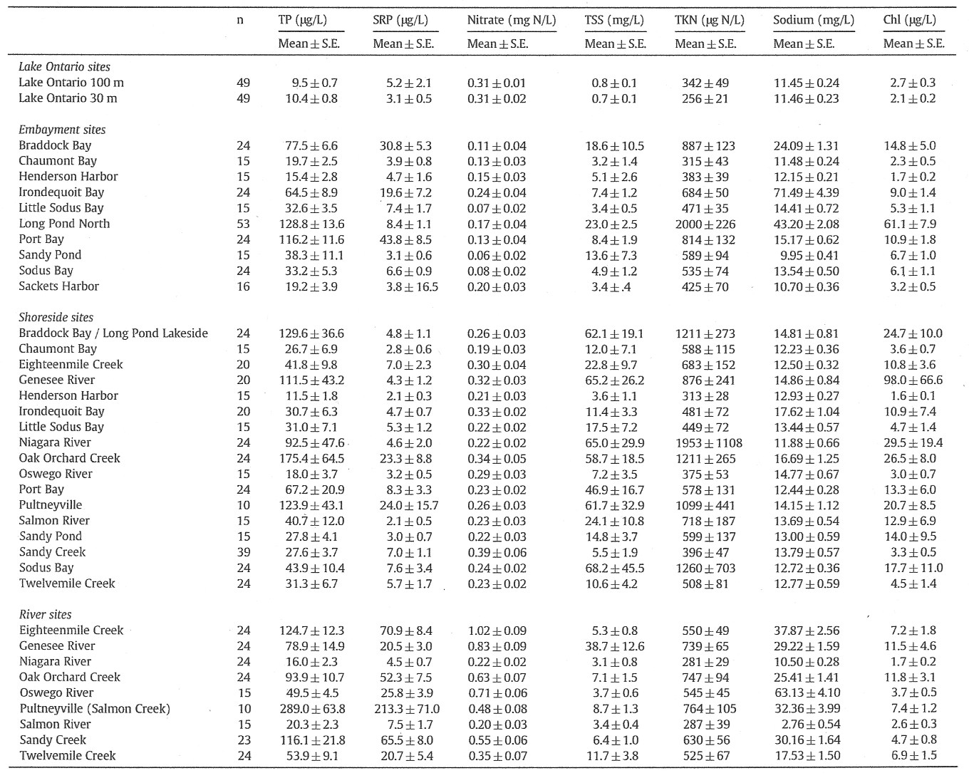

***Table 12****: Mean concentrations (±S.E.) of total phosphorus (TP), soluble reactive phosphorus (SRP), nitrate, total suspended solids (TSS), total Kjeldahl nitrogen (TKN), sodium chloride, Chlorophyll a (Chl a). N=number of samples. Data collected May through October 2003-2009. Non-detects assigned a value of 0.001. Sampling frequency varies from site to site see methodology in source reference. From Makarewicz et al., 2012b.*

**Figure 22**: Mean soluble reactive phosphorus (SRP) concentration grouped by conductivity percentile for each of the 5 surveys in 2008.***Table 12****: Mean concentrations (±S.E.) of total phosphorus (TP), soluble reactive phosphorus (SRP), nitrate, total suspended solids (TSS), total Kjeldahl nitrogen (TKN), sodium chloride, Chlorophyll a (Chl a). N=number of samples. Data collected May through October 2003-2009. Non-detects assigned a value of 0.001. Sampling frequency varies from site to site see methodology in source reference. From Makarewicz et al., 2012b.*

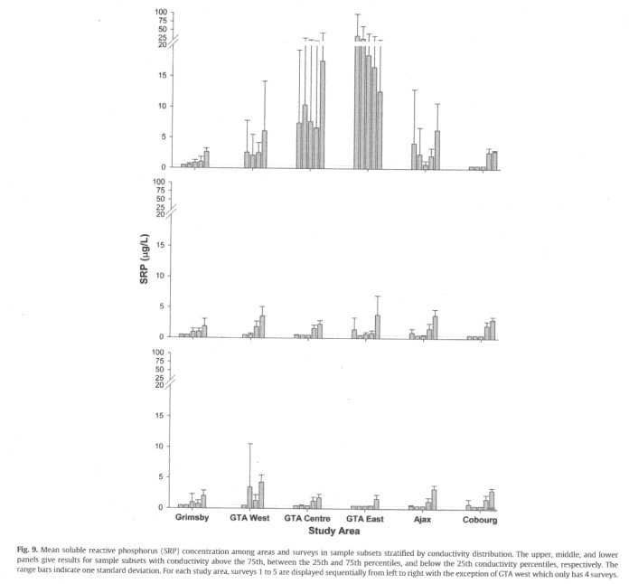



**Figure 23**: Mean soluble reactive phosphorus (SRP) concentration grouped by conductivity percentile for each of the 5 surveys in 2008.

The top panel is the above the “>75th percentile” grouping, the middle pane is the “25th to 75th percentile” grouping; and, the bottom panel is the < “25th” percentile grouping. From Howell et al., (2012).

The top panel is the above the “>75th percentile” grouping, the middle pane is the “25th to 75th percentile” grouping; and, the bottom panel is the < “25th” percentile grouping. From Howell et al., (2012).

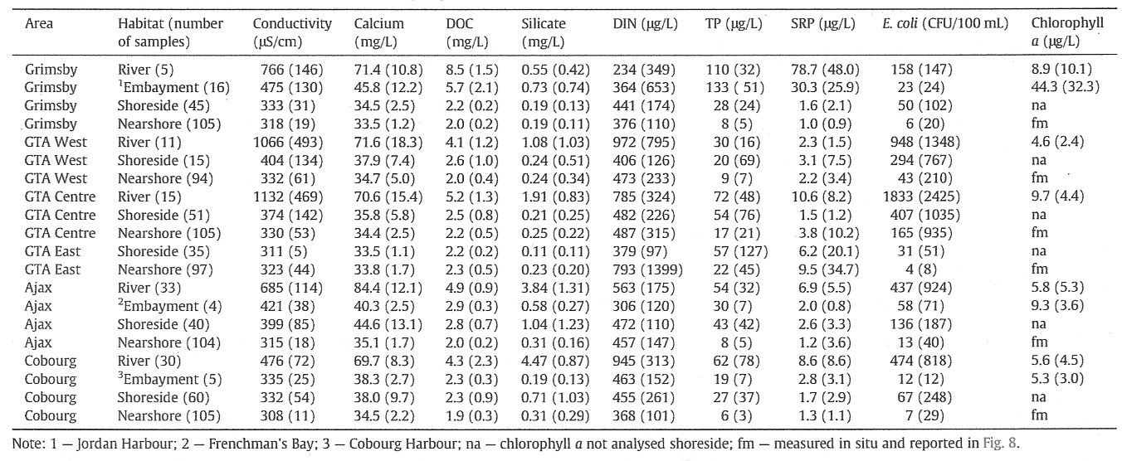

***Table 13****: Mean concentrations and standard deviation of water quality parameters in surface samples among habitats by study polygon in 2008. DOC- dissolved organic carbon, DIN – dissolved inorganic nitrogen, TP – total phosphorus, SRP soluble reactive phosphorus. From Howell et al., 2012a.*

**Figure 24**: Box plots of TP (ug/l), Chl a (ug/l) and algal cell densities (areal standard units, A.S.U./ml) measured each month of the year in untreated water from 4 water treatment plants along the Canadian shore of Lake Ontario.***Table 13****: Mean concentrations and standard deviation of water quality parameters in surface samples among habitats by study polygon in 2008. DOC- dissolved organic carbon, DIN – dissolved inorganic nitrogen, TP – total phosphorus, SRP soluble reactive phosphorus. From Howell et al., 2012a.*

### Nearshore Seasonal Patterns

No observed strong repeatable year-to-year trends for total phosphorus, Chl *a* and total algal densities were found within the Canadian nearshore (Figures 23 and 24) Winter et al., (2012) and Howell et al. (2012b). Although Chl *a* and algal densities tended to be higher during the warmer summer period, these parameters occasionally peaked during the spring and early fall, a trend that might be related to the nearshore hydrology (Winter et al., 2012). TP also, tended to be more elevated in the spring and early fall. An interesting finding by Winter et al., 2012 was the synchronicity of monthly variations in all nutrient concentrations between all stations.

Within the Canadian nearshore, Winter et al., (2012) observed silica and nitrate+nitrite (NO2 + NO3) trends reflected a winter maxima from December to March and a summer decrease with minimum concentrations occurring in the July to September period (**Figure 24**). Measured nutrient concentrations from greater depth (>30m) did not display a similar spring to summer decline(**Figure 25)** and thus supported the conclusion that biological utilization of these nutrients by phytoplankton during the summer months was occurring in the shallower depths and was responsible for the seasonal decline in concentrations Howell et al. (2012b).

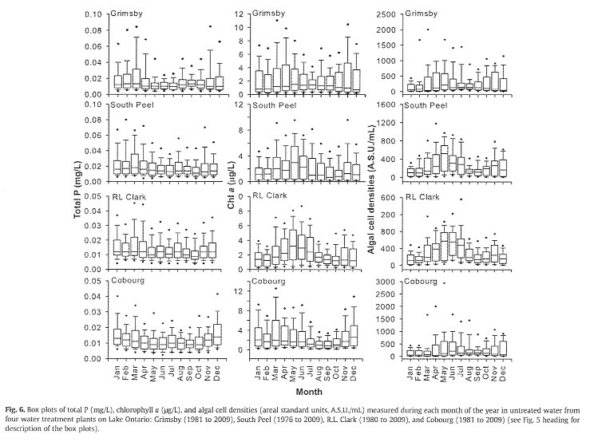

**Figure 23**: Box plots of TP (ug/l), Chl a (ug/l) and algal cell densities (areal standard units, A.S.U./ml) measured each month of the year in untreated water from 4 water treatment plants along the Canadian shore of Lake Ontario.

**Figure 25**: Box plots of TP (ug/l), Chl a (ug/l) and algal cell densities (areal standard units, A.S.U./ml) measured each month of the year in untreated water from 4 water treatment plants along the Canadian shore of Lake Ontario.

*Grimsby (1981-2009), South Peel (1976-2009), R.L. Clark (1980-2009, Cobourg (1981-2009). From Winter et al., 2012.*

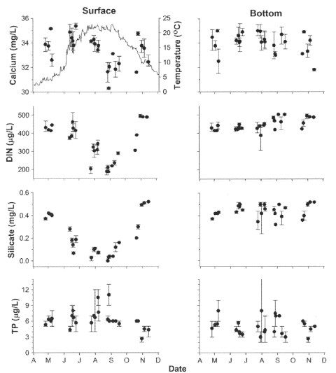

**Figure 24:** Outer nearshore concentrations of Ca, DIN, silicate, and TP at lake surface and above bed.

*Values are means of samples >3km from shore and >30m deep for each survey for each polygon. Range bars are min. max values. Solid line in the upper left panel satellite derived whole lake temperature (NOAA Coast Watch Great Lakes Environmental Analysis). From Howell et al., (2012b).*

Only silicate and nitrate+nitrite displayed a seasonal trend within the Canadian portion of the Lake Ontario’s nearshore with silicate and nitrate+nitrite reaching maximum concentrations during winter and declining to annual lows in the summer period (**Figure 25**). While seasonal patterns of total phosphorus, Chl *a* and total algal densities is less clear.

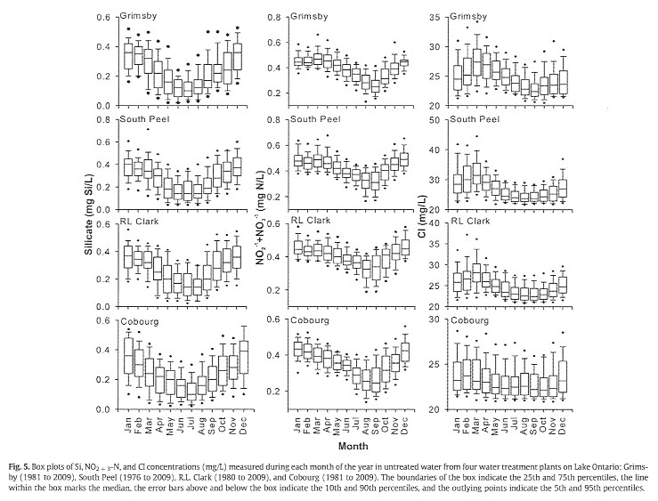

**Figure 25**: Box plots of Si, NO2+NO3 and Cl concentrations measured each month of the year in untreated water from 4 water treatment plants along the Canadian shore of Lake Ontario. Grimsby, South Peel, R.L. Clark, Cobourg. From Winter et al., 2012

### Impact on Water Quality by Lake Circulation Patterns

Physical factors like thermal cycle, wind velocities, bathymetry and shape of coastline combine to make Lake Ontario’s nearshore complex in its circulation patterns, transport and dispersal of tributary, treated wastewater and stormwater (including CSO’s) discharges, resuspension and erosion of sediment and direct run-off from the land. The high variability in water quality within the nearshore is caused by the interplay of these physical factors in the mixing of water masses with varying characteristics from a variety of sources (e.g. tributaries, direct discharges, upwelling, downwelling). Both Makarewicz (2012d) and Howell (2012b) have demonstrated that plumes tend to orient parallel to shore away from the point of discharge in the direction of the lake currents. The term “coastal boundary layer” is used to denote the portion of the lake 5 to 10km from shore (Boyce 1997) in which mid-lake circulation adjusts to the presence of shores. There is a clear separation between offshore wave-like motion and the more current-like motion within this nearshore zone that flows parallel to the coast and during upwelling and downwelling events there may be an appreciable exchange between nearshore and offshore water (Blanton 1974). Howell et al., (2012b) found that the direction of tributary and WWTP plumes away from discharge points could be variable due to changes in direction of nearshore currents further adding to the variability of water quality within the nearhsore. Makarewicz et al., (2012c) noted the reversal in the dispersion of the Genesee plume from to the west against the predominant east to west flow direction along the south shore. Reversal in nearshore currents can occur over short time spans of 6-10 hours after changes in wind direction (Blanton 1974). These short duration changes in current direction contribute to the variability in nearshore water quality with plumes reversing on themselves.

The spring thermal bar effects lake circulation through limiting mixing of the offshore colder water with warmer nearshore water during the annual warming phase. During springtime sampling Makarewicz et al., (2012b) found a clear difference between the shore-side water temperature of 13.8oC verses the offshore temperatures of 5.5 and 5.8oC. Distinct nutrient regimes existed on each side of the thermal front. TP levels on the shore-side were generally higher and ranged from 4.9 to 49.8 μg/L and turbidity was also elevated due to entrapment of tributary inputs, while the lake-side TP ranged from 4.9-9.7 μg/L. In contrast to the TP concentrations, higher concentrations of nitrate and silica were observed on the lake-side of the thermal front however, the lower levels of these nutrients in the shore-side may be due to biological uptake by phytoplankton growth in the warmer nearshore waters. This is supported by measured Chl *a* concentrations that were higher on the shoreside of the thermal bar than offshore. In another study, Malkin et al., (2010) suggest that lower SRP concentrations observed in warmer nearshore waters during the springtime was due to the early onset of algae growth utilizing the more available phosphorus and may be related to the variability in TP. This early production of phytoplankton would be available as food for mussels and may help to initiate the onset of SRP flux by dreissenids (see SRP Flux by Dreissenids).

The predominant westerly winds along the axis of Lake Ontario cause frequent transient episodes of upwelling of colder hypolymnetic water on the north shore and downwelling along the south shore of Lake Ontario. The exchange of deeper offshore water is known to cause decreases in nearshore water temperatures and may cause changes in the nearshore water quality pattern. In a 2008 nearshore study along the Canadian shore Howell et al., (2012b) noted upwelling events occurred 15, 12, and 9 times over the GTA East, Ajax and Cobourg polygons, respectively and only once at the Grimsby polygon. The movement of hypolimneitc water into the nearshore periodically resulted in broad onshore–offshore gradients in dissolved nutrients (e.g. nitrate) and particulate material along the coastline. It made it difficult to discern the relative influence of upwelling compared with an effect by dreissenids. Median Chl *a* concentrations were lower within the colder nearshore waters on seven of the upwelling dates and turbidity was lower on only four of these dates suggesting that resuspension of bottom sediments and shoreline erosion could overwhelm the effects of upwelling and the ability of mussels to reduce turbidity.

During upwelling events at the Halton and Durham study site between 2004 and 2008, Malkin et al., (2010) did not detect any associated increase in nutrient concentrations in the littoral zone. The very low nutrients more recently detected in offshore waters supports the conclusion that upwelled hypolimnetic water is no longer a source of nutrients to the nearshore as once determined by Haffner et al. (1984) and would no longer provide a source of nutrients for *Cladophora* growth. In their study of hydrodynamics and water quality in the nearshore area in western Lake Ontario (Hamilton-Burlington area), Yerubandi et al., (2012) found that westerly and easterly wind induced upwelling and downwelling events play a role in variability of water quality at the western Lake Ontario study site in the Hamilton, Burlington area. During a summer upwelling event TP concentrations slightly increased in the bottom of the water column (2 m above bottom) versus the surface concentrations at a shallow sampling site while no change in the vertical gradient of TP was observed at the other sites. During a downwelling event later in the summer, higher concentrations of TP and SRP were observed at all sampling sites. Yerubandi et al., (2012) noted that the wave-induced shear stress was not sufficient to cause resuspension of sediment during the upwelling however, during the downwelling the wave-induced energy exceeded the shear stress threshold causing resuspension of sediment which may have led to increased TP and SRP concentrations.

It would appear that the effects of upwelling on and downwelling on nearshore water quality, beyond temperature changes, is dependent on both meteorological and site specific conditions that include prevailing wind direction, lake fetch and water depth. For example, Yerubandi et al., found that the winds from the east across a large expanse of Lake Ontario created strong enough wave-induced shear stress to resuspend sediment at all sampling depths thereby increasing TP and SRP concentration.

### Conclusions

1. The evidence presented clearly shows spring nutrient levels (TP, SRP) have decreased within coastal zones of both the north and south shores however, the lack of a continued decrease within parts of the south coast may indicate either the loading to this area has not decreased over the past 20 years or the elevated levels are due to the influence by the Niagara River plume. Spring TP along the south coastal/nearshore area routinely exceeds the 10 ug/l GLWQA objective and high SRP values >19 ug/l also define this area. <<Need Niagara River info./data to refer to – re: influence of the Niagara R.>>.
2. Along the Canadian nearshore there was a west to east gradient of total phosphorus with higher levels observed in the more urbanized west end of the lake and decreasing in an easterly direction.
3. Within the nearshore water quality varies through time and space and is affected by the magnitude of the tributary and point source flows, flow patterns within the nearshore, wind directions and distance from shore.
4. Due to the predominant westerly winds across Lake Ontario, the northwestern shore experiences a high occurrence of upwellings. The effects of upwelling and downwelling on nearshore water quality, beyond temperature changes, is dependent on both meteorological and site specific conditions that include prevailing wind direction, lake fetch and water depth that all have a role in creation of the shear stress needed to resuspension of bottom sediment.
5. Patterns of lake circulation can affect water quality. Entrapment of tributary and point source discharges within the nearshore during formation of the spring thermal bar leads to a buildup of nutrients which may play an important role in the early promotion of pelagic and benthic algae in the warmer nearshore waters. A deep chlorophyll maxima that occurs during nearshore spring stratification period may be an important food source for dreissenids, which may be fuel for production of soluble reactive phosphorus by the mussels.

# Role of Dreissenids on *Cladophora* Abundance

The re-emergence of *Cladophora* at nuisance levels within Lake Ontario has raised concerns again over the state of the Lake. *Cladophora* is once again growing to levels that are causing a nuisance by fouling shorelines and beaches around the Lake. The reemergence of *Cladophora* is linked to the colonization of Lake Ontario by the invasive dreissenid mussels; first *Dreissena polymorpha* (zebra mussel) and later *Dreissena bugensis* (quagga mussel). The colonization of Lake Ontario by invasive mussels occurred rapidly over a 7-8 year period starting around 1990 on the southwestern shore (Haynes 1990 as cited in Stewart and Haynes, 1994) with high densities (5,919-55,508 individuals/m2) of invasive mussels making up 79-93% of the macroinvertebrate community in 1991-1992 along the southwestern shore (Stewart and Haynes, 1994). Kilgour et al., (2000) reported low densities (730-3,250 individuals/m2) of *Dreissena* along the western Canadian shore. Nichols et al., 2001 used raw water data from 6 widely separated Canadian drinking intakes and applying CUSUM analysis to phytoplankton and chlorophyll functions to indicate break-points in the long-term data suggestive of initial filter feeding by dreissenids. The assessment by Nichols et al., (2001) showed that changes in the chlorophyll and phytoplankton occurred first in 1992 in the Grimsby area and by 1997-98, the mean phytoplankton densities and chlorophyll concentrations had roughly stabilized at all drinking water intakes in the study.

The nearshore shunt hypothesis by Hecky et al., (2004) is a conceptual framework that suggests dreissenid mussels have altered the environment in the lower Great Lakes through several processes that has led to the reemergence of *Cladophora*. The mussels have altered the substrate through increasing the surface area for *Cladophora* attachment. Although the now dominant quagga mussels prefer hard substrate, they have expanded onto softer sand and silt bottom types and provide additional hard surface for *Cladophora* growth. Through their filtering action, dreissenids have reduced turbidity and hence greatly improved the depth of the euphotic zone. Increasing this depth would increase the depth and area within the lake that can support *Cladophora* growth. Dreissenids have also altered the cycling of nutrients through intercepting the flow of particulate phosphorus from the nearshore to the offshore and converting it to a more soluble, bioavailable form that may promote *Cladophora* growth. Excreted feces or pseudo feces that contain phosphorus settle on the bottom of the lake and remain within the nearshore however, the significance of the nutrient value of this material for *Cladophora* growth is unknown.

Round goby (*Neogobius melanostomas*) and invasive fish, is well established within the Great Lakes. Penutto et al., (2012b) found high densities of the fish in cobble substrates encrusted with dreissenids and estimated there were 700 million round gobies in Lake Ontario. A number of researchers (Walsh et al., 2007, Taraborelli et al., 2010; Pennutto et al., 2012b) have investigated round goby predation on dreissenids in Lake Ontario. Results from these studies conclude that although gobies are consuming the mussels as a major component of their diet, they have only reduced the dreissenid population within the Bay of Quinte by 1% (Taraborelli et al., 2010) and have little impact on mussel density within Lake Ontario’s nearshore (Penutto et al., 2012b). Walsh et al., (2007) found that round goby diet in the profundal zone of southwestern Lake Ontario shifted to fewer gobies and a greater proportion of *Mysis* in deeper (130m) verses shallower (85 and 95 meter) waters. It would appear that the round goby does help control the mussel population but not to the extent that makes a significant difference. The following discussion covers some key investigations into the role dreissenid mussels play in the promotion of *Cladophora* growth in Lake Ontario.

## Distribution of Dreissenid Mussels in the Nearshore of Lake Ontario

Wilson et al., (2006) sampled 52 sites within Canadian waters from a location just west of the Niagara River to near Kingston, Ontario and determined that on average dreissenids covered 65% of the substrate sampled (Figure 26). The density of mussel percent cover varied by substrate with the hard bedrock and cobble having higher coverage (78.6 and 72.6%, respectively) and sand (37.1%) and silt (40.2 %) being least covered. Quagga mussel numbers and biomass dominated all sampling sites. They also reported a positive association between *Cladophora* percent cover and mussel cover and upwelling. Wilson et al., (2006) also estimated a total population of 6.32 x 1012quagga mussels within the 810.9 km2 area of Canadian waters extending from the mouth of the Niagara River to just past Prince Edward County.

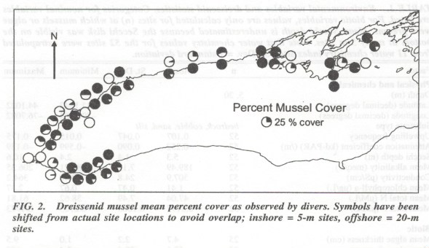

**Figure 26**: Dreissenid mussel mean percent cover as observed by divers.

*From Wilson et al., (2006).*

As part of the 2008 Lake Ontario Nearshore Nutrient Study, dreissenids mussel abundance, biomass, and size distribution were estimated at four Canadian and three U.S. locations out to a depth of 20 meters by Pennuto et al., (2012). Differences in substrate between the Canadian and U.S. study locations were observed, with bedrock being prevalent at the Canadian sites and sand and cobble dominant at U.S. sites. Mussel density was positively correlated with hard substrate at the U.S. locations. Mussels density was approximately six times greater on the Canadian verses the U.S. side of the Lake with mean densities of 5848 and 903 mussels/m2, respectively (Figure 27 C and D). Quagga mussels were dominant at all depths making up >99% of the mussel community. Mussel density decreased in a west to east direction along the south shore. Higher Chl *a* and turbidity were measured within Mexico Bay in eastern Lake Ontario relative Oak Orchard and may be indicate lower mussel filtering capacity.

**Quote from Wilson et al., (2006)**

“The lasting impression of this work should be of the enormity of change that has occurred in the Lake Ontario nearshore zone from the invasion first of zebra mussels, to the near complete displacement of zebra mussels by quagga mussels. Although dreissenid densities have subsided somewhat from those measured in the early to mid-1990s, the shear magnitude of the effect on the bottom habitat is staggering, both in terms of mussel biomass present (830,000 metric tons) and the amount of substrate modified by the presence of mussels (from 60 to 65% of the substrate in the Canadian nearshore)”.

**Figure 26**: Mean dreissenid seasonal valve length (mm), density (no./m2) and shell-free mass (SFDM) (g/m2) at different depths in Lake Ontario’s nearshore, 2008.**Quote from Wilson et al., (2006)**

“The lasting impression of this work should be of the enormity of change that has occurred in the Lake Ontario nearshore zone from the invasion first of zebra mussels, to the near complete displacement of zebra mussels by quagga mussels. Although dreissenid densities have subsided somewhat from those measured in the early to mid-1990s, the shear magnitude of the effect on the bottom habitat is staggering, both in terms of mussel biomass present (830,000 metric tons) and the amount of substrate modified by the presence of mussels (from 60 to 65% of the substrate in the Canadian nearshore)”.

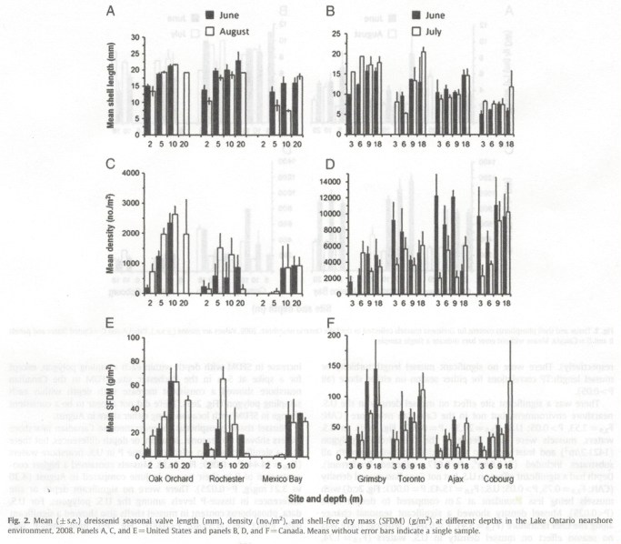

**Figure 27**: Mean dreissenid seasonal valve length (mm), density (no./m2) and shell-free mass (SFDM) (g/m2) at different depths in Lake Ontario’s nearshore, 2008.

**Figure 27**: Mean dreissenid seasonal valve length (mm), density (no./m2) and shell-free mass (SFDM) (g/m2) at different depths in Lake Ontario’s nearshore, 2008.

*Panels A, C, and E = United States and panels B, D, and F = Canada. Means without error bars indicate a single sample. From Pennuto et al., 2012.*

## Dreissenid Effects on Water Clarity

As phytoplankton production declined in response to phosphorus controls, water clarity improved in Lake Ontario. A second period of increasing water transparency occurred in the 1990s in Lake Ontario and a number of researchers (Dobiesz, et al., 2009; Auer et al., 2010; Malkin et al., 2010; Dove et al., 2015; Holeck et al., 2015) have documented this further enhancement in water clarity concurrent with dreissenid colonization. Holeck et al., (2015) analyzed long-term (1981-2011) datasets for the offshore found the change point in the spring secchi depth trend in1998 where the average secchi depth prior to 1998 was 8.2m and after 1998 the average secchi depth was 13.6m. Holeck et al., also found secchi depths in the 2000s were double those measured in the 1980s. Dove and Chapra (2015) found that the greatest summer secchi depth increases occurred since the 1990s and coincided with the expansion of dreissenid mussel populations. Malkin et al., (2010) noted that spring secchi depth in the offshore and nearshore of Lake Ontario increased more sharply in the 1990s. Auer et al., found a decrease in average light extinction coefficients (Kpar) values from the pre-dreissenid (1976-1990) to the post dreissenid periods (1995-2003) of 0.50 and 0.29, respectively, indicating an increase in water clarity post-dreissenids.

Using the long-term secchi depth dataset from 1968 to 2002 for Lake Huron, Erie and Ontario, Dobiesz, et al., (2009) assessed changes in water clarity over 3 periods; 1) pre-phosphorus controls; 2) post phosphorus controls and pre dreissenid establishment; and post dreissenid establishment. Amongst the three lakes, Lake Ontario displayed the largest change in water clarity (+3.1 m) and following dreissenid colonization water clarity within all three Lake Ontario basins (Western, Eastern and Outlet basins) increased. The change in water clarity within Lake Ontario over the entire 34 years of record represents a secchi depth that more than doubled from a low of 1.7 in 1968 to 4.8m in 2002.

Binding et al., using satellite imagery of water-leaving radiance (reflectance) from the Coastal Zone Color Scanner (CZCS) deployed from 1978 to 1986 and the Sea-viewing Wide Field-of-view Sensor (SeaWiFS) in orbit since 1997, analyzed changes in water clarity within the Great Lakes. Suspended organic and inorganic particulate matter within the lakes causes scattering of light, which leads to increases in measured water-leaving radiance and water-leaving radiance in the green visible spectrum is interpreted as an indicator of turbidity. Using Environment and Climate Change Canada’s historical secchi disc data for Lake Erie, Binding et al., (2007) were able to develop empirical relationships between secchi depth and both the CZCS and SeaWiFS measures of water-leaving radiance. Figure 28a and b shows that secchi depth is largely uniform across Lake Ontario with secchi depths of 3-4 m for the 1979 to 1985 CZCS period and increase noticeably to 6-8 m by the 1998-20005 SeaWiFS period. Figure 28c confirms the lake-wide increase in water clarity with an increase in secchi depth of 2-4 m. Binding et al., (2007) states that the lack of large regions of resuspension of bottom sediment within the Lake suggests either biochemical changes or reduction in productivity or a reduction in the intensity and/or frequency of whitening events are driving the change in water quality. Detection of large changes in spring and summer secchi depth suggests a lower influence of algal blooms (productivity) on water clarity in recent years.

Figure 29 provides a time series of water-leaving radiance and shows peaks in reflectance attributed to whitening events that take place regularly in Lake Ontario during August and September. The figure shows the frequency and intensity is less in recent years than during the CZCS period of deployment (1979-1985) suggesting a reduction in lake whitening events coincident with the establishment of mussels. The analysis of satellite imagery also shows that in recent years, secchi depth declines to a minimum in September, which is one month later than during the CZCS period. These data show the reduction in lake productivity and reduction in the frequency and intensity of lake whitening events have occurred since the establishment of dreissenids and this has resulted in increased water clarity (as measured by secchi depth).

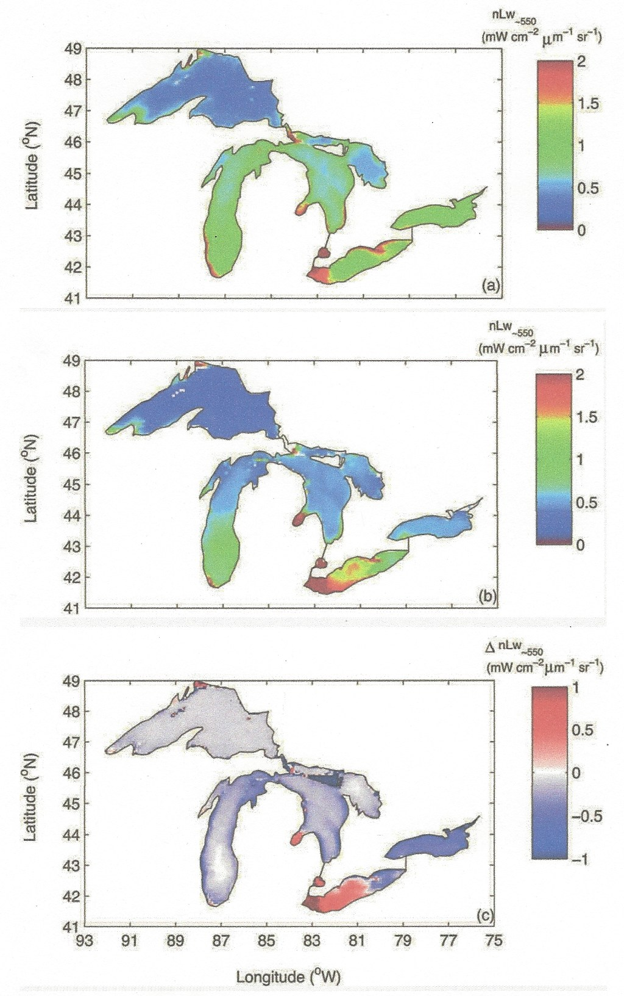

**Figure 28**: (a) Average CZCS nLw550 for the period 1979-1985, (b) WiFS nLw550 for the period 1998-2005 and (c) difference between two images.

*From Binding et al., 2007.*

**Figure 28**: Monthly lake-wide average nLw550 from CZCS (open circles) and the SeaWIFS (closed circles) for Lake Ontario.*From Binding et al., 2007.*

Declining trends in offshore calcium concentrations support the conclusion by Binding et al., (2007). Long-term Great Lakes Surveillance Program data shows an initial decline in the offshore calcium concentration from 41 mg/l to 38.5 mg/l over the period of 1971-1990 and this decline is due to enhanced point source controls. A more rapid decline, post 1990, due to mussel colonization of Lake Ontario was observed by Dove (2009). Barbiero et al., (2006) and Malkin et al., (2010) suggest an alternate cause for the reduction of Lake Ontario calcium caused by dreissenid mussel uptake in Lake Erie, which resulted in a sufficient decrease of calcium loading to Lake Ontario. Even though calcium levels are lower and data suggest the intensity and frequency of Lake whitening has decreased, major lake-wide whitening events, as depicted in the August 2013 satellite image (Figure 29) may still occur in Lake Ontario when conditions are favourable.

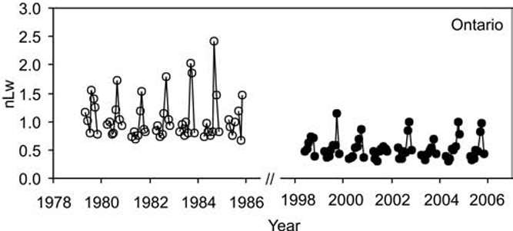

**Figure 29:** Monthly lake-wide average nLw550 from CZCS (open circles) and the SeaWIFS (closed circles) for Lake Ontario.

*From Binding et al., (2007)*

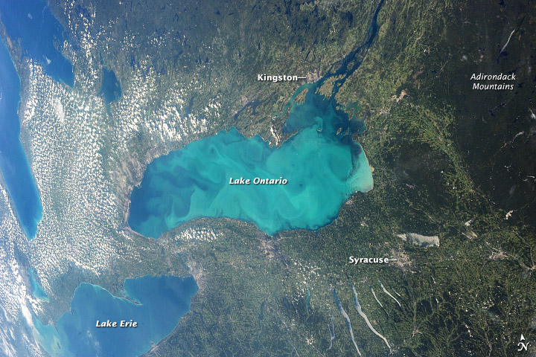

**Figure 30**: Photograph from the International Space Station highlights a late-summer whitening event visible across much of Lake Ontario on August 24, 2013.

*Photograph Credit NASA*

**Figure 290**: Average SRP profile above dreissenid/Cladophora beds. *Photograph Credit NASA*

Using satellite imagery of submerged aquatic vegetation from the mid 1970s to 2010 at Ajax, Ontario, Brooks et al., 2015 analyzed the relative impact of phosphorus loading controls and dreissenids on areal coverage of submerged aquatic vegetation (SAV) in this part of Lake Ontario. Satellite images were examined in three intervals: one representing conditions prior to responses to phosphorus controls, a second following phosphorus loading reductions but prior to dreissenid colonization, and the third representing conditions when dreissenids were well established. Results of this analysis show that the Ajax location exhibited signs of a decrease in SAV extent in the 1980s in response to basin-wide phosphorus management and this was followed by an increase in the mid to late 1990s of total area mapped following the presence of invasive mussels (Figure 30). The depth to which the bottom could be classified from the satellite imagery doubled from between 3-4 meters in 1975 to between 7-8 meters in 2011. No definitive assessment between 2010 SAV extent to the pre-phosphorus control period or post phosphorus-control prior to dreissenid colonization was provided. However, the doubling of depth to which the substrate could be classified supports the findings that increased water clarity post dreissenids has increased *Cladophora* productivity.

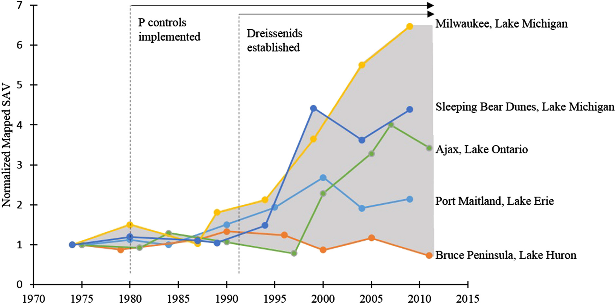

***Figure 31****: Timeline of change in SAV area at the five focus areas, annotated with relevant events.*

*Green line represents the Ajax, Lake Ontario study site. From*

*From Brooks et al., 2014.*

A more qualitative assessment on water clarity changes is based on the observation that in the early pre-phosphorus control years and into the 1980s most surveys of *Cladophora* within Lake Ontario did not sample depths greater than 5 meters (Higgins et al., 2008). It is presumed that this was due to the fact that the euphotic zone did not extend much beyond this depth. More recent studies routinely sample and map *Cladophora* at depths of 10 meters or greater. For example, Higgins et al., (2012) reported on *Cladophora* stands at 2, 5, 10, and 20 meter depths on the U.S. side of Lake Ontario and at depths up to 18 meters on the Canadian side. Depew et al., (2011) mapped *Cladophora* in the 6-7 meter depth in western Lake Ontario and up to 9 meters at Presqu’ile Provincial Park in the eastern section of the Lake. Within the Presqu’ile Park Study site Dejong (2000) sampled and recorded *Cladophora* biomass of 84 gDW/m2 exceeding the nuisance level of 50 gDW/m2 at depths reaching 9.1 m. The fact that researchers are currently sampling dense *Cladophora* stands at greater depths than during the early 1980s (post phosphorus-controls and pre-dreissenids) and prior, is further evidence of a greatly increased light environment within Lake Ontario in the post dreissenid era.

## SRP Flux by Dreissenid Mussels

Part of the nearshore shunt hypothesis explains the excessive growth of *Cladophora* within the nearshore region is partly due to the ability of mussels to filter out particulate phosphorus from the water column and transform it into more bioavailable forms. This process of transforming particulate phosphorus into a more soluble form should result in higher soluble reactive phosphorus (SRP) in the base of the water column just above the mussel bed. A number of studies within Lake Ontario (Makarewicz et al (2014), Ozersky et al., 2009, Martin 2010, and Howell, 2016) have investigated the potential SRP flux by dreissenids by measuring water-column profiles of SRP concentrations at the mussel-water boundary layer and at various depths above the mussel beds.

Makarewicz et al. (2014) measured SRP concentrations at various levels above mussel beds at a south shore site and found a trend of increasing SRP levels closer to the mussel bed but the trend was not significant (Figure 31). They concluded high variability and low SRP concentration at “shallow” open water sites where lake currents and wave action act to disperse SRP may have made detection of a significant trend difficult.

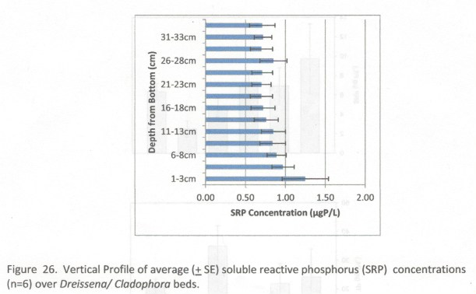

**Figure 32**: Average SRP profile above dreissenid/Cladophora beds.

*From Makarewicz et al, 2014.*

*et al., 2014.*

Martin (2010) conducted similar water column profiles of SRP concentrations above mussel beds in the Ajax area along the north shore, and included Chl *a* measurements. SRP and Chl *a* profiles above the mussel beds were sampled 8 times over the period of April to October, 2009 at depths of 5 (shallow), 9 (mid) and 17 (deep) meters. The results showed higher near bottom SRP concentrations over the mussel-beds compared to surface waters was most consistent and most pronounced at greater depths with significantly greater SRP concentrations above the mussel beds than higher up in the water column(Figures 32 and 33). Chl *a* displayed the opposite trend with lower concentrations above the mussel bed and hand higher concentrations near the surface, possibly indicating the effect of by dreissenid filtration and greater light near the surface. Martin (2010) concluded that at the shallow station, greater mixing throughout the water column iswind driven and longshore currents may have affected the consistent detection of a trend. Greater demand for SRP by *Cladophora* in shallow water than in light limited deeper waters may have also reduced SRP in the overlying water immediately above the mussel bed at the shallower site.

To investigate the contribution of P flux by mussels, Ozersky et al., (2009) carried out a study using incubation chambers to avoid dispersion and biological utilization of SRP. Incubation chambers were deployed and sealed over mussel-invested substrate with no *Cladophora*, mussel-free rock with periphyton only and chambers containing only lake water. This study took place in the urbanized Halton Region shoreline, near Oakville, Ontario. The substrate in this area is dominated by hard bedrock in depths of 25 meters and less, making the entire littoral zone suitable for both mussels and *Cladophora*. After a 2-hour incubation period water from inside each chamber was sampled and results showed SRP levels increased in the mussel chambers on 3 experimental dates and ranged from 1.9 ug/l to 4.2 ug/l (Figure 34). It should be noted that an upwelling event occurred on the date with the lowest SRP concentration in the mussel and mussel free chambers. It is suggested the colder water temperatures may have affected the excretion of SRP by dreissenids and periphyton. Based on results from the incubation chambers an average dreissenid excretion rate was estimated at 0.45mg SRP/m2/hour. Comparison of modeled P uptake rates by *Cladophora* to the average dreissenid excretion rate demonstrated that dreissenids are capable of excreting P in excess of the *Cladophora* demand (Figure 35).

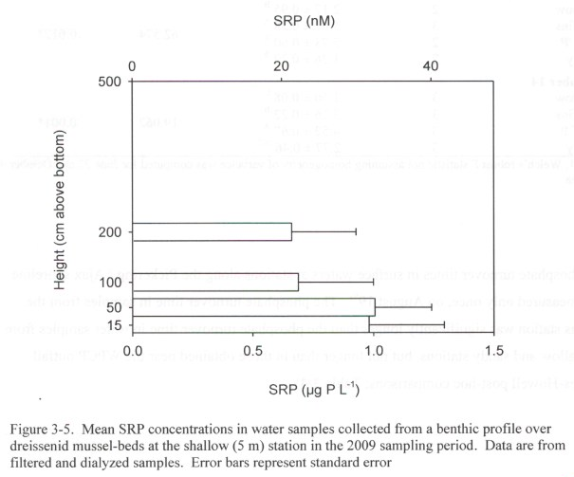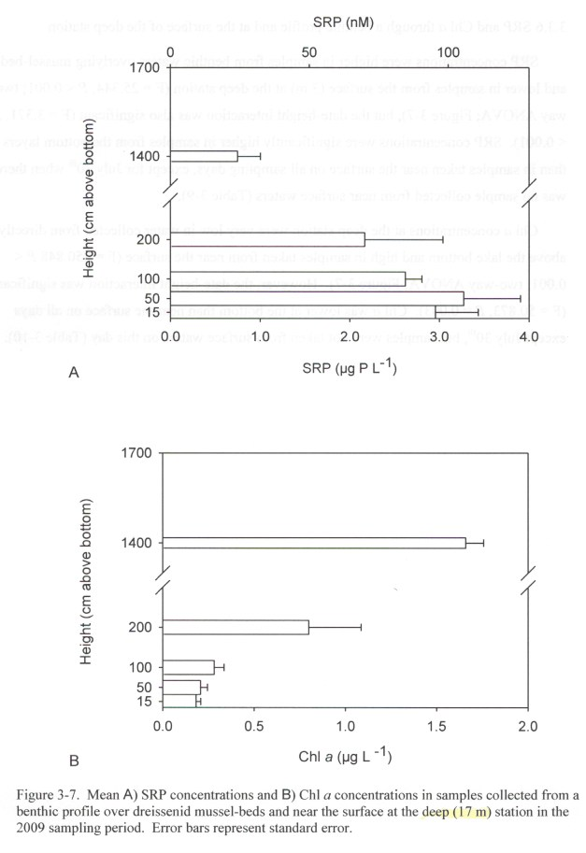

**Figure 33**: Mean SRP profile above dreissenid mussel beds at a shallow 5m station in 2009.

**Figure 34**: Mean SRP (A) profile above dreissenid mussel beds at a deep 17m station 2009.

From Martin 2010.

From Martin 2010.

*From Martin 2010.*

**Figure 33**: SRP (ug/l) at the start of the 2-hour incubations (white bars) and following the 2-hour incubation over mussel encrusted rock (black bars), mussel free rock (dark grey bars) and chambers containing only water (light gray bars).*From Martin 2010.*

A study by Dayton et. al., (2014) in Lake Michigan further supports the importance of SRP flux by dreissenids by demonstrating the formation of a SRP concentration boundary layer (CBL) 5-17 centimeters above mussel beds under quiescent conditions. Concentrations in the CBL ranged from 2-8 ug/l. Using the Great Lakes *Cladophora* Model, time intervals to saturate (1 day) and deplete (14 days) internal *Cladophora* phosphorus were determined. Comparison of the time intervals to saturate and deplete *Cladophora* phosphorus stores to the recurrence of quiescent conditions showed that the frequency of formation of CBLs would be sufficient to satisfy the *Cladophora* growth requirements over the entire May to August period.

Dayton et al., (2014) also demonstrated that during quiescent periods a SRP boundary layer builds up 5-15 centimeters above the mussel bed, but under turbulent conditions the increased current entrains the excreted SRP resulting in more uniform distribution throughout the water column (Figure 36panels 4.7a and 4.7b). A similar finding by Dayton et al., (2014) as Oszersky et al., (2009) is that the SRP buildup in the boundary layer above the mussel beds is ecologically significant and is occurring at a location in the water column inhabited by *Cladophora*. Another important finding by Dayton is that particulate phosphorus concentrations above the mussel beds are depleted the longer quiescent conditions persist and this leads to an eventual reduction in SRP flux.

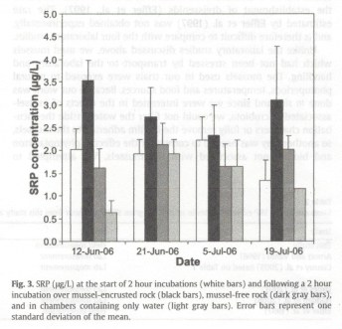

**Figure 35**: SRP (ug/l) at the start of the 2-hour incubations (white bars) and following the 2-hour incubation over mussel encrusted rock (black bars), mussel free rock (dark grey bars) and chambers containing only water (light gray bars).

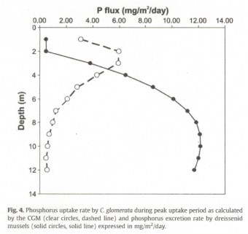

**Figure 36**: Modeled (CGM) P uptake by Cladophora during peak period (open circles and dashed lines) an P excretion rate by dreissenids (solid circles and solid line).

**Figure 32**: Modeled (CGM) P uptake bu Cladophora during peak period (open circles and dashed lines) an P excretion rate by dreissenids (solid circles and solid line).

Error bars represent standard deviation. From Ozersky et al., 2009.

Error bars represent standard deviation. From Ozersky et al., 2009.

*From Ozersky et al., 2009.*

**Figure 32**: SRP profiles above dreissenid beds confirming build-up of SRP in benthic boundary layer with increasing quiescent duration.*From Ozersky et al., 2009.*

Howell (2016) reported on a 2012 study of water column SRP, dissolved phosphorus (DP) and Total Inorganic Nitrogen (TIN) at various levels above the mussel beds at four study sites along Lake Ontario’s north shore (Toronto East, Ajax, Oshawa and Cobourg). Results showed that SRP and DP concentrations were often higher near the lakebed and TIN was more often lower (Figure 37) indicating the importance of recycling of particle phosphorus to more bioavailable and soluble forms by mussels.

Other factors that may affect the rate of SRP flux are temperature and mussel size. Excretion rates are generally positively associated with temperature, with clear seasonal impacts observed (Ozersky et al. 2009, Naddafi et al. 2008). The mass-specific recycling or excretion rates are higher in smaller mussels (Arnott and Vanni 1996), so often by virtue of significant numbers, locally, excretion rates could be high. In large mussels, filtration rates and production of fecal matter are substantially higher than in small mussels (Young et al. 1996).

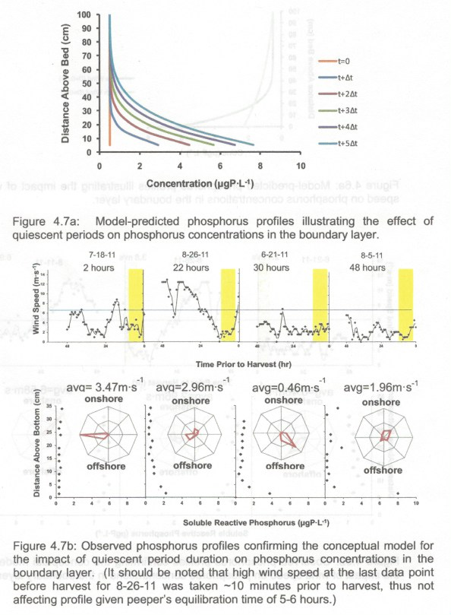

**Figure 37**: SRP profiles above dreissenid beds confirming build-up of SRP in benthic boundary layer with increasing quiescent duration.

From Dayton 2011.

**Figure 33**: Nearbed nutrient concentrations compared with surface concentrations at four Northshore study sites.Dayton 2011.

Clearly the evidence is strong that dreissenid mussels are excreting SRP at ecologically significant levels and that under optimal conditions (quiescent periods) the buildup of SRP at the *Cladophora*-mussel interface may exceed the demand for *Cladophora* growth.

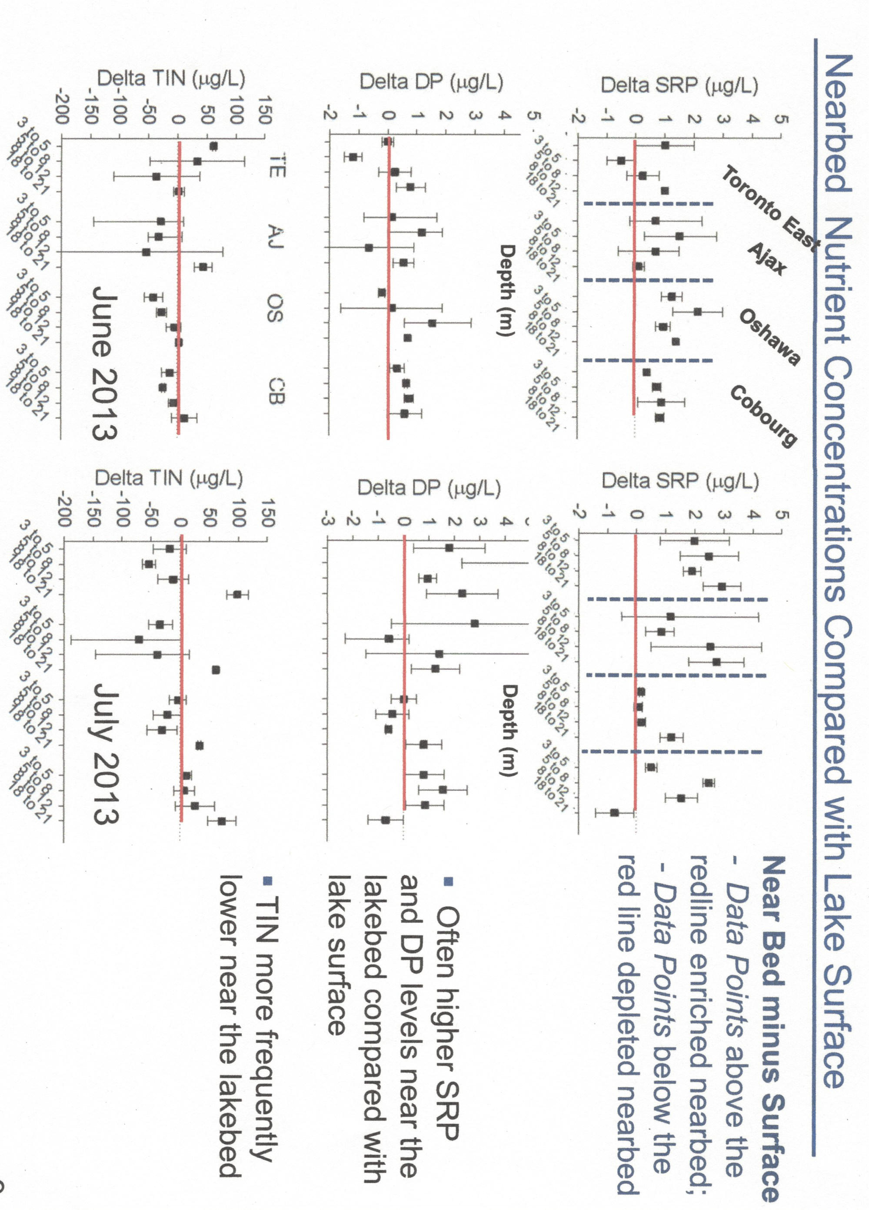

**Figure 38**: Nearbed nutrient concentrations compared with surface concentrations at four Northshore study sites.

ns compared with surface concentrations at four Northshore study sites.

*Howell 2016.*

*Howell 2016.*

**Figure 346**: Satellite-derived Lake Ontario Submerged Aquatic Vegetation (SAV) map.

### Conclusions

1. Dreissenid mussels are well established within Lake Ontario with quagga mussels (*Dreissena bugensis*) dominating the mussel population. Both the amount of substrate colonized and density of dreissenids appears to be greater on the north verses the south shore. This may be due to the greater availability of suitable hard substrate along the north shore coastal area.
2. Since the establishment of dreissenid mussels within Lake Ontario, water clarity has increased beyond the levels attained through phosphorus controls alone. This additional increase in water clarity began around the early 1990’s. The increased water transparency caused by invasive mussels has resulted in significant changes in the depth distribution and total *Cladophora* biomass integrated over the euphotic zone in Lake Ontario.
3. Although the theoretical and conceptual support for the connection between the ability of dreissenids to remove phytoplankton (and therefore particulate phosphorus) via grazing and excrete soluble forms of nitrogen and phosphorus, empirical support is less robust., Although near bottom gradients of soluble reactive phosphorus have been demonstrated overlying dreissenid beds at concentrations that are ecologically meaningful for Cladophora, it is unclear if this is a result of direct excretion or decomposition of fecal and/or pseudofecal material, or allochthonous material trapped within mussel beds.. Elucidation and quantification of these processes will be important for characterizing the dominant factors responsible for near bottom P gradients.

# *Cladophora* in Lake Ontario

*Cladophora glomerata* (*Cladophora*) is a filamentous green alga widely distributed throughout the Great Lakes and in many freshwater lakes around the world. *Cladophora* grows attached to hard substrates in nutrient rich waters. In the 1960’s and into the late 1970s nuisance blooms resulting in shoreline and beach fouling were well documented in the lower Great Lakes, including Lake Ontario. The die off of large stands of *Cladophora* and the wash-up onto shores and beaches severely reduced the aesthetic quality of these shorelines, which deterred public use and lowered property values. Public outcry over the state of the Great Lakes resulted in the signing of the 1972 Great Lakes Water Quality Agreement (GLWQA) between Canada and the United States. The commitment by the two countries to reduce phosphorus loading and the ban on phosphates in detergent resulted in the minimizing the nuisance growth of *Cladophora* in the lower Great Lakes. The widespread resurgence of *Cladophora* blooms within Lake Ontario started in the mid-1990’s even though phosphorus levels had declined considerably since the early 1970s. Current phosphorus levels within Lake Ontario offshore waters are at an all-time low and are below the GLWQA objective of 10 ug/l. The notable increase in *Cladophora* abundance and shoreline fouling was coincident with the colonization of invasive dreissenid mussels in the Lake. The colonization of Lake Ontario by zebra (Dreissena polymorpha) followed by quagga (*Dreissena rostriformis* bugensis) mussels occurred over a period from 1991 to 1995 (Nichols et al., 2001) and cover great swaths of the lake-bed, which resulted in the rapid re-engineering of nutrient cycling, the light environment and changes to the benthic habitat within Lake Ontario. This dramatic change, which occurred in less than a decade, has led to the resurgence of *Cladophora* at nuisance levels.

## *Cladophora* Distribution and Abundance in Lake Ontario

Brooks et al., (2015) generated Great Lakes basin-wide maps of submerged aquatic vegetation (SAV) using Landsat TM satellite imagery. The SAV cover was classified into 3 bottom types; ‘dense SAV’ (≥ 75% SAV cover), ‘less dense SAV’ (≥ 25% SAV) and ‘bare substrate’ (<25% SAV). With this high degree in mapping precision (84%) for Lake Ontario, the SAV map is a useful tool for identifying the extent and distribution of SAV throughout the Lake. Brooks, et al., found that 40% of Lake Ontario’s nearshore zone was mapped as SAV and was the highest amongst all of the Great Lakes. The densest SAV occurred along the north shore near Toronto, Ontario with growth in the Ajax area, near the Pickering Power Station and the St. Lawrence River east of Kingston, Ontario being particularly dense. The southern shoreline near Rochester, NY was also identified as an area of significant SAV (Figure 38). A review of this map shows the distribution of SAV (*Cladophora*) is much more pervasive on the Canadian verses the U.S. shoreline (possibly due to geology and greater available hard substrate along the north shore). (See interactive Great Lakes SAV map at <http://www.mtri.org/cladophora.html>).

Specific locations of reported problems of shoreline fouling by *Cladophora* include St. Catherines, Oakville, Ajax, Newcastle, Presqu’ile and Kingston, Ontario and Rochester, Kendall and Hamlin, New York. In these areas complaints of shoreline fouling, beach closures and intake clogging have increased since the establishment of dreissenid mussels with in Lake Ontario

## *Cladophora:* Then and Now

**Figure 39**: Satellite-derived Lake Ontario Submerged Aquatic Vegetation (SAV) map.

From http://www.mti.org/cladophora.html

From http://www.mti.org/cladophora.html

There are few direct *in situ* monitoring studies to base a complete empirical historical account of the changes in *Cladophora* abundance from pre-phosphorus controls to current time. As well, earlier investigations rarely, if ever, sampled *Cladophora* in depths greater than 5 meters, while today *Cladophora* is routinely sampled at depths of 0.5 to 20 meters (and deeper) in Lake Ontario, which adds a level of complexity into assessing differences in *Cladophora* abundance from the early 1970s to recent time. Painter and Kamaitis (1987) documented a substantial (58%) decline in *Cladophora* biomass at seven Lake Ontario sites from 1972 (pre-phosphorus controls) to 1983 (post-phosphorus control). Due to this improvement in lake-wide conditions, it appears monitoring of *Cladophora* fell out of “vogue” and was no longer a priority; leaving a gap in data between the mid-1980s to late 1990s, post dreissenid colonization. Fortunately, several researchers have applied a variety of techniques that include model hindcasting using the *Cladophora* Growth Modeling, analysis of archived satellite imagery and compilation of limited data to provide some perspective on changes in *Cladophora* abundance.

A study cited in Higgins et al., (2008) using data from the same seven sites as Painter and Kamaitis (1987) states that in 2006 Lake Ontario *Cladophora* biomass was 30-60% lower at depths of 0-1.5 meters than in 1982-83 and is similar at 3 meters depth. *Cladophora* biomass at all depths (0-3m) was 12-25% lower in 2006 than in 1972. It should be noted that the survey data used in this comparison study is based on depths up to 3 meters and therefore do not reflect a comparison of total depth integrated biomass for 2006. For this reason, it is difficult to draw a definitive conclusion from this study except it shows recent *Cladophora* biomass in shallow depths (≤3m) is less than in the past. Shallower depths tend to be phosphorus limited as opposed to light limited and therefore the observations by Higgins et al., (2008) may reflect the recent lower ambient lake nutrient concentrations as opposed to 1972 and 1982-1983. In the study of urban influences on *Cladophora* blooms Higgins et al. (2012), noted that at study sites affected by nutrient enrichment in Lake Ontario *Cladophora* biomass sometimes exceeded 100g DM/m2. Although the measured biomass densities are problematic they are well below the levels observed during the 1970s (>200g DM/m2) in the lower Great Lakes (and below values found in both the Lake Erie eastern basin and Lake Michigan, post dreissenids).

Malkin et al., (2008) applied the *Cladophora* Growth Model (CGM) to predict the independent and combined effects of decadal-scale changes in light attenuation (Kdpar) and *Cladophora* tissue phosphorus content (Qp) on biomass accumulation. Two decades were chosen for this hindcasting study: early pre-phosphorus abatement in the 1970’s; and, the early 1980’s post-phosphorus controls prior to colonization of dreissenids in western Lake Ontario (Oakville). Field data obtained in the Oakville area of Lake Ontario from 2004 and 2005 were used to calibrate and validate the CGM and as baseline years for comparison to the two historic periods. After conducting the model analysis, it was concluded that the effects of lower Qp and the lower light attenuation (i.e. greater water clarity) observed in 2004 and 2005 compared to historical decades (1970s and 1980s) operate in opposing directions on seasonal *Cladophora* density and depth distribution. The overall result was the peak attached biomass for 1982-83 was 1.4 times higher than 2004-05 and the cumulative biomass was 2.04 times higher. For 1972, the peak attached biomass was 1.6 times higher than in 2004-05 and the cumulative biomass was 2.66 times greater.

In a similar model hindcasting exercise, Auer et al., (2010) concluded that the *Cladophora* growth potential at the same site as Malkin et al., (2008) would be 39% (using the GLCM) to 61% (using the CGM) greater under recent conditions than the pre-dreissenid period (1976-1981). Auer et al., (2010) suggest the difference in conclusions between the two studies is attributable to the characterization of the nutrient environment used in each study. Malkin et al., (2008) used site specific measurements of Cladophora tissue concentration (Qp) to drive the CGM model while Auer et al., used ambient water SRP data from raw water sampled at water intakes in the study area and nearshore sites sampled by Malkin et al., (2008). The application of the CGM and GLCM by Malkin et al., (2008) and Auer et al., (2010) highlight that enhanced light penetration in the post-dreissenid period has increased the depth and area of substrate suitable for supporting *Cladophora* production drawing attention to these other factors in controlling *Cladophora* abundance.

*Cladophora* has experienced a resurgence in Lake Ontario and although the current biomass appears to be below densities that were experienced in the early 1970s, findings from the hindcast modeling studies show increased water clarity has led to greater depth integrated production of *Cladophora* in recent years.

## Landscape Influences on *Cladophora* Production/Abundance

Dreissenids mussels have re-engineered nutrient cycling and increased water transparency within Lake Ontario and these changes have led to conditions that favour *Cladophora* growth. Tributary, point source and direct run-off enter the lake through the nearshore, mixing and passing through these waters and habitats where dreissenids and *Cladophora* co-exist before eventually mixing with offshore waters. These land-based discharges carry with them nutrient loads which may also add to the production of *Cladophora*. Determination of the relative contribution of terrigenous and anthropogenic nutrient loads to the promotion of nuisance *Cladophora* growth will be necessary for making management decisions. This section looks at some key Lake Ontario studies that shed light on the relative contributions of dreissenids and land-based loading on nuisance growth of *Cladophora*.

To determine landscape influences on *Cladophora* growth rates and bloom occurrences Higgins et al. (2012) surveyed conditions at seven Lake Ontario sites; four in Canadian waters and three in the United States (Figure 39). These sites were selected to provide a gradient of land use from urbanized (GTA, Rochester) to low impacted landscape (Mexico Bay and Cobourg). Growth and accumulation of *Cladophora* was not uniform among the sites. Depth integrated *Cladophora* biomass varied by six times between sites (Figure 40c), with the majority of the site-to-site differences (~90%) occurring within shallow depths (≤5m) where growth rates were phosphorus limited, while at greater depths the biomass values were similar (Figure 41a). These data show that increases in biomass at impacted sites (e.g. Toronto and Ajax) were primarily driven by increased phosphorus-availability, rather than other potential factors (e.g. light availability, temperature). This conclusion was further supported through *Cladophora* Growth Model sensitivity analysis (Figure 42) which indicated that variations in water clarity or temperature at SRP concentrations typical of low impact sites could not account for increases in depth-integrated biomass and changes in depth distribution of biomass between low impact and high impact sites. Higgins et al., 2012 also concluded that growth rates along south and north shores are strongly phosphorus-limited and local watershed phosphorus loading was the main driver in the spatial variability of *Cladophora*.

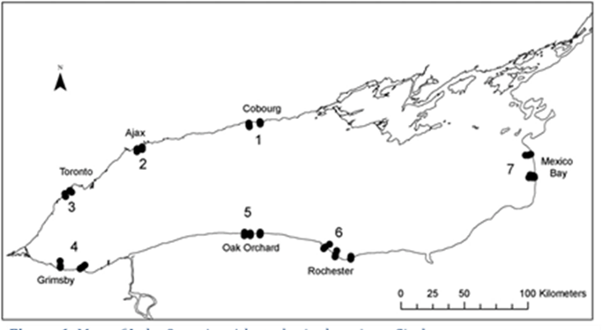

***Figure 40****: Map of Lake Ontario with study site locations.*

*Circles represent*

*transects where Cladophora samples were collected. From Higgins,et al., 2012*

Higgins et al. (2012) also point out that in locations where point sources had little influence over water quality, *Cladophora* biomass was below the 50g DM/m2 proposed for ‘bloom’ or ‘nuisance’ conditions (Higgins et al. 2008). The low-impact sites had a range of dreissenid densities, but even at sites (e.g. Cobourg) where densities were high they were apparently uncapable of supplying soluble phosphorus in sufficient quantity to produce nuisance *Cladophora* blooms. Results demonstrate that in the absence of localized enrichment in Lake Ontario dreissenids mussels were not generally capable of supplying phosphorus to *Cladophora* in sufficient amount to overcome the severely phosphorus-limited growth. Areal *Cladophora* biomass at sites not influenced by localized enrichment was <50gDM/m2, suggesting that such levels represented a base line condition for sites influenced by whole-lake SRP concentrations in the absence of local sources. This finding is important because it suggests that nuisance blooms are generally restricted to areas of localized nutrient enrichment in nearshore areas of the Lake Ontario.

A modeling study performed for the period of 2007-2008 in the urbanized Pickering-Ajax area along the north shore was able to predict the role of a local municipal wastewater treatment plant and tributary on the growth of *Cladophora* (Leon et al., 2009). The model accounted for simultaneous processes of advection, dilution of nutrient sources and biological utilization. Based on the modeling results the wastewater treatment plant was identified as the only nutrient source having an appreciable effect on seasonal accumulation of algal biomass within the study area. Removing the influence of the municipal wastewater treatment plant decreased the biomass accumulation by about 10% in 2007, a year of severe fouling in the study area. The following year was wet and saw increased tributary inputs however, with the elevated tributary load and the wastewater treatment plant inputs included the predicted *Cladophora* biomass was 30% lower.

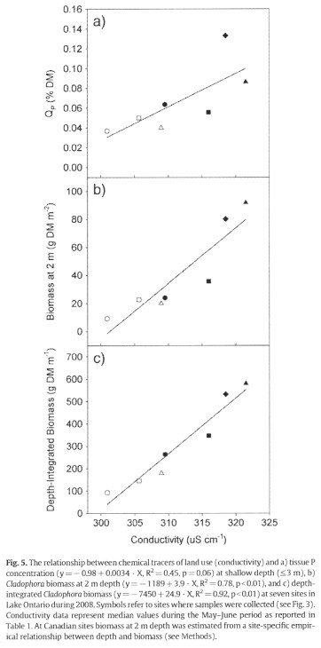

**Figure 41**: The relationship between chemical tracers of land use (conductivity) and a) tissue P concentration, b) Cladophora biomass and depth integrated biomass.

Symbols represent: Cobourg (closed circle); Ajax (closed triangle); Toronto (closed diamond); Grimsby (closed square; Oak Orchard (open circle); Rochester (open square); and, Mexico Bay (open triangle). Conductivity data represent median values during May-June period. At Canadian sites biomass at 2m depth estimated from site-specific empirical relationships. From Higgins et al., 2012.

Symbols represent: Cobourg (closed circle); Ajax (closed triangle); Toronto (closed diamond); Grimsby (closed square; Oak Orchard (open circle); Rochester (open square); and, Mexico Bay (open triangle). Conductivity data represent median values during May-June period. At Canadian sites biomass at 2m depth estimated from site-specific empirical relationships. From Higgins et al., 2012.

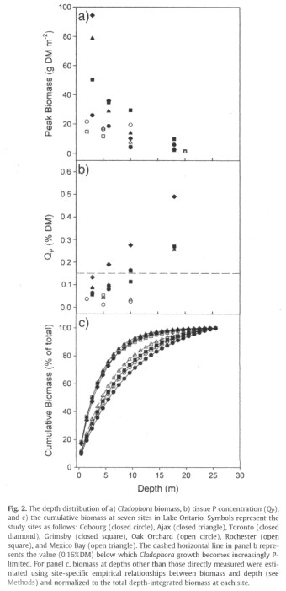

**Figure 42**: Depth distribution of a) Cladophora biomass, b) tissue P concentration (Qp), and c) cumulative biomass at seven sites in Lake Ontario.

Symbols represent: Cobourg (closed circle); Ajax (closed triangle); Toronto (closed diamond); Grimsby (closed square); Oak Orchard (open circle); Rochester (open square); and Mexico Bay (open triangle). Dashed line in panel b) represents the value (0.16%) below which Cladophora becomes increasingly P-limited. For panel c, biomass at depths other than those directly measured were estimated using site-specific empirical relationships between biomass and depth and normalized to the total depth integrated biomass at each site. From Higgins et al., 2012.

**Figure 38**: The relationship between chemical tracers of land use (conductivity) and a) tissue P concentration, b) Cladophora biomass and depth integrated biomass.Symbols represent: Cobourg (closed circle); Ajax (closed triangle); Toronto (closed diamond); Grimsby (closed square); Oak Orchard (open circle); Rochester (open square); and Mexico Bay (open triangle). Dashed line in panel b) represents the value (0.16%) below which Cladophora becomes increasingly P-limited. For panel c, biomass at depths other than those directly measured were estimated using site-specific empirical relationships between biomass and depth and normalized to the total depth integrated biomass at each site. From Higgins et al., 2012.

Observed SRP in the autumn of 2007 and 2008 were highly elevated and considered consistent with an enrichment of the coastal boundary layer along the north shore, resulting from many nutrient sources east and west of the study area and from within. The authors conclude this enrichment is important in supporting algal growth and is only apparent once the intense biological demand declines with seasonal declines in light and temperature. Overall, it was concluded that elimination of *Cladophora* problems could not be eliminated through control of local inputs alone however, the authors caution that careful consideration should be given to any increase in nutrient inputs.

Lake Ontario Shoreline Algae Action Advisory Committee (2008) undertook a 5-year study (2002-2006) investigation into the impact of local nutrient sources on *Cladophora* biomass production in the highly urbanized Oakville area of Lake Ontario. Land based sources of nutrients to the study site included 2 municipal wastewater treatment plants (WWTP), numerous stormwater outfalls and Sixteen Mile and Cooksville Creeks. Lake Ontario Shoreline Algae Action Advisory Committee (2008) undertook a 5-year study (2002-2006) investigation into the impact of local nutrient sources on *Cladophora* biomass production in the highly urbanized Oakville area of Lake Ontario. Land based sources of nutrients to the study site included 2 municipal wastewater treatment plants (WWTP), numerous stormwater outfalls and Sixteen Mile and Cooksville Creeks. Based on five key findings it was concluded that local sources of nutrients had a limited effect on *Cladophora*. The key findings were:

*circles and dashed lines refer to measured and simulated data respectively for low impact site (Cobourg), and solid circles represent measured data for a high impact site (Toronto). Solid lines in panel a represent CGM simulations for increased water clarity (-0.15m-1Kpar), and in panel b represent increased SRP (+1.0mg Pm-3), from baseline conditions at the ‘low impact’ site. Panel c indicated the effect of using SRP (dashed line) or Qp (solid line) on modeled output compared with measured data (solid circles) at the Rochester site. From Higgins et al., 2012.*

*circles and dashed lines refer to measured and simulated data respectively for low impact site (Cobourg), and solid circles represent measured data for a high impact site (Toronto). Solid lines in panel a represent CGM simulations for increased water clarity (-0.15m-1Kpar), and in panel b represent increased SRP (+1.0mg Pm-3), from baseline conditions at the ‘low impact’ site. Panel c indicated the effect of using SRP (dashed line) or Qp (solid line) on modeled output compared with measured data (solid circles) at the Rochester site. From Higgins et al., 2012.*

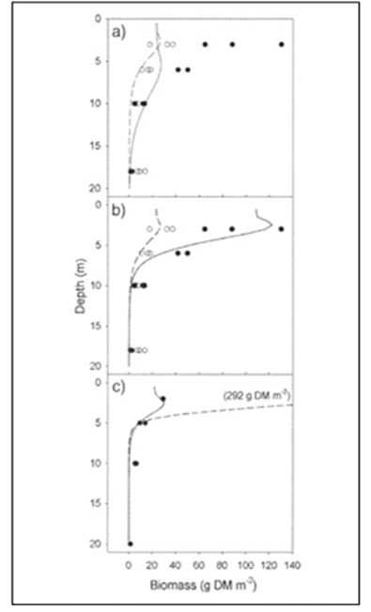

***Figure 43****: Cladophora growth model (CGM) simulations vs. measured data in Lake Ontario during 2008.*

*In panels a and b: open*

**Figure 39**: Depth distribution of a) Cladophora biomass, b) tissue P concentration (Qp), and c) cumulative biomass at seven sites in Lake Ontario.*In panels a and b open*

* Spatial patterns of *Cladophora* growth and biomass accumulation do not indicate point sources of total phosphorus and SRP are stimulating growth within the vicinity of point sources
* Along the shoreline the effect of municipal WWTP SRP concentrations were observed but decreased rapidly to reference concentrations within 0.5 km (Figure 43)
* Tissue phosphorus consistently declined through the growing season at all 2 meter sites regardless of proximity to point sources
* There were no differences in total phosphorus and SRP concentrations in overlying water among sites
* During the growth period, phosphorus was rapidly incorporated by *Cladophora* at a rate of 4-5 mgP/m2/d at 2 m depth. This rate of uptake is equivalent to depleting all of the SRP in the overlying water column at 2 meters every day (with lesser removal but still significant for greater depths).

Another perspective on landscape influence is provided in Depew et al., 2011 using a hydroacoustic method to measure and map large and nuisance accumulations of *Cladophora* in the Great Lakes. With this technique, Depew et al., (20110 were able to estimate algal cover and height over long stretches of shoreline at 4 locations within Lake Ontario (Figure 44 panels C and D) and other locations in Lakes Erie and Huron. The sites were chosen to represent a variety of land cover from urban to Provincial Park, even an offshore shoal, Dobb’s Bank in Lake Ontario, which is remote from direct land influences was surveyed. The results of multivariate hierarchical partitioning analysis of the data indicated that *Dreissena* abundance is the factor of significance in explaining *Cladophora* biomass at the study sites while “urban and agricultural land cover contributed little in the way of independent effects to the realized patterns of nuisance Cladophora standing crop”.

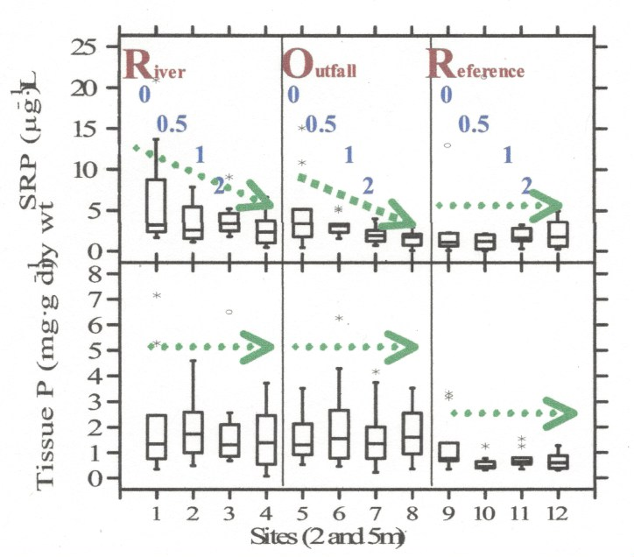

**Figure 44**: Gradients of P concentration away from point sources

effect on Cladophora tissue concentrations is not apparent. At shallow sites similar low tissue P concentrations by mid-July are achieved. River is 16 Mile Creek; Outfall is near Petro Canada Pier and reference is off park at Guelph Line. From LOSAAAC 2008.

effect on Cladophora tissue concentrations is not apparent. At shallow sites similar low tissue P concentrations by mid-July are achieved. River is 16 Mile Creek; Outfall is near Petro Canada Pier and reference is off park at Guelph Line. From LOSAAAC 2008.

*are easily demonstrated in water but*

*Survey locations are noted on the maps with*

*Survey locations are noted on the maps with*

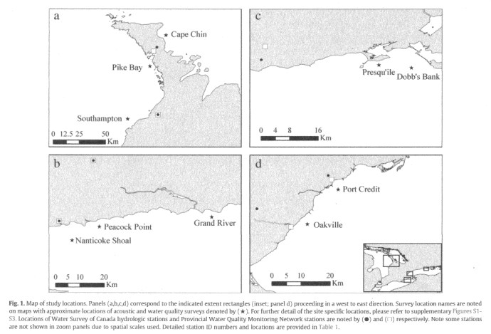

**Figure 45**: Map of Cladophora study locations.

**Fige 353**: Conceptualized model of phosphorus profiles reflecting mussel density on concentration boundary layer (4.5a) and observed phosphorus profiles reflecting mussel density on concentration boundary layer (4.5b).**Figure 42**: Map of Cladophora study locations.

the approximate location of acoustic and water quality surveys marked by a ★. Locations of Water Survey of Canada hydrologic stations and Provincial Water Quality Monitoring Network stations are noted by  and ☐, respectively. From Depew et al., (2012)

the approximate location of acoustic and water quality surveys marked by a ★. Locations of Water Survey of Canada hydrologic stations and Provincial Water Quality Monitoring Network stations are noted by  and ☐, respectively. From Depew et al., (2012)

Land cover however, may not have been a suitable representation of land use intensity (e.g. amount per area of fertilizer application or urban nutrient loads). Although not included in the analysis, the Dobb’s Bank shoal site supported nuisance stands of *Cladophora* (defined as > 50g DW/m2) even though it is well removed from land-based nutrient sources and water quality water quality was similar to offshore conditions. The coverage of nuisance algae was not as expansive as the nearshore sites but this was a result of less surface area available at shallower depths (<3M) at Dobb’s Bank than at the nearshore sites where the highest biomass occurred.

Dayton (2011) found that a concentration boundary layer formed above a mussel bed in quiescent conditions and the higher SRP concentration in that layer can increase Cladophora growth. The Dayton (2011) study in Lake Michigan near Sleeping Bear Dunes National Lakeshore, well removed from local nutrient sources, complements the findings between *Cladophora* biomass and mussel density in Lake Ontario by Depew et al., (2009). Dayton (2011) observed that under similar conditions at 2 sites with varying mussel densities of 350 mussels/m2 and 3000 mussels/m2 the higher mussel density generated greater SRP. A maximum near-bottom SRP concentration of 8ug/l was observed for the high-density mussel site which was double the SRP concentration at the lower mussel density site (Figure 45). This would suggest the higher the mussel density the greater the SRP production and therefore, the greater potential for *Cladophora* production and is supportive of the relationship observed by Depew et al., (2011).

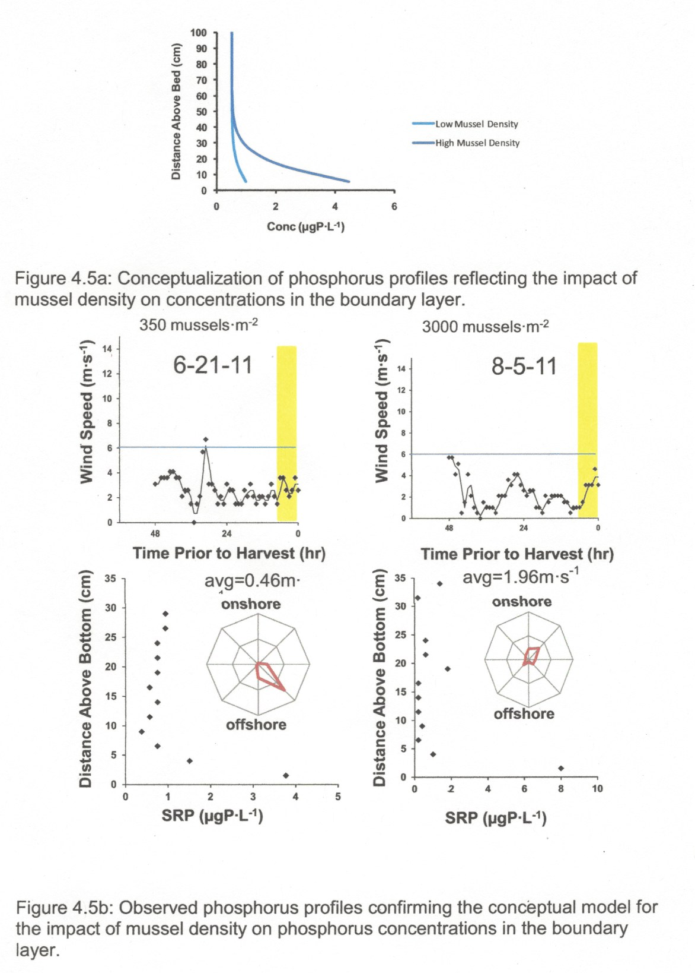

**Figure 46**: Conceptualized model of phosphorus profiles reflecting mussel density on concentration boundary layer (4.5a) and observed phosphorus profiles reflecting mussel density on concentration boundary layer (4.5b).

Note scale difference in x-axis (SRP concentration) in 4.5b. From Dayton (2011).

**Figure 36**: Scatterplot and linear trend line for percent of beach closed days due to accumulated algae each year versus the corresponding cumulative temperature contrast between nearshore and offshore waters.Note scale difference in x-axis (SRP concentration) in 4.5b. From Dayton (2011).

## Thermal Bar and *Cladophora* Production

The spring time thermal bar has been shown to restrict mixing of nearshore warmer waters with the offshore colder and denser water mass. The lack of mixing entraps of tributary and point source discharges on the shoreside of the thermal front resulting in the build-up of nutrient concentrations. Warmer temperatures and higher nutrient concentrations within the shallow waters promotes conditions favorable for the early onset of pelagic and benthic algae growth. The following discussion provides some insight into the role the thermal bar may play in the production of *Cladophora* in Lake Ontario.

**Figure 47**: Scatterplot and linear trend line for percent of beach closed days due to accumulated algae each year versus the corresponding cumulative temperature contrast between nearshore and offshore waters.

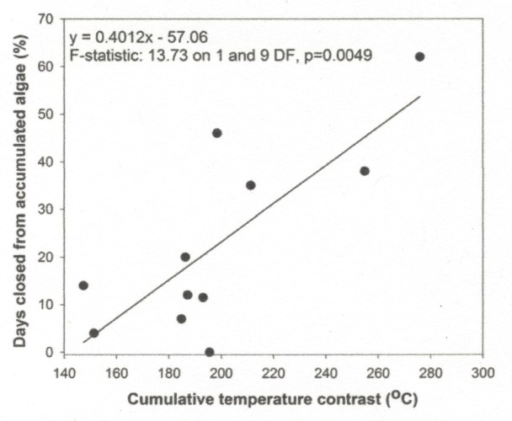

*determined over the range of year day 105 to year day 155. From Vodacek 2012.*

*over the range of year day 105 to year day 155. From Vodacek 2012.*

*The temperature contrast was*

*The temperature contrast was determined*

Combining the spring time heating time series from thermal satellite imagery for 2000-2011 with the local health department records for the same time period for beach closures due to fouling by *Cladophora*, Vodacek (2012) found a strong correlation between the cumulative temperature contrast between nearshore and offshore waters within the Rochester embayment and the percent of closed days due to accumulation of *Cladophora* (Figure 46). From this relationship it was concluded that nearshore heating during the springtime is a predictor of *Cladophora* abundance in the summer. In a related study, Vodacek (cited in Makarewicz et al., 2015) evaluated the relationship between satellite imagery derived measures of water clarity (as reflectance nF90) and lake water temperature for the offshore and nearshore in Rochester Bay, and accumulated *Cladophora* over a 91-day period from March 31 to June 28 (year day 90 to 181) for the period of 2000 to 2010. An outcome from this study was an improved relationship over the nearshore spring “water temperature relationship to accumulation of beach *Cladophora*” from Vodacek (2012), with the offshore measure of light availability (Kd490[7]) in the offshore area (normalized over the 91-day range). The finding was surprising since the light availability (or reflectance) is derived from the offshore region not the nearshore where the benthic alga grows and causes fouling of Ontario Beach. To explain this outcome, the author provides a couple of thoughts and mentions how , conditions in offshore regions represent an integration of a wider range of lake-wide spatial and temporal conditions than the nearshore. During the winter and early spring, prior to any nearshore stratification, the lake is relatively well mixed both vertically and horizontally. Consequently, the nutrient concentrations would be somewhat uniform across the lake and the offshore region may reflect a carry-over signal from the previous year, such as a whitening event which may influence the offshore springtime water clarity in the following year.

Secondly, the measure of offshore conditions starting on March 31 occurs prior to any significant nearshore stratification and therefore the offshore region may be a better measure of longer-term nearshore conditions than a nearshore signal. It may be the longer-term conditions that the *Cladophora* are responding to than the relatively noisy short-term conditions within the nearshore. These findings suggest that inter-annual variability in *Cladophora* abundance is at least in part controlled by lake-wide conditions and not only local short-term conditions.

Warmer temperatures on the shoreside of the thermal bar during springtime have been shown to promote early phytoplankton growth as evidenced by higher observed Chl *a* concentrations within the nearshore verses the offshore side of the thermal bar. To understand the potential role of a deep chlorophyll maxima (DCM) as a food source for dreissenid mussels during the thermal bar, spring period, Malkin et al, (2012) undertook a mussel growth study along the Halton Region littoral zone in northwestern Lake Ontario. The study involved two experiments using quagga mussels in predator exclusion cages during 2009. For the first experiment (exp 1), mussels in predator exclusion cages were deployed on the bottom and at 2 meters off bottom at three stations (shallow 6m, middle 9m and deep 18m) along a perpendicular transect from shore. The deployment was for a period from April 28 to July 20. The 2-meter height above bottom was chosen to avoid any boundary layer concentration caused by mussel grazing. Experiment 2 (exp 2), involved the same type of deployment of caged mussels except the deployment period was from July 21 to October 25. Using water column profiles Malkin et al., observed the formation of a DCM, first in the shallowest areas and then progressing offshore. During the spring time, Chl *a* fluorescence was always higher near the bottom than the surface. In the summer, there was less Chl *a* fluorescence in the nearshore verses the offshore. Measurements of mussel growth in the predator exclusion found that the suspended mussels grew significantly faster than the bottom-caged mussels, as measured by change in shell free dry weight. No significant difference in growth weight among the suspended mussels was detected between the 2 experiments. In contrast, positive growth among the bottom-caged mussels occurred over the first three-month period (exp 1) however, there was no mussel growth among the bottom-caged mussels for the second experiment, which occurred over the period of July 21 to October 25. The inference from these results is that the bottom-caged mussels were food limited during both the spring and summer-fall deployment periods but to differing degrees. During the spring and the onset of stratification the food supply (phytoplankton), as measured by Chl *a* fluorescence, was available near the bottom of the water column and is present as part of an annually recurring DCM. Based on these findings Malkin et al., (2012) suggest that littoral-zone dreissenid mussels are nourished by the development of a DCM during the onset of stratification (i.e. spring thermal bar).

A modeling study to analyze the *Cladophora* dynamics along the north shore in the Ajax area of Lake Ontario (Leon et al., 2009) was unable to capture the effects of the thermal bar on water quality however, the authors suggest that the bar may help confine inputs closer to shore early in the season prior to the high *Cladophora* nutrient demand. If the bar was adding “fuel” for growth of the benthic algae there would need to be some type of storage mechanism. Particulate sedimentation, aided by dreissenid filtration may be such a mechanism that enriches the benthic habitat. Nutrients released later from the decomposition of the settled material could fuel *Cladophora* growth when light and temperature conditions improve. In order for this process to work the particulates would have to deposited early in the season and retained long enough for the nutrients to be available when conditions are appropriate for *Cladophora* growth.

### Conclusions

1. Aerial coverage of *Cladophora* appears to be more pervasive on the Canadian verses the U.S. nearshore area based on satellite mapping. This is possibly due to geology which provides greater available hard substrate along the north shore.
2. Density of Cladophora is currently lower at comparable depths than the densities measured in the 1970s and 1980s and recent *Cladophora* tissue concentration is lower than in the past, reflecting a lower phosphorus environment. Due to the greater depth of Cladophora growth currently observed, the present overall production may be similar to the 70s and early 80s.
3. The results of studies reviewed provide differing conclusions as to whether anthropogenic sources of nutrients are driving localized nuisance growth of *Cladophora*. It would appear that under conditions of land-based phosphorus enrichment in nearshore waters *Cladophora* growth is exacerbated however, under conditions low light attenuation, hig dreissenid density, large quantity of available hard substrate, quiescent periods or protected areas, dreissenid mediated environments also can support dense *Cladophora* growth at low ambient background phosphorus concentrations. This fact raises the question whether nuisance growth of *Cladophora* can be eliminated through local control of land-based phosphorus loads or whether a whole-lake approach is required.

# Lake Ontario Embayments

In this report Lake Ontario has been broken down into three general geographical classifications which are reported on separately: offshore; nearshore; and, embayments. Embayments have been defined as bodies of water that are part of Lake Ontario’s nearshore and their shores form part of the overall Lake Ontario coastline. Due to the restricted exchange of water with the main lake, water quality within these embayments is influenced more by the surrounding landscape than the conditions within the main section of Lake Ontario. It is for this reason that they have been separated and classified as a separate geographical grouping. Examples of the bodies of water captured by the embayment classification include the Bay of Quinte, Hamilton Harbour on the north shore and Irondequoit Bay and Soddus Bay along the south shore of Lake Ontario. Figure 47 identifies the many embayments surrounding Lake Ontario that are addressed in this section.

Embayments are important features of Lake Ontario that provide a variety of ecological and economic services, and are sources of water for communities and industries. Embayments also provide assimilative capacity for treated industrial and municipal wastewater. Some of Lake Ontario’s most expansive and productive coastal wetlands are located within these embayments. For example, the Bay of Quinte contains 50% of Lake Ontario’s coastal wetlands and the Black River Bay contains the 2000-acre Dexter Marsh, a significant wetland recognized by the U.S. Department of the Interior. Many of the embayments provide spawning and rearing habitats for fish and wildlife important to Lake Ontario’s ecosystem and act as staging and resting areas for migrating birds and waterfowl. The sheltered aspects of these embayments provide safe harbours, boating and recreational fishing opportunities away from the sometimes rough waters of the open lake. Their beaches, campgrounds and resorts attract tourists and are an important aspect of local economies. For these reasons, protection and enhancement of the water and environmental quality within these embayments are important and require constant vigilance and investment.

Due to the impact from the surrounding watersheds, industrial and municipal direct discharges and the restricted flushing rates, many of Lake Ontario’s embayments suffer from high nutrient loads and poor water quality conditions. Unlike the open Lake Ontario which is experiencing the resurgence of overabundance of *Cladophora*, these embayments suffer from the over production of pelagic algae, including blue green algae and cyanobacteria blooms and the production of related toxins, as well as excessive macrophyte growth in some of the shallower areas and embayments.

There are numerous embayments encircling Lake Ontario and providing a detailed review of each one is not within the scope of this report. For this reason, a summary table has been developed to highlight the nutrient status, sources of nutrients and management actions to address their water quality issues. The table is divided into U.S. Embayments and Canadian Embayments. Within the table a brief discussion is given to identify the general location of the embayment within Lake Ontario, special features such as significant wet lands or protected areas, water quality challenges and management actions. A listing of the most recent water quality concentrations for total phosphorus (TP), soluble reactive phosphorus, nitrates and Chlorophyll *a* (Chl *a*) is provided. Many of the embayments suffer from re-cycling of phosphorus from the sediment which is associated with anoxic conditions in the hypolimnion and for this reason it is noted in the table whether an embayment suffers from conditions of hypoxia. The table also identifies whether the embayment experiences either blue green or cyanobacteria blooms.

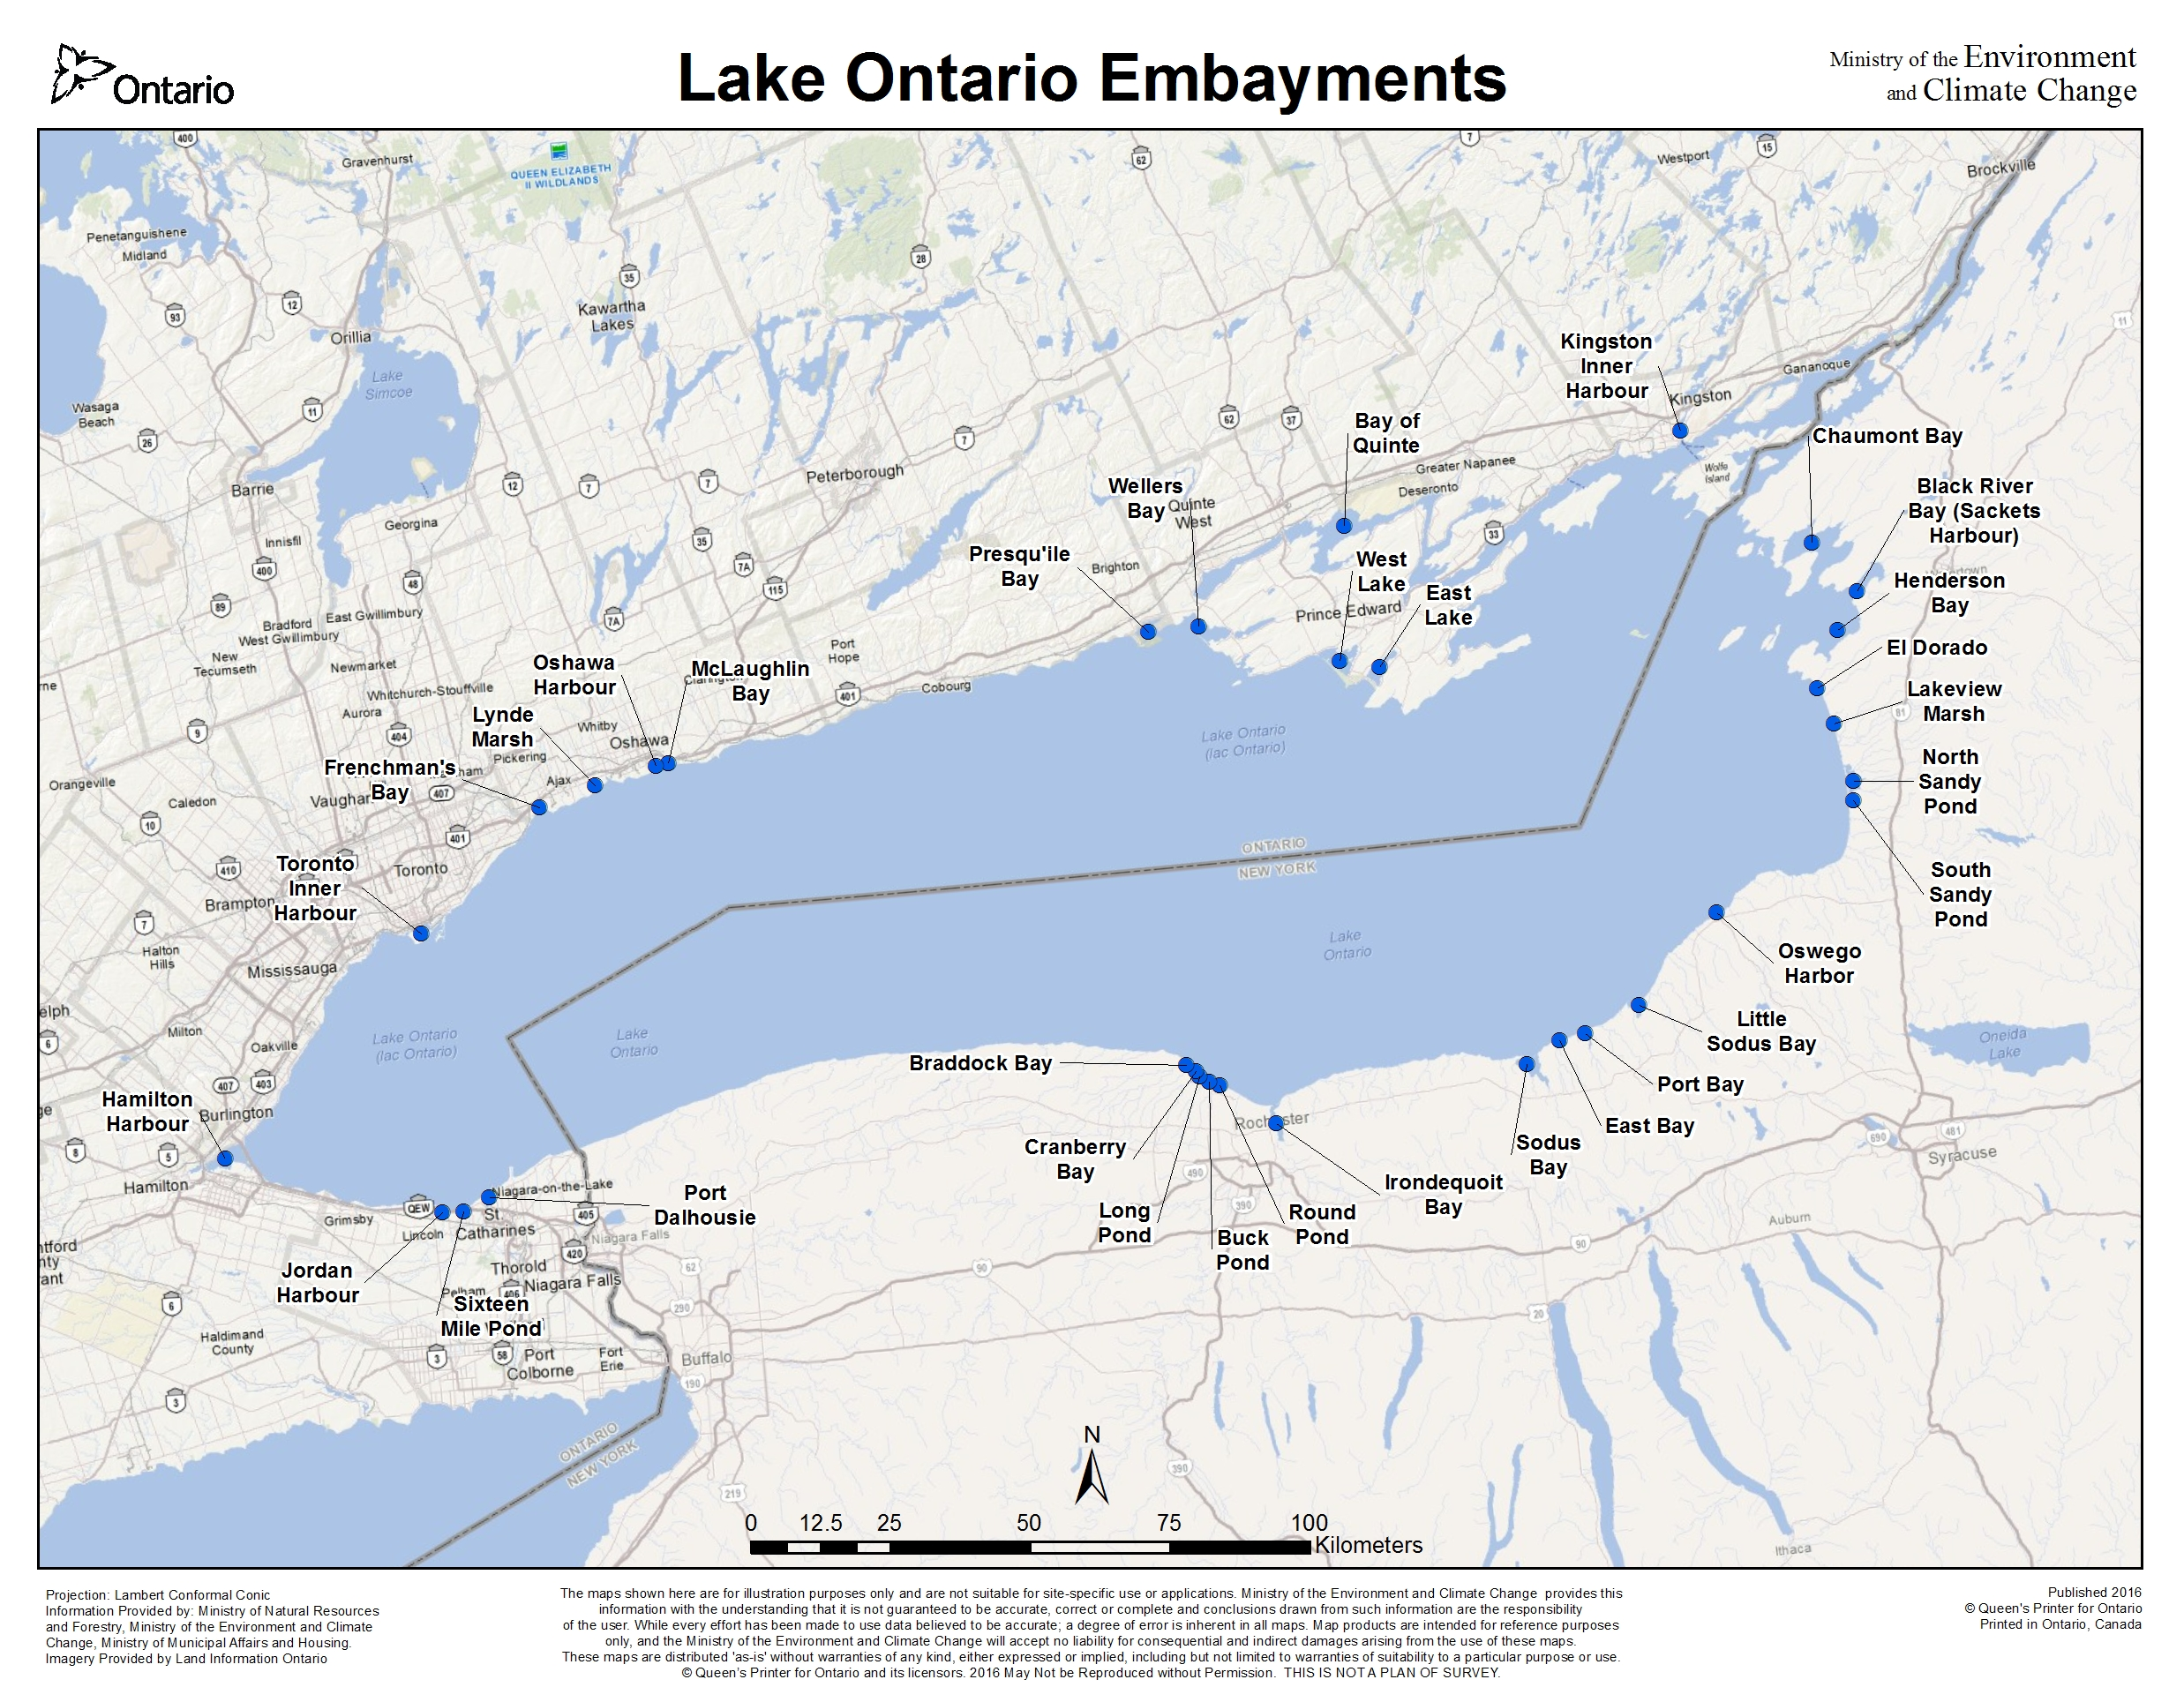

***Figure 48****: Map - Lake Ontario Embayments.*

## U.S. Embayments

***Table 14****: U.S. Embayments*

| **U.S. Embayments** | **Description** | **TP (ug/l)** | **SRP (ug/l)** | **Nitrate (mg/l)** | **Chl *a* (ug/l)** | **Hypoxia** | **Algal/Cyano Blooms** | **References** |
| --- | --- | --- | --- | --- | --- | --- | --- | --- |
| **Chaumont Bay** | A 9000-acre embayment located on the eastern shore of Lake Ontario, south of the St. Lawrence River. Three tributaries enter into the Bay forming 3 smaller bays. The shoreline is lined with development however, the main land-use within the watershed is agriculture. Algal blooms occur regularly and cause problems with water recreational activities (e.g. swimming and boating). Sources of nutrients to the Bay include failing septic systems, which are considered the primary source and direct discharge of treated sewage. The Bay experiences algal blooms and excessive weed growth. TP, SRP and phycocyanin levels in the Bay have decreased since 2003. Values provided to the right are mean concentrations based on once per month sampling from May through to October, 2005 to 2009 | 19.7 | 3.9 | 0.1 | 2.3 |  | Yes | Makarewicz (2000); Makarewicz (2010 report 36) |
| **Black River Bay (Sackets Harbor)** | Black River Bay located on the eastern shore of Lake Ontario is a narrow bay that contains the 2,000 acre relatively pristine Dexter Marsh at the northeast head of the Bay. Due to the lack of a barrier beach, Dexter Marsh is buffeted by waves making it a unique coastal marsh habitat that is recognized by the U.S. Department of the Interior. The Black River is the main tributary flowing into the Bay. Values provided to the right are mean concentrations based on once per month sampling from May through to October, 2005 to 2009. | 19.2 | 3.8 | 0.2 | 3.2 |  |  | Makarewicz (2000); Makarewicz et al., (2012) |
| **Henderson Bay** | Henderson Bay is a 4-mile long embayment located along at the far south eastern shore of Lake Ontario, just south west of Sacket's Harbour. The Hamlet of Henderson Harbour is located within the Bay and supports a Charter Boating industry. Sources of nutrients to the Bay are partially treated sewage from the Hamlet of Henderson Harbour and failing septic systems from homes and commercial establishments situated around the Bay. The waters are considered impaired due to excessive macrophyte growth and aesthetics. Overall TP and Chl *a* levels are low in comparison to other New York State embayments. Phycocyanin has been detected within the Bay with annual summer average concentrations ranging from <3 to >9 ug/l over the period of 2005-2009, with levels in more recent years (2007 and 2008) lower than in 2005-2006. Values provided to the right are mean concentrations based on once per month sampling from May through to October 2005 to 2009. | 15.4 | 4.7 | 0.15 | 1.7 |  |  | Makarewicz (2000); Makarewicz (2010 report 38) |
| **El Dorado** |  |  |  |  |  |  |  |  |
| **Lakeview Marsh** |  |  |  |  |  |  |  |  |
| **North Sandy Pond** | North Pond is located within Mexico Bay at the eastern end of Lake Ontario. It is formed by the eastern Lake Ontario sand dunes that form a 17-mile barrier between the lake and inland waters. Connection to the main lake is through a narrow channel throughout the sand barrier. North and South Sand Ponds form one of the largest coastal bay ecosystems on Lake Ontario. North Pond is affected by an overabundance of aquatic weeds. Algal blooms result in thick green slime on the surface of the water and macrophytes. Sources of nutrients to these Ponds are from agriculture run-off, septic systems, "gray water" discharge and lawn run-off. The Oswego County Soil and Water Conservation District is working to reduce both point and non-point source loading of nutrients into both North and South Sandy Pond. Values provided to the right are mean concentrations based on once per month sampling from May through to October 2005 to 2009. | 33.5 |  | 0.246 | 22.8 |  |  | Makarewicz (2000); http://waterqualitydata.us/portal/ |
| **South Sandy Pond** | South Pond is located within Mexico Bay at the eastern end of Lake Ontario. It is formed by the eastern Lake Ontario sand dunes that form a 17 mile (27 km) barrier between the lake and inland waters. Connection to the main lake is through a narrow channel throughout the sand barrier. The South and North Ponds form one of the largest coastal bay ecosystems on Lake Ontario. The North Pond is affected by an overabundance of aquatic weeds. Algal blooms result in thick green slime on the surface of the water and macrophytes. Sources of nutrients to these Ponds are from agriculture run-off, septic systems, "gray water" discharge and lawn run-off. The Oswego County Soil and Water Conservation District is working to reduce both point and non-point source loading of nutrients into both North and South Sandy Pond. Values provided to the right are mean concentrations based on once per month sampling from May through to October 2005 to 2009. | 30.1 |  | 0.344 | 12.6 |  |  | Makarewicz (2000); http://waterqualitydata.us/portal/ |
| **Oswego Harbor** |  |  |  |  |  |  |  |  |
| **Little Sodus Bay** | Little Sodus Bay is a small 728-acre embayment on the south shore of Lake Ontario located to the east of Oswego. It is connected to Lake Ontario through a narrow channel. The surrounding watershed is mostly forest (61%) with agriculture (20%) and developed lands (18%) making up most of the land use. The Bay suffers from nuisance algae and dense aquatic weeds, especially in the shallower areas. Fish spawning is considered to be stressed due to hypoxic conditions. No long-term trend in Chl *a* has been observed however, phycocyanin levels peaked in 2009 at a concentration of 95 ug/l. Data presented to the right are means for May through October, 2003 to 2009. | 32.6 | 7.4 | 0.07 | 5.3 | Yes | Yes | Makarewicz (2010 report 39); Makarewicz (2012b) |
| **Port Bay** | Port Bay is located between Rochester and Oswego, New York, and is a large (21 sq. mi.) embayment that is relatively shallow (<25 ft.). The perimeter of the Bay consists primarily of residential development with portions of the shoreline and the watershed being part of the Lake Shores Marsh Wildlife area. The surrounding land use is mostly agricultural. The Bay suffers from eutrophic conditions and is listed on New York States 303d list of Impaired Waters due to excessive TP concentrations. The main sources of nutrients to Port Bay are direct discharge of treated sewage and runoff from neighbouring agricultural lands. Phycocyanin concentrations have varied over the period of 2005-2009 from <10 to >40ug/l. The N : P ratio within Port Bay changes seasonally from a high of 26.3 in May to lows of 5.84 and 6.3 in July and August, respectively, which indicates N limitation. Values provided to the right are mean concentrations based on once per month sampling from May through to October 2003 to 2009. | 116.2 | 43.8 | 0.130 | 10.9 | Yes | Yes | Makarewicz (2010 report 43); Makarewicz et al., (2012) |
| **East Bay** |  |  |  |  |  |  |  |  |
| **Sodus Bay** | Sodus Bay is located about midway between Oswego and Rochester, New York. This embayment is 4.4 miles (7km) long and 2.4 miles (4km) wide. It is partially separated from Lake Ontario by a 1.5 mile (2.4km) barrier beach. The surrounding land-use is mostly forested (61%) followed by agriculture (30%), and development and wetlands both at 4%. The Bay supports boating (power and sail) and other recreational water activities. Although 50% of the Bay is less than 3m in depth it has been observed to stratify typically in mid-summer however, in 2013, monitoring showed it stratified for most of July and early August. Sodus Bay experienced cyanobacteria blooms in 2010, 2011 and 2012. The high levels of associated toxins posed not only an aesthetic problem but a human health threat. Microcystin concentrations were detected in all 3 years and exceeded the WHO drinking water guideline (1 ug/l) multiple times in 2011 and 2012 and exceeded both the WHO's drinking water and recreational (20 ug/l) guidelines in 2010 and 2011. Maximum anatoxin-a concentration of 3.1 ug/l was detected in 2011. Excessive macrophyte growth has been a long-standing issue within the Bay. During the cyanobacteria bloom of 2011 maximum concentrations of TP and TN of 389 ug/l and 9100 ug/l were observed. Sources of nutrients to the Bay are the surrounding watershed, internal loading from the sediment during hypolimnetic anoxia conditions, septic systems and macrophyte senescence. Values provided to the right are mean concentrations based on once per month sampling from May through to October 2003 to 2009. | 33.2 | 6.6 | 0.80 | 6.1 | Yes | Yes | Makarewicz (2000); Makarewicz (2010 report 47); Perrie, et al (2015); Makarewicz et al., (2012) |
| **Irondequoit Bay** | Values provided to the right are mean concentrations based on once per month sampling from May through to October 2003 to 2009. | 64.5 | 19.6 | 0.240 | 9.0 | Yes |  | Makarewicz (2010 report 45); Makarewicz et al. (2012) |
| **Round Bay** | Round Pond is located on the westerly portion of Rochester Bay and is small (58 acres) and shallow with a maximum depth of 0.5m. It is more of a wetland than an open body of water. Data presented to the right are 2000 summer mean values. | 52.0 |  | 0.329 |  |  |  | Makarewicz 1994; http://waterqualitydata.us/portal/ |
| **Buck Pond** | Located on the westerly portion of Rochester Bay, Buck Lake is a pond surrounded on three sides by a wetland that is larger in area than its 175 acres of open water. The New York State Department of Environmental Conservation manages it as a wildlife preserve. It discharges directly to Lake Ontario through a narrow channel. Data presented to the right are 2009 summer mean values. | 56.0 | 24.3 |  | 7.2 |  |  | Makarewicz 1994; http://waterqualitydata.us/portal |
| **Long Pond** | Long Pond is located on the westerly portion of Rochester Bay. It is a small shallow lake with a total area of 429 acres and maximum depth of 2.5 meters. The land use within its watershed includes a mix of residential, agriculture, fish and wildlife protected areas and parkland. It is connected to Lake Ontario through a narrow waterway and its trophic status is considered hypereutrophic. TP and SRP have improved in recent years due to the decommissioning of the Spencerport secondary wastewater treatment plant, which discharged into Northrup Creek, a tributary of Long Pond. The Village of Spencerport now operates a sanitary sewer collection system, which covers properties from within the village and from the Village of Ogden. The sanitary sewage is now pumped to a secondary treatment facility and discharged 1 mile out into Lake Ontario. High phosphorus sediment within Northrup Creek and Long Pond can be re-suspended and act as source of recycled nutrients for years to come. Values provided to the right are mean concentrations based on once per month sampling from May through to October 2003 to 2009. | 128.8 | 8.4 | 0.170 | 61 |  | Yes | Makarewicz 2010 Report 51; USGS (1999); Makarewicz et al., (2012) |
| **Cranberry Bay** | Cranberry Pond is located to the west of Long Pond. It has an area of 240 acres and is bordered on the southwest side by a large wetland complex. The maximum depth is 2m. There are no tributary flows to Cranberry Pond and it discharges into Long Pond through an outlet at its southeast corner. Data presented to the right are 2000 summer mean values. | 26.0 |  | 0.165 |  |  |  | Makarewicz 1994; http://waterqualitydata.us/portal/ |
| **Braddock Bay** | Braddock Bay is located to the west of Cranberry Bay at the westerly end of Rochester Bay. The Bay is a small open-inlet estuary and contains the Braddock Bay Fish and Wildlife Management Area, which is considered a major waterfowl nesting, resting and feeding habitat. It is surrounded by a mix of residential development, State Park and protected wildlife areas along parts of the shore. The U.S. Army Corps of Engineers is currently leading efforts to place breakwalls or jetties to reduce wave energy in the Bay so that wetland habitat can be restored. Modeling estimates suggest placement of breakwalls or jetties will increase phosphorus concentrations within the Bay by 10 ug/l. Values provided to the right are mean concentrations based on once per month sampling from May through to October 2003 to 2009. | 78 | 30.8 | 0.110 | 14.8 |  |  | LimnoTech (2014); Makarewicz et al., (2012) |

## Canadian Embayments

***Table 15****: Canadian Embayments*

| **Canadian Embayments** | **Description** | **TP (ug/l)** | **SRP (ug/l)** | **Nitrate (mg/l)** | **Chl a (ug/l)** | **Hypoxia** | **Algal/Cyano Blooms** | **References** |
| --- | --- | --- | --- | --- | --- | --- | --- | --- |
| **Kingston Inner Harbour** | The Kingston Inner Harbour is a shallow body of water with average depth of 3.6 feet. The Kingston Inner Harbour also serves as significant staging area for migratory waterfowl, supports a commercial fishery, and provides angling opportunities. The Cataraqui River is a major tributary flowing into the harbour and the harbour serves as the entryway to the Rideau Canal, which connects Lake Ontario with Ottawa, Canada’s capital. The Great Cataraqui Marsh (400 hectares) is located just upstream from the harbour and is a Provincially Significant Wetland. The Inner Harbour experiences occasional localized cyanobacteria blooms. The many sources of nutrients include urban runoff and combined sewer overflows, leachate from an old municipal waste disposal site and upstream loading from the Cataraqui River. Installation of a large combined sewer overflow (CSO) storage facility in 2006 along the western shore of the Inner Harbour has reduced the frequency and quantity of CSOs to the harbour. The City of Kingston has installed a groundwater interceptor system to capture groundwater leachate from the closed (in 1972) municipal landfill. |  |  |  |  |  | Yes | Malroz Engineering Inc.; City of Kingston (no date available) |
| **Bay of Quinte** | Located in the northeastern part of Lake Ontario, the Bay of Quinte is a narrow 100 km (62 miles) Z-shaped embayment separated from Lake Ontario by Prince Edward County and Amherst Island. It receives direct discharges from six municipal wastewater treatment plants and both point and non-point phosphorus loadings from its 1.75-million-hectare watershed. The Bay of Quinte was designated as an Area of Concern in 1985 due to 10 impaired beneficial uses, one of which was Eutrophication or Undesirable Algae. A Remedial Action Plan (Stage 2 Report "Time to Act") has been in place since 1993 and has guided actions to improve conditions within the Bay. Reduction of excess nutrient inputs has progressed. The annual daily load from direct discharging municipal WWTPs is 4.7 kg/day and a loading of 4.2 kg/day is maintained from May to October. The proportion of algae that are Cyanobacteria has decreased with remediation efforts however, the proportion that produces toxins has increased. The blue-green Microcystis has increased in biomass following the establishment of dreissenid mussels in the Bay during the mid 1990s. The nutrient based delisting targets of 40 μg/L to 30 μg /L in the upper portions of the Bay of Quinte for the period of May to October are close to being met; phytoplankton biomass has declined from an annual average of >10 g/cubic meter to levels equalling the target of 4-5 g/cubic meter. A phosphorus management strategy to direct ongoing and future actions is currently under development. Despite these gains, the trophic status of the Bay is still considered eutrophic. Data presented to the right represent the upper Bay of Quinte mean TP for May to October 2010 to 2013. | 26.3 |  |  | 10.5 | Yes | Yes | Remedial Action Plan Coordinating Committee, (1990); Bay Quinte Coordination Committee (1993); Monitoring Report 24 (2015) |
| **East Lake** | East Lake is an embayment located along the northeastern shore of Lake Ontario and is connected to the lake by Outlet River which flows through a barrier beach, dune complex. The East Lake watershed is mostly agricultural with Sandbanks Provincial Park located along the western shore and seasonal, permanent residential and commercial establishments along its shoreline. Water quality within East Lake has improved with TP concentrations declining from 34 ug/l in 1984 to an average of 15.1 ug/l for the period of 2006-2011. A combination of lower livestock numbers within the watershed and implementation of stewardship measures by the agricultural community may be the reason for the improved water quality. The lake’s trophic status has been classified as mesotrophic. Data presented on the right represent a mean concentration for 2006 to 2011. | 15.1 |  |  |  |  | Yes | Quinte Conservation 2012-13 |
| **West Lake** |  |  |  |  |  |  |  |  |
| **Weller’s Bay** | Wellers Bay is an embayment located on the northeastern shore of Lake Ontario and is separated from the lake by a 12 km barrier beach. Connection to the lake is through a small channel. A good portion of the barrier beach (Bald Head Island and part of another island) makes up the Wellers Bay National Wildlife Area, which is one of the last undeveloped sand spits on Lake Ontario. Access to the Wellers Bay is prohibited due to the National Wildlife Area (NWA) designation to protect fragile beach and dune ecosystems, and sensitive wildlife habitats, and also to reduce the risk of exposure to and injury from Unexploded Explosive Ordnance (UXO) on the site. In the 1940s, the Department of National Defence used the Bald Head area as a bombing range. |  |  |  |  |  |  | https://www.ec.gc.ca/ap-pa/default.asp?lang=En&n=C35E0810-1 |
| **Presqu’ile Bay** | A relatively small bay located on the west of and linked to the Bay of Quinte through the Murray Canal. The bay connects to and exchanges with the open waters of Lake Ontario through a narrow area to the south east. The Ontario Ministry of the Environment and Climate Change (MOECC) maintains a Lake Ontario nearshore index station in the centre of Presque'ile Bay. Data from a MOECC index station provided long-term mean concentrations from 1990 to 2012. Due to increasing reports from the Town of Brighton and its residence of increased algae and macrophytes within the Bay, a study was undertaken in 2013 to investigate the cause. TP showed a decreasing trend over the period of sampling and the trophic status was considered as mesotrophic. Values presented to the right are 2012 annual means. | 8.3 | 1.3 | 0.101 | 4.6 |  |  | Gilbert (2014); Beniot (2015 unpublished) |
| **McLaughlin Bay** | McLaughlin Bay is monitored as part of the Durham Region Coastal Wetland Monitoring Project. Total phosphorus, nitrate and Chl *a* values represent average July concentrations from 2002 to 2007. | 170 |  | 0.48 | 8.84 |  |  |  |
| **Oshawa Harbour** |  |  |  |  |  |  |  |  |
| **Lynde Marsh** | Lynde Marsh is monitored as part of the Durham Region Coastal Wetland Monitoring Project. Total phosphorus, nitrate and Chl *a* values represent average July concentrations from 2002 to 2007. | 120 |  | 1.27 | 12.9 |  |  |  |
| **Frenchman’s Bay** | Frenchman’s Bay is monitored as part of the Durham Region Coastal Wetland Monitoring Project. Total phosphorus, nitrate and Chl *a* values represent average July concentrations from 2002 to 2007. | 100 |  | 0.49 | 9.6 |  |  |  |
| **Toronto Inner Harbour** | The Toronto and Region was designated as an Area of Concern (AOC) in 1987 due to impairment of beneficial uses including Eutrophication or Undesirable Algae. The Toronto Inner Harbour makes up the central waterfront component of the AOC and is separated from Lake Ontario by the Toronto Islands. Connection to the lake is provided by shipping channels on the east and west ends of the harbour. The Don river is the only tributary emptying into the harbor. The Don River receives nutrients from stormwater and CSO discharges, as well as treated municipal sewage. The Inner Harbour receives nutrients from direct discharge of stormwater and combined sewer overflows. Eutrophication or Undesirable Algae was assessed in 2015 through the application of the Carlson and Simpson (1996) trophic state index to observed TP and Chl *a* concentrations, and secchi depth. Based on this assessment the trophic status was changed from eutrophic to mesotrophic. The City of Toronto has been active in reducing combined sewer overflows along its waterfront, Inner Harbour and Don River. The goal is to capture and treat 100% of stormwater and combined sewage. This action will further improve conditions within the harbour. Data presented to the right are for the Inner Harbour and TP represents the range in spring means from 1993-2013. The Chl *a* value represents the 2008 summer median concentration. | 12-22 |  |  | 4.8 | No | No | Dahmer, (2014) |
| **Hamilton Harbour** | Hamilton Harbour is a 2150-hectare Bay located at the extreme western end of Lake Ontario. It was identified as an Area of Concern (AOC) in 1987 due to poor water quality (low dissolved oxygen, high nutrient concentrations, aesthetic impacts) caused by soil erosion in the watershed, discharges from two steel plants and three municipal wastewater treatments plants. The Harbour also receives urban runoff and combined sewer overflows from the cities of Hamilton and Burlington. The Harbour is connected to Lake Ontario through the Burlington Shipping Channel. TP concentrations within the Harbour greatly improved by approximately 50% from 1987 to 1997 however, little change has occurred since then. Planned upgrades to the municipal wastewater treatment plants are expected to reduce current TP loads by 60%. Data suggest that conditions have recently changed and the sediment phosphorus release may delay water quality improvements for many years following reductions in TP loadings. A target load of 142 kg/day has been established for delisting the beneficial use impairment of Eutrophication or Undesirable Algae. Data to the right are geometric means based on 21 years of data (1987-2007) for spring TP, SRP, nitrates and summer Chl *a*. | 31.6 | 1.6 | 1.9 | 14.1 | Yes | Yes | Environment Canada (20??); Hiaret-Baer (2009); Jonlija (2014) |
| **Jordan Harbour** |  |  |  |  |  |  |  |  |
| **Sixteen Mile Pond** |  |  |  |  |  |  |  |  |
| **Port Dalhousie** | Port Dalhousie is located to the west of the Niagara River and Welland Canal. The bulk of water discharged into the pond originates in Lake Erie and is diverted for hydro electrical production from the Welland Canal into Twelve Mile Creek, which flows into the Martindale Pond and then into Port Dalhousie. The Port Dalhousie wastewater treatment plant discharges into the outlet from the bay to Lake Ontario. The surrounding watershed includes a mix of urban and rural/agricultural development. Water quality within Port Dalhousie was monitored in 2013 by the Ontario Ministry of the Environment and Energy on four survey dates from May to October. Data to the right represent mean values for all 4 of the 2013 survey dates. | 29 | 8.6 | 0.308 | 1.5 |  |  | Howell, (2016 unpublished) |

# Model Development in Lake Ontario

The re-emergence of the benthic algae *Cladophora* and associated problems of shoreline fouling and clogging of water intakes has raised concern regarding water quality within the nearshore of Lake Ontario. The nuisance levels of *Cladophora* currently experienced are reminiscent of the pre-phosphorus control period when high lake-wide phosphorus concentrations were driving growth. Phosphorus loading and ambient concentrations have declined in the Lake. The conditions under which the production of *Cladophora* is currently occurring within Lake Ontario are quite different than those during the pre-phosphorus control period of the 1960’s and early 1970’s and during the post implementation of phosphorus controls, prior to the establishment of zebra and quagga mussels. The colonization of Lake Ontario by invasive dreissenid mussels in the 1990s has been a game changer. These mussels have altered the light regime through enhancing water transparency and have re-engineered the way phosphorus is cycled through the system. The improved water clarity has led to an increase in the depth of photic zone, which has resulted in much greater area of the lake-bed that can support *Cladophora* growth. Through their filtering action dreissenids remove particulate phosphorus that originates from land based discharges and offshore sources and excrete it as bioavailable phosphorus, more easily used by *Cladophora*. Excreted feces or pseudo feces settle on the bottom and remain within the nearshore. Through this process, phosphorus is retained within the nearshore while offshore productivity is low.

Unlike Lake Erie, Lake Ontario does not suffer from blue green algal or cyanobacteria blooms on either a Lake-wide or basin scale. These types of events are limited to many of Lake Ontario’s embayments. Instead, Lake Ontario suffers from a nearshore that is experiencing the over production of *Cladophora*, while the offshore suffers from low phosphorus concentrations that have raised concern that current concentrations are insufficient to support a healthy level of lake productivity. Research has shown *Cladophora* growth in the post dreissenid period has responded to the increased light environment and to the soluble reactive phosphorus environment that is mediated by ambient lake concentrations and possibly the SRP flux by dreissenids. The flux of SRP from dreissenids is dependent on the availability of particulate phosphorus from both land-based (tributaries, stormwater and combined sewer outfalls and wastewater treatment plants) and open lake sources (phytoplankton). Thus the obvious management action to reduce *Cladophora* growth is to manage land-based sources of phosphorus as a means of reducing ambient SRP concentrations and dreissenid SRP flux. On the other hand, further reduction of phosphorus raises concerns with regard to protection of offshore productivity. For example:

* What are the levels of particulate phosphorus and SRP that need to be attained in order to control *Cladophora* growth to “acceptable” levels?
* What are the implications of further reduction in Lake Ontario phosphorus loading to offshore productivity, and how will future phosphorus load reductions for Lake Erie further impact Lake Ontario’s productivity? That is, how will the food web dynamics in the offshore be affected by potential nearshore management decisions that may alter the bottom-up controls in an already stressed (low productivity) environment?
* Do we have sufficient knowledge of the phosphorus-mussel-*Cladophora* interaction in order to make sound science-based phosphorus loading decisions (i.e. set targets) that will achieve a desired reduction in *Cladophora* production (i.e., below nuisance biomass concentrations) while protecting offshore productivity?

These are difficult questions to answer without understanding the implications of outcomes from management decisions to control phosphorus loading to Lake Ontario. A modeling framework that can address the phosphorus-dreissenid-*Cladophora*-offshore food web dynamic would provide a tool to assist lake managers answer these challenging questions and assist them in making informed decisions. Efforts are underway within Lake Ontario to develop a model or series of linked models that will relate adjustments in phosphorus loading to *Cladophora* production. The new modeling approach recognizes the need to incorporate hydrodynamic processes, as well as water quality and ecological interactions in a linked manner to simulate the nearshore phosphorus-mussel-*Cladophora* dynamics. The generalized approach first addresses the phosphorus-mussel-*Cladophora* relationship by applying a 3D-hydrodynamic lake-wide model linked to an ecological model that in turn is linked to a *Cladophora* growth model (Figure 48). That is the output variables from the hydrodynamic-water quality model drives the ecological model, which includes dreissenid, phytoplankton, zooplankton interactions, and the output from this model drives the *Cladophora* growth model. The role that each of the models play within the generalized framework is described.

The **3D-hydrodynamic-water quality model** is applied on a lake-wide basis since whole-lake processes drive near-shore circulation. The level of detail or resolution needed for much of the lake differs from that needed in the nearshore. This is due to the variation in the nearshore natural gradients of momentum, concentration, temperature, tributary and point source influences, dispersion, etc., and also the higher density and interest in understanding physical, biological and chemical process in the nearshore. Computational efficiency can be achieved by using a lower resolution grid for the offshore where conditions are more homogeneous and a finer, higher spatial resolution grid within the nearshore where conditions are more temporally and spatially variable. Thus the 3D-hydrodynamic model defines the plume dispersion within the nearshore and resulting water column concentrations and the nearshore-offshore exchange of phosphorus (particulate and bioavailable). It provides time-series of temperatures and nutrient concentrations at any depth that is important for dreissenid SRP flux.

The **Ecological Model** uses the output of water quality (e.g. temperature, nutrient and other variable concentrations) from the 3D-hydrodynamic model, incorporates the cycling of phosphorus throughout the system by phytoplankton, zooplankton, dreissenid mussel beds and *Cladophora* and produces a time series of SRP at any site or depth.

The ***Cladophora* Growth Model** uses the SRP concentrations from the ecological model, as well as light and temperature to model the kinetic uptake of SRP and *Cladophora* growth.

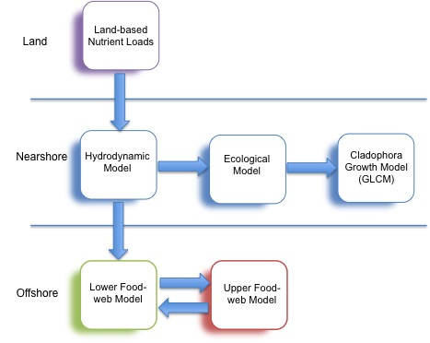

**Figure 49**: Generalized Conceptual Graphic of the Modeling Framework for Lake Ontario.

Development of this modeling framework that links the three model types is being pursued to address *Cladophora* problems in the lower Great Lakes. Currently two research teams are working under separate Great Lakes Restoration Initiative (GLRI) contracts to develop and apply the 3D-hydrodynamic, Ecological and Great Lakes *Cladophora* Growth Model (GLCM) in a linked and coupled model framework for Lake Ontario.

A Michigan Technical Institute (MTI) research team is utilizing the Finite Volume Community Ocean Model (FVCOM) model for hydrodynamic simulations. They are modifying a generalized ecological model designed to pair with FVCOM in linked hydrodynamic-biogeochemical application. Modifications to the linked models known as FVCOM-GEM will accommodate site-specific Great Lakes algorithms and coefficients. The Great Lakes *Cladophora* Model (GLCM 2.0) will be linked in series to the FVCOM-GEM model for development and application in Lake Ontario.

A second research team from LimnoTech has chosen to use the same hydrodynamic model, FVCOM, as the MTI group due to its flexibility in developing a computational grid that will provide the high resolution needed for the nearshore. The Advanced Aquatic Ecosystem Model (A2EM) ecological modeling framework has been selected for coupling with the FVCOM. The A2EM has been developed for Great Lakes applications and integrates all the nutrient dynamics, plankton dynamics, dreissenids, and *Cladophora* in the same framework, so feedback interactions among them can be modeled. This model will also provide input of spatial and temporal distribution of the lower food web plankton biomass. The result of coupling the 2 models is FVCOM-UGA2EM modeling framework. The initial study site for the development and application of the FVCOM-UGA2EM modeling framework is the southwest Lake Ontario nearshore region between the Niagara River and Rochester. Possible future work could extend the area to the entire New York coastline and even to the entire lake if so desired

In order to support the development of this important modeling framework, coordinated monitoring of water quality, dreissenids and *Cladophora* will be required. Examples of the types of variables that require characterization in order to accurately calibrate and validate these models include:

* Water column TP and particulate phosphorus as a measure of the nutrient supply for dreissenid SRP excretion;
* Water column soluble reactive phosphorus, especially within the near bottom layer just above the mussel beds;
* *Cladophora* abundance (g DW/m2) and phosphorus content at varying depths as an indicator of the algael’s phosphorus status
* Mussel community structure that includes, mussel density and mussel size distribution at varying depths throughout the study area as a measure of the mussel SRP flux potential

The two modeling initiatives described above have a strong focus on the nearshore and the computations needed to determine the *Cladophora* growth response to environmental variables, including changes in phosphorus loading. The FVCOM-UGA2EM coupled model not only deals with the nearshore phosphorus-mussel-*Cladophora* but also addresses the combined nutrient and lower food web (phytoplankton and zooplankton) interactions. The next modeling challenge is to develop an offshore food-web model for Lake Ontario that can relate nutrient management changes to offshore productivity. That is, model the bottom-up and top-down food web responses to various phosphorus management scenarios.

Rain and DePinto (1996) and Kao et al., (2016) provide examples of food web modeling approaches that could be considered in the development of a Lake Ontario food web model. Rain and DePinto (1996) developed a food web model using a simplified food chain (Figure 49) to predict sustainability of Chinook salmon in Lake Ontario at various sustained stocking rates. The response of Chinook salmon biomass to varying nutrient conditions was also considered in this modeling exercise. Kao et al., (2016) assessed the top-down control imposed by top predators (e.g. Chinook salmon) and bottom-up controls (dreissenids and nutrient controls) on the collapse of the Lake Huron alewife population. The modeling was able to show that the Chinook impact on the alewife population was relatively constant before the collapse. The bottom-up controls caused by nutrient abatement measures and the additional impact by dreissenid mussels tilted the balance in alewife population to an unsustainable level where recovery of this prey fish species is unlikely within Lake Huron. Although predictions for Lake Ontario cannot be made, Kao et al., (2016) point out that the biomass flow to Chinook salmon in Lake Ontario (and Michigan) is similar to Lake Huron, and through a simple pelagic pathway: phytoplankton ➔zooplankton ➔alewives ➔Chinook salmon. The flow of energy through the pelagic pathway is consistent with the approach used by Rain and DePinto (1996) for Lake Ontario (see Figure 49).

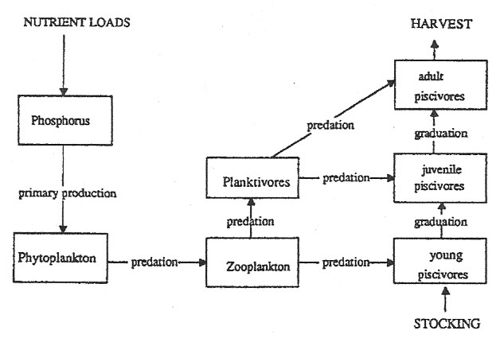

**Figure 50**: Conceptual diagram for Lake Ontario ecosystem model. Excretion and mortality fluxes omitted for clarity.

*From Rain and DePinto, 1996.*

## Summary of Model Applications Within Lake Ontario

A review of modeling approaches applied to Lake Ontario was undertaken to assist identification of the sources of valuable information needed for further model development. This review is not meant to be a comprehensive summary of all model approaches applied within Lake Ontario, instead by identifying some key modeling initiatives applicable to nutrient management, resources and effort in accumulating input parameters and ambient data needed to calibrate and validate future modeling efforts may be minimized. The review is organized by model type (e.g. Watershed Models - both rural/agricultural and urban, Hydrodynamic Models, *Cladophora* Growth Models and Coupled Models) and provides a brief example of model applications.

### Rural Watershed Models

Agricultural Non-Point Source Pollution Model (AGNPS)

The AGNPS model was developed by the U.S. Department of Agriculture and is a distributed model that simulates agriculture watersheds on an event basis. This model has been enhanced and replaced by a continuous-simulation, multi event version however, the earlier event based version of the AGNPS was successfully calibrated and verified for southern Ontario. The model was applied by the Toronto and Region Conservation Agency within the Duffins Creek watershed to assist in land-use decisions through identification of high source areas of sediment and phosphorus, evaluation of the efficacy of non-point source controls and to assess the loading of sediment and phosphorus delivered to Lake Ontario. The model has been calibrated and verified for the southern Ontario watershed, including Duffins Creek (Toronto and Region Conservation Authority, 2003).

### Soil and Water Assessment Tool (SWAT)

The SWAT model is used in large agricultural watersheds with varying soils, land use and management practices to predict the impact of land management practices on water, sediment and chemical yields. It can be run for long periods of time and has been applied in the Genesee River watershed on the U.S. side of Lake Ontario, and the Rouge River and Duffins Creek watersheds on the Canadian side of Lake Ontario.

Within the Genesee River watershed, a total of six calibrated and validated models were developed, five upstream models and a sixth model, the Genesee River Soil and Water Assessment Tool (GRSWAT), which models the “Lower Main Stem” portion of the Genesee River. Model simulations for the Genesee River have been conducted for several scenario categories: natural forested/wetland; grassed waterways; wastewater treatment options; and stream channel remediation. Simulations for all categories have been run to create outcomes for the entire Genesee watershed. TP load allocation by source has also been accomplished for the Genesee watershed using the GRSWAT model Makarewicz et al., (2015).

On the Canadian side of the Lake the SWAT model parameter estimation, sensitivity analysis, calibration and validation were performed using a high spatial resolution dataset (flow and water quality) for the Rouge River watershed. The parameters were then directly applied to the neigbouring Duffins Creek watershed. The model performed well in both watersheds in reproducing flow patterns and parameter concentrations (TP, TSS, TN and mineral P). Asadzadeh et al., (2015) provides a full account of the model input data, performance evaluation, water quality simulation, assumptions and study limitations. Work is underway to apply the SWAT model to the Humber River watershed which is located on the west side of Toronto (Luis Leon, Environment Canada personal communication February 8, 2016).

### Stormwater Management Model (SWMM)

The SWMM model developed by the U.S Environmental Protection Agency is planning, analysis and design related to stormwater runoff, combined and sanitary sewers, and other drainage systems in urban areas. It has been used to create the ROCSWMM model for the City of Rochester and Town of Irondequoit storm sewer networks. It has been calibrated for nine storm sewer sites using the discharge measurements and calculated TP and total suspended solids (TSS) loads from single storm events. The validation values indicated that the ROCSWMM accurately predicts the response within the Rochester’s and Town of Irondequoit’s storm sewer system. The model has been used to estimate the annual TP load from the storm sewer system to the Genesee River. The predicted annual TP load from the Rochester storm sewer system (2,277 kg) was considered small when compared to the overall TP loading (625,694 kg) from the Genesee River (Makarewicz et al., 2014).

### HSPF

HSPF (Hydrological Simulation Program – Fortran) simulates for extended periods of time the hydrologic, and associated water quality, processes on pervious and impervious land surfaces and in streams and well-mixed impoundments. The model computes stream flow hydrographs and water quality characteristics using continuous rainfall and meteorological records. It can handle both rural and urban watersheds and has been applied in Lake Ontario watersheds by both the Credit Valley Conservation and the City of Toronto.

The Credit Valley Conservation (CVC) manages the Credit River watershed and 11 other smaller tributaries that discharge directly to Lake Ontario. The Credit River watershed is a mix of rural and about one-third of the watershed being urbanized. An urban landscape surrounds the 11 smaller tributaries. As part of their Lake Ontario Integrated Shoreline Strategy (LOISS), the CVC has applied the HSPF to provide continuous model simulations of high resolution time series of water quality loadings at the Lake Ontario shoreline from all Credit Valley source streams and the main Credit River for a one-year period (October 1, 2010 to September 30, 2011). The model was calibrated for stream flow and water quality using measured stream flow, precipitation and the event mean concentrations. Parameters covered by the loading simulations include total suspended solids, Nitrate+Nitrite, ammonia, total phosphorus, orthophosphate, copper, zinc, E. coli and chloride.

As part of the City of Toronto’s Wet Weather Flow Master Plan (WWFMP), the HSPF model was applied to simulate hydrologic process as well as pollutant generation and transport for separated sewer catchments within 4 watersheds: Mimico Creek and Etobicoke Creek, Humber River, Don River, and Highland Creek. Model simulations were used to evaluate potential management options considered as part of the Environmental Assessment for the WWFMP to reduce urban run-off, reduce basement flooding and pollutant source reduction. Model simulations were set up to simulate in-stream concentrations within each water course and the waterfront of Lake Ontario. Eleven water quality parameters were simulated: total phosphorus, total suspended solids, total Kjeldahl nitrogen, nitrate+nitrite, E. coli, total lead, total zinc, dieldrin, benzo(g.h.i.)perylene, and temperature. The HSPF model was calibrated for flow and water quality based on data from the Water Survey of Canada stream gauges for the period of 1991 to 1996 and from an extensive water quality monitoring undertaken by the City of Toronto from 1990 to 1996.

### *Cladophora* Growth Model (CGM)

The *Cladophora* growth model is based on several dynamic variables including: light temperature, phosphorus, and carrying capacity. The biomass is a function of growth and loss (respiration and sloughing) terms. The model predicts specific growth by subjecting an empirically determined maximum specific growth rate, based on available light and temperature, to forcing functions that account for in situ conditions that are, most often, sub-optimal (Higgins PhD Thesis). The more modern versions of the *Cladophora* growth model are based on the original “Canale and Auer” model, which was developed and validated in proximity to a sewage treatment outfall in Lake Huron.

Malkin et al., 2008 calibrated and validated the CGM at the Oakville study site along the north shore of Lake Ontario in 2004 and 2005 using water quality and meteorological data. These two base years provided a contrast in climate with differences in spring warming and mean surface irradiance, with 2004 being the cooler of the 2 years. Malkin et al., (2008) used the model to conduct a comparison of historical (hindcasting) Cladophora production to recent time (2004 and 2005) and to forecast the direct effects of climate warming on seasonality and magnitude of *Cladophora* growth. Using estimated historical light attenuation (Kpar) and measured *Cladophora* tissue P concentration it was determined that peak attached biomass for 1982-83 was 1.4 times higher than 2004-2005 and cumulative biomass was 2.04 higher for 1972, peak biomass was 1.6 times higher than 2004-2005 and cumulative biomass was 2.66 times higher. Forecasting *Cladophora* biomass at increasing temperatures due to climate change concluded that there was a marginal increase in peak biomass with a 1oC and 2oC increase in temperature above the 2004-2005 baseline years.

As part of the study to determine landscape associated influence on *Cladophora* growth in Lake Ontario, Higgins et al., (2012) applied the CGM using median SRP and tissue P concentrations (Qp) in separate simulations. SRP concentrations yielded depth integrated biomass that was 8X higher than *in situ* measurements however, simulations with Qp values yielded biomass estimates similar to *in situ* measured values. An observation made based on the study findings is that the lower Qp and increased water clarity (lower Kpar value) observed since 1972 work in opposing directions on the seasonal growth of *Cladophora*. The increase in water clarity helping to offset the gains made in controlling P levels in Lake Ontario.

Auer et al., (2010) examined changes in nutrient and light environments of three Great Lakes (Lakes Michigan, Erie and Ontario) as they have influenced *Cladophora* growth with respect to P controls and in the post dreissenid period. Both the CGM and Great Lakes *Cladophora* Model (GLCM) were used in this study. For Lake Ontario, the P-management time period was 1976-1990 and post dreissenid period was 1996-2005. Modeling of the pre-dreissenid period predicted that reductions of SRP levels due to P controls resulted in the reduction of *Cladophora* growth on the order of ~40%. When the combined effects of increased light conditions and reduced SRP of the post-dreissenid period were modeled for Lake Ontario, the growth potential for *Cladophora* increased 39% (GLCM) and 61% (CGM). The key factor in this assessment is that increased water clarity has offset the gains made controlling *Cladophora* growth through management of phosphorus by dramatically increasing the depths supporting growth thereby increasing the habitat for the benthic algae.

The results of the CGM application described above by Auer et al., (2010) differ from those of Malkin et al., (2008) in which there was an estimated decrease in the depth-integrated *Cladophora* biomass in the post dreissenid period. Auer et al., (2010) suggests the difference in results is attributable to the manner in which the studies characterized the nutrient environment. Auer et al., (2010) used SRP data from water intakes and sites sampled by Malkin et al., (2008) to drive the CGM, while Malkin et al., (2008) used measured internal phosphorus concentrations (Qp). Malkin et al., (2008) found when using Qp the model better predicted observed growth dynamics for the Oakville area, a similar finding as Higgins et al., (2012) for seven Lake Ontario sites.

### Lake Hydrodynamic Models

An evaluation of the performance of three hydrodynamic models in Lake Ontario was conducted by Huang et al., (2010). The three models evaluated included the: Princeton Ocean Model (POM); Canadian Version Diecast Model (CANDIE); and, Estuary Lake Computer Model (ELCOM). Each of the models’ outputs was compared to observed Lake Ontario meteorological (e.g. wind speed and directions, long and shortwave radiation, surface air temperature) and limnological (current velocities, water temperature and profiles) collected from an intensive survey in the spring-fall 2006. Results of the comparisons showed that the three models performed well overall at reproducing observed lake conditions (current velocity, surface temperature patterns) with some biases. All models have limitations in predicting vertical mixing schemes. Overall the POM performed as well as or better than the other models for most measures.

The 3-dimensional hydrostatic Estuary Lake Computer Model (ELCOM) has been applied in eastern Lake Ontario and the upper St. Lawrence (Paturi et al., 2012) and in the Port Hope and Cobourg area (Paturi et al., 2014) to simulate both hydrodynamics and contaminant transport to delineate “Intake Protection Zones” (IPZs) around drinking water intakes. In both applications, the models were comprehensively validated against observed water levels, temperature, current and dissipated observations. Overall, the ELCOM application to both eastern Lake Ontario and the Upper St. Lawrence, and the Port Hope – Cobourg study areas performed well. Both Paturi et. al., (2012) and Paturi et al., (2014) provide the details on the comprehensive validation of the model for both applications in Lake Ontario and the St. Lawrence River.

### Princeton Ocean Model

The Princeton Ocean Model has been used for a number of Great Lakes studies, has been the computational engine for the NOAA Great Lakes Coastal Forecast System and is maintained at NOAA’s Great Lake Environmental Research Laboratory. It has been applied by Atkinson et al., (2012) in the Oak Orchard Creek, Rochester Embayment and Sandy Creek/Mexico Bay study areas on the south shore of Lake Ontario. The POM was coupled with a finer grid nested model as described in Atkinson et al., (2012), 2km x 2km to 200m x 200m grids, respectively. This POM study demonstrated the feasibility of using a nested approach to hydrodynamic modeling but highlighted the need for finer resolution to reproduce certain observed features within the nearshore, such as thermal fronts. A finer scale in the order of tens of meters may also be needed to accommodate tributary inflows. The finer spatial resolution allows for closer match in to site measurements and for a closer matching of bathymetry, since the area averaged is much smaller, thus avoiding the loss of detail through the averaging over a larger grid area. The model and data comparisons for the nested regions were promising and additional development work is needed in 3 areas: 1) finer resolution in the order of tens of meters to resolve observations such at thermal fronts and tributary inputs; 2) impact of different initial conditions should be explored in greater detail; and 3) alternative mixing formulations should be evaluated to better simulate mixing near to shore.

### ELCD-CGM Nested 3D Hydrodynamic Model

A 3D hydrodynamic model, coupled with an ecological model was developed by the Centre for Water Research at the University of Western Australia. The coupled model, ELCOM-CAEDYM (ELCD), was refined by Leon et al., (2009) and coupled with the *Cladophora* Growth Model to describe *Cladophora* growth and detachment in the Pickering-Ajax area of Lake Ontario. A key area of the model development was the nesting of the ELCD to provide finer spatial resolution in the order of 50m nearshore grid coupled to the broader whole lake spatial scale grid of 2km. The model was validated against water quality data collected every 2-3 weeks from late April to mid-October, 2007 and 2008. The field years provided an excellent contrast between wet (2007) and dry (2008) weather conditions. Agreement between model predictions and water quality variables most important to *Cladophora* growth (SRP, TP, light penetration, and temperature) was very good. Model agreement between the 2007 and 2008 water quality observations without any parameter adjustment between years suggested the predictions were reasonably robust. The modeling study identified the municipal wastewater treatment plant as the only nutrient source within the study area having an appreciable effect on seasonal accumulation of algal biomass. The removal of the municipal wastewater treatment plant as a nutrient load would have decreased the *Cladophora* biomass accumulation by about 10% in 2007, a year of severe fouling in the area.

The present day ELCOM-CAEDYM simulations for Pickering-Ajax will be initialized to begin the simulation with the data from spring 2004 (Oveisy et al. 2015) and run continuously until fall 2010. The Lake Ontario model will employ model forcing files and validation data from previous studies (2004, Oveisy et al. 2015; 2006, Rao et al. 2008, Boegman and Rao 2010, Paturi et al. 2015a; 2006-07, Oveisy et al. 2012; 2007 and 2008, Leon et al 2012; 2010, Paturi et al. 2015b) (Luis Leon personal communication, February 8, 2016).

### MIKE – 3 Model

MIKE‐3 software, based on the whole of Lake Ontario, was used in nested mode to simulate the currents and water quality along the northshore of Lake Ontario between Etobicoke Creek west to the Clarkson Water Pollution Plan in Mississauga. The model was used to predict the currents and temperature and the water quality resulting from WPCPs and several tributary discharges, the largest being the Credit River. Total Phosphorus (TP), Total Suspended Solids (TSS), PO4, Ortho-Phosphate or Soluble Reactive Phosphorus (SRP), E. Coli and Conductivity were the water quality parameters modeled.

Mike-3 was also used in nested mode within the nearshore along the Toronto Waterfront and Inner Harbour as part of the “Don River and Central Waterfront Environmental Assessment” for wet weather (WW) and combined sewer overflow (CSO) control. The focus of the model development and application was to assess the impact of different WW and CSO controls on E. coli and recreational beach quality. The model underwent detailed calibration, validation and sensitivity analysis. Model verification and performance details are provided in Dewey (2012). Although this study is focused on E. coli, the extensive flow, lake current and meteorological dataset would be available for application to predict current and future water quality impacts of phosphorus loads after wet weather controls are in place. In addition, the model has been applied to the neighbouring nearshore area to the west of Toronto (Etobicoke Creek to Clarkson Waste Water Control Plant) and together with the modelled Toronto area would provide large aerial coverage upon which to build further modelling efforts.

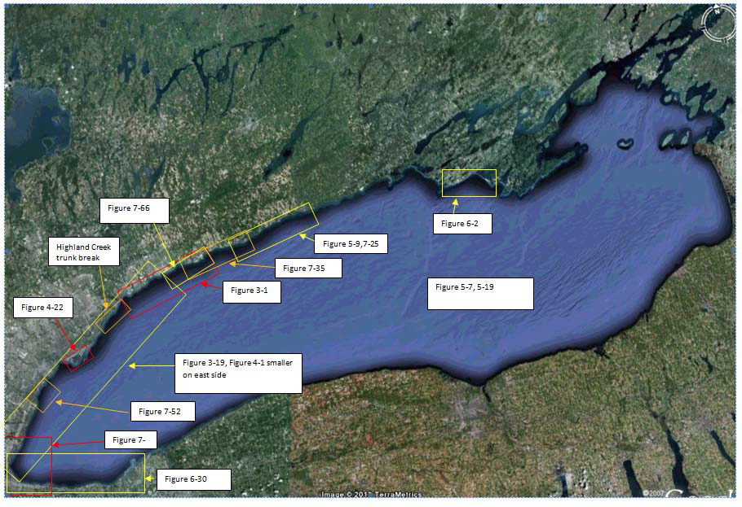

**Figure 51**: Model grids applied to the spill scenarios along the north coast of Lake Ontario.

*From Dewey, 2012.*

*From Dewey,*

The MIKE-3 system was also used by the Lake Ontario Collaborative (LOC) in the

assessment of spill scenarios for the Surface Water Protection Study of the water intakes along the north shore of Lake Ontario from west of the Niagara River to Prince Edward County in the east. Figure 50 depicts the areas covered by the model grids applied to the spill scenarios along the north coast of Lake Ontario.

# Recommendations

1. Lake Ontario agencies should work together to establish consistent binational practices and methodology for estimating loads. Consistency in approach will allow for accurate tracking and reporting of loading, and will assist lake managers in making sound management decisions.
2. Lake Ontario agencies should consider the development of unit area inputs from watersheds as a means of identifying problem watersheds (and sub-watersheds) and sewer-sheds with high unit area nutrient loading. This type of approach will assist in focusing resources as needed and will also provide a metric upon which to track the effectiveness of any required abatement actions in both rural and urban landscapes.
3. Although not heavily focused on as part of this report, projected urban growth within the Lake Ontario watershed was identified by Lake Ontario Algae Action Advisory Committee (LOSAAAC, 2008) as a risk to increasing future nutrient loading in the Halton area. Population growth throughout the northwestern shore (Greater Toronto Area) is expected to increase by 3 million over the next 25 years and poses a risk of increased phosphorus loading to the Lake from direct discharge and runoff. It is recommended that the tracking of nutrient loads form rapidly urbanizing landscapes be considered by the Lake Ontario agencies.
4. A considerable percent (~30% to 60%) of Lake Ontario’s phosphorus load originates in Lake Erie and is delivered through the Niagara River and Welland Canal. However, the Welland Canal is not included in the calculations of upstream loading to Lake Ontario. It is recommended that Niagara River and Welland Canal loading to Lake Ontario continue to be monitored for the long-term, especially since future decisions for phosphorus load reductions in Lake Erie will have management implications for Lake Ontario. As well, to assess compliance with the GLWQA phosphorus target of 7,000 metric tons per year, the portion of the Lake Erie load delivered through the Welland Canal must be considered as part of the upstream load.
5. Lake Ontario agencies consider development of a strategy to address the four priority science needs related to groundwater nutrient contributions identified in the report “Groundwater science relevant to the Great Lakes Water Quality Agreement: A Status Report” (Grannemaman and Van Stemvoort. Eds. Draft. 2015). Through support for these science needs the significance of the nutrient contribution from groundwater to the Lake will be addressed.
6. The monitoring of offshore and nearshore waters has provided valuable information to track temporal and spatial changes in the nutrient status of these regions in Lake Ontario. This information has provided a means to monitor compliance with the Great Lakes Water Quality Agreement’s ecosystem objective for phosphorus and has also provided information that is critical for the effective management of Lake Ontario. It is recommended that current U.S., Canadian, state and provincial monitoring programs for Lake Ontario be maintained at current levels and expanded where and when needed to support specific initiatives (e.g. development of modeling frameworks, research on significance of nutrient sources for *Cladophora* growth). The current monitoring programs not only deliver on the two countries’ GLWQA commitment to monitor the Great Lakes ecosystem, they also provide a basis for tracking the effectiveness of management actions and are an important component of an adaptive management framework.
7. The overabundance of *Cladophora* is a key feature of the nearshore nutrient question within Lake Ontario. Currently there are no ongoing monitoring programs to track *Cladophora* abundance over time. Monitoring of Cladophora tissue phosphorus (Qp) would provide insight into the overall growing conditions and allow for expert interpretation on nutrient exposure. This information is useful for determining temporal trends, response in *Cladophora* abundance to year-to-year variability in environmental conditions and for use in current and future *Cladophora* growth modeling. It is highly recommended that the Lake Ontario agencies develop and implement a *Cladophora* monitoring strategy.
8. A number of studies have documented the increased light environment caused by dreissenid filtering of particulate matter from the water column. This additional increase in water clarity has led to production of *Cladophora* at much greater depths than in the pre-dreissenid period. Although the cause of nuisance growth of *Cladophora* appears to be related to dreissenid mussels and the changes they have caused in the light environment and the cycling of nutrients, there are still questions regarding the significance of dreissenid driven SRP, anthropogenic sources of phosphorus and lake-wide ambient concentrations in the production of *Cladophora*. For this reason, it is recommended that continued research into the causal factors of luxuriant growth of *Cladophora* be supported.
9. Modeling is a useful tool for understanding the interplay of man-made and environmental variables (e.g. light attenuation/turbidity, temperature, nutrient loads, dreissenid mussels, phytoplankton, *Cladophora*, hydrodynamics) in the promotion and constraint of *Cladophora* growth. Development of modeling frameworks that assist in understanding the complex dynamic relationships among environmental and anthropogenic variables and assist in making management decisions to control nuisance *Cladophora* growth should be supported.

Key to the success of model development efforts is the availability of accurate environmental information needed to calibrate, validate and drive the models. It is recommended that consideration be given to apportion monitoring efforts to the acquisition of data needed by model development teams. This will require collaboration between monitoring and modelling experts, and lake managers.

1. Low phosphorus concentrations in Lake Ontario’s offshore has raised concern regarding the sustainability of productivity within this region of the Lake. The ability to predict the response of the offshore food web to phosphorus loading options for the control of *Cladophora* in the nearshore is needed to make sound management decisions. A food web model that can be linked to hydrodynamic-ecological-*Cladophora* type model frameworks would allow for a balance between management actions to control nuisance *Cladophora* growth and protection of offshore productivity. It is therefore paramount that the development and operation of a sound Lake Ontario food web model be completed prior to the establishment of phosphorus targets or enacting management actions to reduce phosphorus loads.

Development of a Lake Ontario food web model that is linked or coupled to a hydrodynamic-ecological-Cladophora modeling framework will require collaboration between experts from multiple disciplines: water quality/hydrodynamic modeling, aquatic food web modeling, fisheries management, water quality monitoring and lake managers.

# Bibliography

Arnott, D. L., & Vanni, M. J. (1996). Nitrogen and phosphorus recycling by the zebra mussel (Dreissena polymorpha) in the western basin of Lake Erie. *Canadian Journal of Fisheries and Aquatic Sciences*, *53*(3), 646-659.

Asadzadeh, M., Leon, L., McCrimmon, C., Yang, W., Liu, Y., Wong, I. & Bowen, G. (2015). Watershed derived nutrients for Lake Ontario inflows: Model calibration considering typical land operations in Southern Ontario. *Journal of Great Lakes Research*, *41*(4), 1037-1051.

Atkinson, J. F., Edwards, W. J., & Feng, Y. (2012). Physical measurements and nearshore nested hydrodynamic modeling for Lake Ontario nearshore nutrient study. Journal of Great Lakes Research, 38, 184-193.

Auer, M. T., Tomlinson, L. M., Higgins, S. N., Malkin, S. Y., Howell, E. T., & Bootsma, H. A. (2010). Great Lakes Cladophora in the 21st century: same algae—different ecosystem. Journal of Great Lakes Research, 36(2), 248-255.

Barbiero, R. P., Tuchman, M. L., & Millard, E. S. (2006). Post-dreissenid increases in transparency during summer stratification in the offshore waters of Lake Ontario: is a reduction in whiting events the cause?. *Journal of Great Lakes Research*, *32*(1), 131-141.

Bay of Quinte Coordination Committee, (1993). Stage II Report, Time to Act. Prepared by the Bay of Quinte Coordination Committee with assistance from the Public Advisory Committee.

Benoit, N. (2015). Presqu’Ile Bay Water Quality Study 2013 – DRAFT – June 30, 2015. Ontario Ministry of the Environment and Climate Change.

Binding, C. E., Jerome, J. H., Bukata, R. P., & Booty, W. G. (2007). Trends in water clarity of the lower Great Lakes from remotely sensed aquatic color. *Journal of Great Lakes Research*, *33*(4), 828-841.

Blanton, J. O. (1974). Some characteristics of nearshore currents along the north shore of Lake Ontario. *Journal of Physical Oceanography*, *4*(3), 415-424.

Brooks, C., Grimm, A., Shuchman, R., Sayers, M., & Jessee, N. (2015). A satellite-based multi-temporal assessment of the extent of nuisance Cladophora and related submerged aquatic vegetation for the Laurentian Great Lakes. Remote Sensing of Environment, 157, 58-71.

City of Kingston. By-pass Reduction: What We Have Done. Retrieved from <http://www.utilitieskingston.com/Wastewater/Bypass/Reduction>

D'Andrea, M., Snodgrass, W. J., & Chessie, P. D. (2004). Development of a wet weather flow management master plan for the City of Toronto. *Water quality research journal of Canada*, *39*(4), 417-431.

Dayton, A.I. (2011). Cladophora, Mass Transport, and the Nearshore Phosphorus Shunt (Master of Science Thesis) Michigan Technological University

Dejong, D.C. (2000). The growth and distribution of the green alga Cladophora at Presqu'ile Provincial Park: Implications for management (Ontario). (Masters of Science Thesis). Wilfrid Laurier University.

Depew, D. C., Houben, A. J., Guildford, S. J., & Hecky, R. E. (2011). Distribution of nuisance Cladophora in the lower Great Lakes: Patterns with land use, near shore water quality and dreissenid abundance. Journal of Great Lakes Research, 37(4), 656-671.

Depew, D. C., Stevens, A. W., Smith, R. E., & Hecky, R. E. (2009). Detection and characterization of benthic filamentous algal stands (Cladophora sp.) on rocky substrata using a high‐frequency echosounder. Limnology and Oceanography: Methods, 7(10), 693-705.

Dewey, R. (2012 Toronto Inner Harbour Water Quality Modeling. Appendix 3.3 Assessment of Receiving Water Response To alternative Wet Weather Flow Controls. City of Toronto’s Don River and Central Waterfront Project – Class Environmental Assessment Study Report. Prepared for the City of Toronto and MMM Group.

Dewey, R. (2012). Presentation – Lake Ontario Model. Part II. Presented at the Lake Ontario Collaborative Wrap-up Workshop, November 20, 2012.

Dolan, D. M., & Chapra, S. C. (2012). Great Lakes total phosphorus revisited: 1. Loading analysis and update (1994–2008). Journal of Great Lakes Research, 38(4), 730-740.

Dove, A. 2009. Long-term trends in major ions and nutrients in Lake Ontario. J. Aquatic Ecosystem Health & Management. 12(3) 281-295.

Dove, A., & Chapra, S. C. (2015). Long‐term trends of nutrients and trophic response variables for the Great Lakes. *Limnology and Oceanography*, *60*(2), 696-721.

Grannemaman and Van Stemvoort. Eds. Draft. 2015. Groundwater science relevant to the Great Lakes Water Quality Agreement: A Status Report.

Gudimov, A., Ramin, M., Labencki, T., Wellen, C., Shelar, M., Shimoda, Y., ... & Arhonditsis, G. B. (2011). Predicting the response of Hamilton Harbour to the nutrient loading reductions: a modeling analysis of the “ecological unknowns”. *Journal of Great Lakes Research*, *37*(3), 494-506.

Hecky, R. E., Smith, R. E., Barton, D. R., Guildford, S. J., Taylor, W. D., Charlton, M. N., & Howell, T. (2004). The nearshore phosphorus shunt: a consequence of ecosystem engineering by dreissenids in the Laurentian Great Lakes. *Canadian Journal of Fisheries and Aquatic Sciences*, *61*(7), 1285-1293.

Higgins, S. N., E. T. Howell, S. J. Guildford, L. Campbell, V. Hirriat-Baer, R. E. Hecky. 2008. An Ecological Review Of Cladophora Glomerata (Chlorophyta) in the Laurentian Great Lakes. J. Phycol. 44, 839–854.

Higgins, S. N., E. T. Howell, S. J. Guildford, L. Campbell, V. Hirriat-Baer, R. E. Hecky. 2008. An Ecological Review Of Cladophora Glomerata (Chlorophyta) in the Laurentian Great Lakes. J. Phycol. 44, 839–854.

Higgins, S. N., E. T. Howell, S. J. Guildford, L. Campbell, V. Hirriat-Baer, R. E. Hecky. 2008. An Ecological Review Of Cladophora Glomerata (Chlorophyta) in the Laurentian Great Lakes. J. Phycol. 44, 839–854.

Higgins, S. N., Pennuto, C. M., Howell, E. T., Lewis, T. W., & Makarewicz, J. C. (2012). Urban influences on Cladophora blooms in Lake Ontario. Journal of Great Lakes Research, 38, 116-123.

Hiriart-Baer, V. P., Milne, J., & Charlton, M. N. (2009). Water quality trends in Hamilton Harbour: two decades of change in nutrients and chlorophyll a. *Journal of Great Lakes Research*, *35*, 293-301.

Holeck, K. T., Rudstam, L. G., Watkins, J. M., Luckey, F. J., Lantry, J. R., Lantry, B. F., & Johnson, T. B. (2015). Lake Ontario water quality during the 2003 and 2008 intensive field years and comparison with long-term trends. Aquatic Ecosystem Health & Management, 18(1), 7-17.

Holeck, K.T., J. M. Watkins, E. L. Mills, O. Johannsson, S. Millard, V. Richardson, K. Bowen. 2008. Spatial and long-term temporal assessment of Lake Ontario water clarity, nutrients, chlorophyll a, and zooplankton. J. Aquatic Ecosystem Health & Management, 11(4):377–391.

Howell, E. T. (2016). Deciphering the Anthropogenic and Ecological Drivers of Cladophora abundance in Lake Ontario Presentation at the Annex 4 & 10 Workshop on the Sate of Cladophora Science in the Great Lakes. January 27, 2016. Ann Arbor Michigan.

Howell, E. T., Chomicki K. M., Kaltenecker G. (2012a). Patterns in water quality on Canadian shores of Lake Ontario: Correspondence with proximity to land and level of urbanization. J. Great Lakes Research. 38: 32-46.

Howell, E. T., Chomicki K. M., Kaltenecker G. (2012b). Tributary discharge, lake circulation and lake biology drivers of water quality in the Canadian Nearshore of Lake Ontario. J. Great Lakes Research. 38: 47-61.

Howell, E.T., (2016). Unpublished data for Port Dalhousie.

Huang, A., Rao, Y. R., Lu, Y., & Zhao, J. (2010). Hydrodynamic modeling of Lake Ontario: An intercomparison of three models. Journal of Geophysical Research: Oceans, 115(C12).

Johengen, T. H., Johannsson, O. E., Pernie, G. L., & Millard, E. S. (1994). Temporal and seasonal trends in nutrient dynamics and biomass measures in Lakes Michigan and Ontario in response to phosphorus control. Canadian Journal of Fisheries and Aquatic Sciences, 51(11), 2570-2578.

Kilgour, B. W., Bailey, R. C., & Howell, E. T. (2000). Factors influencing changes in the nearshore benthic community on the Canadian side of Lake Ontario. *Journal of Great Lakes Research*, *26*(3), 272-286.

Lake Ontario Lake-wide Management Plan, 1998. Stage 1: Problem Definition.

Lake Ontario Shoreline Algae Action Advisroy Committee. 2008. Lake Ontario Shoreline Algae Action Advisory Committee. Final Report. Submitted to Halton Region Council.

Leon, L. F., Smith, R. E., Malkin, S. Y., Depew, D., Hipsey, M. R., Antenucci, J. P., ... & Rao, R. Y. (2012). Nested 3D modeling of the spatial dynamics of nutrients and phytoplankton in a Lake Ontario nearshore zone. Journal of Great Lakes Research, 38, 171-183.

Leon, L. F., Smith, R., Mailkin, S., Depew, D., & Hecky, R. E. (2009). Modelling and analysis of Cladophora dynamics and their relationship to local nutrient sources in a nearshore segment of Lake Ontario. Completed on behalf of University of Waterloo.

LimnoTech, (2014). Total Phosphorus Modelling if Braddock Bay. Prepared for the Ecology and Environment Inc. under contract to U.S. Army Corps of Engineers, Buffalo District & U.S. Environmental Protection Agency.

Makarewicz, J. C., Booty, W. G., & Bowen, G. S. (2012a). Tributary phosphorus loading to Lake Ontario. Journal of Great Lakes Research, 38, 14-20.

Makarewicz, J. C., Lewis, T. W., & Boyer, G. L. (2012c). Nutrient enrichment and depletion on the shoreside of the spring thermal front. *Journal of Great Lakes Research*, *38*, 72-77.

Makarewicz, J. C., Lewis, T. W., Boyer, G. L., & Edwards, W. J. (2012d). The influence of streams on nearshore water chemistry, Lake Ontario. *Journal of Great Lakes Research*, *38*, 62-71.

Makarewicz, J. C., Lewis, T. W., Rea, E., Winslow, M. J., & Pettenski, D. (2015). Using SWAT to determine reference nutrient conditions for small and large streams. *Journal of Great Lakes Research*, *41*(1), 123-135.

Makarewicz, J. C., T. W. Lewis, A. Vodacek. 2014. Lake Ontario Nearshore Study (LONNS 2013). Report to the United States Geologic Survey. Project Number 1107921-1-63530.

Makarewicz, J. C., T. W. Lewis, C. M. Pennuto, J. F. Atkins, W. J. Edwards, G. L. Boyer, E. T. Howell, G. Thomas. (2012b). Physical and chemical characteristics of the nearshore zone of Lake Ontario. 38: 21-32.

Makarewicz, J. C., T. W. Lewis, C. M. Pennuto, J. F. Atkins, W. J. Edwards, G. L. Boyer, E. T. Howell, G. Thomas. (2012). Physical chemical characteristics of the nearshore zone of Lake Ontario. 38: 21-32.

Makarewicz, J.C., (2000). New York’s North Coast A Troubled Coastline: Lake Ontario Embayments Initiative. Technical Reports. Paper 5. http//digitalcommons.brockport.edu/tech_rep/5

Makarewicz, J.C., (2010). Chaumont Bay Jefferson County, New York. Technical Report 36. http//digitalcommons.brockport.edu/tech_rep/36

Makarewicz, J.C., (2010). Henderson Harbour Jefferson County, New York. Technical Report 38. http//digitalcommons.brockport.edu/tech_rep/38

Makarewicz, J.C., (2010). Irondequoit Bay Monroe County, New York. Technical Report 45. http//digitalcommons.brockport.edu/tech_rep/45

Makarewicz, J.C., (2010). Little Sodus Bay Cayuga County, New York. Technical Report 39. http//digitalcommons.brockport.edu/tech_rep/39

Makarewicz, J.C., (2010). Long Pond Monroe County, New York. Technical Report 51. http//digitalcommons.brockport.edu/tech_rep/51

Makarewicz, J.C., (2010). Port Bay Wayne County, New York. Technical Report. http//digitalcommons.brockport.edu/tech_rep/43

Makarewicz, J.C., (2010). Sodus Bay Wayne County, New York. Technical Report 47. http//digitalcommons.brockport.edu/tech_rep/47

Malkin, S. Y., Dove, A., Depew, D., Smith, R. E., Guildford, S. J., & Hecky, R. E. (2010). Spatiotemporal patterns of water quality in Lake Ontario and their implications for nuisance growth of Cladophora. Journal of Great Lakes Research, 36(3), 477-489.

Malkin, S. Y., Guildford, S. J., & Hecky, R. E. (2008). Modeling the growth response of Cladophora in a Laurentian Great Lake to the exotic invader Dreissena and to lake warming. Limnology and Oceanography, 53(3), 1111-1124.

Malroz Engineering Inc. (no date). Environmental Impact Study Cataraqui Park, Kingston, Ontario, Executive Study. Retrieved from: https://www.google.ca/search?q=City+of+Kingston+Inner+Harbour+Cataraqui+Park&ie=utf-8&oe=utf-8&gws_rd=cr&ei=zOHNVvSFF6HtjgSZ2YCQAw

Martin, G.M. (2010). Nutrient sources for excessive growth of benthic algae in Lake Ontario as inferred by the distribution of SRP (Master of Science in Biology Thesis). University of Waterloo, Ontario, Canada.

Monitoring Report 24 (2015). Project Quinte Annual Report (2013). Prepared by Project Quinte Members in Support of the Bay of Quinte Remedial Action Plan.

Naddafi, R., Pettersson, K., & Eklöv, P. (2008). Effects of the zebra mussel, an exotic freshwater species, on seston stoichiometry. *Limnology and Oceanography*, *53*(5), 1973-1987.

Nicholls, K. H. (2001). CUSUM phytoplankton and chlorophyll functions illustrate the apparent onset of dreissenid mussel impacts in Lake Ontario. *Journal of Great Lakes Research*, *27*(4), 393-401.

Ontario Ministry of the Environment and Climate, Change. In prep. Water quality of 15 streams in agricultural watersheds of Southwestern Ontario 2004 – 2009. Seasonal patterns, regional comparisons, and the influence of land use.

Ozersky, T., Malkin, S. Y., Barton, D. R., & Hecky, R. E. (2009). Dreissenid phosphorus excretion can sustain *C. glomerata* growth along a portion of Lake Ontario shoreline. Journal of Great Lakes Research, 35(3), 321-328.

Painter, D. S., & Kamaitis, G. (1987). Reduction of Cladophora biomass and tissue phosphorus in Lake Ontario, 1972-83. Canadian Journal of Fisheries and Aquatic Sciences, 44(12), 2212-2215.

Paturi, S., Boegman, L., & Rao, Y. R. (2012). Hydrodynamics of eastern Lake Ontario and the upper St. Lawrence River. *Journal of Great Lakes Research*, *38*, 194-204.

Paturi, S., Boegman, L., Bouffard, D., & Rao, Y. R. (2014). Three-Dimensional Simulation of Lake Ontario North-Shore Hydrodynamics and Contaminant Transport. *Journal of Hydraulic Engineering*, *141*(3), 04014082.

Pennuto, C. M., Howell, E. T., Lewis, T. W., & Makarewicz, J. C. (2012). Dreissena population status in nearshore Lake Ontario. Journal of Great Lakes Research, 38, 161-170.

Pennuto, C. M., Howell, E. T., & Makarewicz, J. C. (2012b). Relationships among round gobies, Dreissena mussels, and benthic algae in the south nearshore of Lake Ontario. *Journal of Great Lakes Research*, *38*, 154-160.

Perri, K.A, J.M. Sullivan, G.L. Boyer (2015). Harmful algal bloom in Sodus Bay, Lake Ontario: A comparison of nutrients, marina presence, and cyanobacterial toxins. Journal of Great Lakes Research. 21, 326-337.

Pickett, R. L. (1976). Lake Ontario circulation in November. *Limnology and Oceanography*, *21*(4), 608-611.

Quinte Conservation (2012-13). State of Lake, East Lake Watershed 2012-2013. Retrieved from: <http://quinteconservation.ca/site/images/stories/water/studies/east_lake/el_sol.pdf>

Remedial Action Plan Coordinating Committee, (1990). Stage I Report: Environmental Setting and Problem Definition.

Richardson, V., G. J. Warren, M. Nielson, P. Horvatin. 2012. Cooperative Science and Monitoring Initiative (CSMI) for the Great Lakes – Lake Ontario 2008. J. Great Lakes Research 38: 10-13.

Statistics Canada, 2013. Human Activity and the Environment (16-201-X). <http://www.statcan.gc.ca/pub/16-201-x/2013000/aftertoc-aprestdm1-eng.htm>

Stewart, T. W., & Haynes, J. M. (1994). Benthic macroinvertebrate communities of southwestern Lake Ontario following invasion of Dreissena. *Journal of Great Lakes Research*, *20*(2), 479-493.

Taraborelli, A. C., Fox, M. G., Johnson, T. B., & Schaner, T. (2010). Round goby (Neogobius melanostomus) population structure, biomass, prey consumption and mortality from predation in the Bay of Quinte, Lake Ontario. *Journal of Great Lakes Research*, *36*(4), 625-632.

Toronto and Region Conservation Authority. (2003) Agricultural Non-point Source (AGNPS) Modeling of Duffins and Carruthers Creek.

Walsh, M. G., Dittman, D. E., & O'Gorman, R. (2007). Occurrence and food habits of the round goby in the profundal zone of southwestern Lake Ontario. *Journal of Great Lakes Research*, *33*(1), 83-92.

Wilson, K. A., Howell, E. T., & Jackson, D. A. (2006). Replacement of zebra mussels by quagga mussels in the Canadian nearshore of Lake Ontario: the importance of substrate, round goby abundance, and upwelling frequency. Journal of Great Lakes Research, 32(1), 11-28.

Winter, J. G., Howell, E. T., & Nakamoto, L. K. (2012). Trends in nutrients, phytoplankton, and chloride in nearshore waters of Lake Ontario: Synchrony and relationships with physical conditions. *Journal of Great Lakes Research*, *38*, 124-132.

Yerubandi. R., Milne, J. E., & Marvin, C. H. (2012). Hydrodynamics and water quality in western Lake Ontario. Journal of Great Lakes Research, 38, 91-98.

Young, B. L., Padilla, D. K., Schneider, D. W., & Hewett, S. W. (1996). The importance of size-frequency relationships for predicting ecological impact of zebra mussel populations. *Hydrobiologia*, *332*(3), 151-158.

# Appendix 1 – Summary of Lake Ontario Monitoring

**Lake Ontario Nutrient Dreissenid and Cladophora Monitoring**

|  |  |  |  |  |  |  |  |
| --- | --- | --- | --- | --- | --- | --- | --- |
|  | **Agency** | **Location** | **Parameters** | **Date/Season** | **Contact** | **Contact Info** | **Comments** |
| **Tributary Monitoring** | Ontario Ministry of the Environment and Climate Change | Major Canadian tributaries to Lake Ontario. | TP, SS and other parameters | Once per month April to November |  |  | The Provincial Water Quality Monitoring Network obtains monitors the provinces major tributaries. |
| Natural and Applied Sciences, University of Wisconsin Green Bay; Civil and Environmental Engineering Department, Tufts University, Medford, | All of the Great Lakes (emphasis on lakes Superior, Michigan, Huron and Ontario) | phosphorus, loadings, eutrophication, tributary, municipal, industrial and atmospheric | Data from 1994-2008 | David M. Dolan | doland@uwgb.edu | Article: **Dolan & Chapra (2012).** Great Lakes total phosphorus revisited: 1. Loading analysis and update (1994-2008). |
| State University of New York; Environment Canada, National Water Research Institute; Toronto and Region Conservation Authority | 145 Canadian and American streams entering Lake Ontario | Tributary phosphorus loadings, *Cladophora*, Lake Ontario, nearshore | 2008-2010 for Canadian Sites; tributary data obtained over an 18-year period | Joseph C. Makarewicz | Jmakarew@brockport.edu | Article: **Makarewicz et al. (2012).** Tributary phosphorus loading to Lake Ontario. Communicated by Todd Howell. |
| State University of New York, Department of Environmental Science and Biology | Genesee River watershed | water quality standards, nutrient criteria, streams, SWAT, watershed hydrology, models | Prior to 2014 (2010-2012) | Joseph C. Makarewicz | Jmakarew@brockport.edu | Article: **Makarewicz et al. (2015).** Using SWAT to determine future reference nutrient conditions for small and large streams |
| State University of New York (College at Brockport) | Upper Genesee River, Lower Genesee River; 4 major Genesee tributaries (Canaserag, Honeoye, Black, Oatka Creeks) | Genesee River, water quality, SWAT, phosphorus, management, Lake Ontario | August 2010-August 2012. | Joseph C. Makarewicz | Jmakarew@brockport.edu | Article: **Makarewicz et al. (2015).** Utilizing intensive monitoring and simulations for identifying sources of phosphorus and sediment for directing, siting, and assessing BMPs: The Genesee River example |
| **Nearshore Monitoring** | Ontario Ministry of the Environment and Climate Change | Lakes Huron, Erie, St. Clair, Ontario. Detroit, St. Clair, and St. Lawrence rivers. | Dreissenid Shell Length | April - May & August (1994) | Edward L. Mills | [elm5@cornell.edu](mailto:elm5@cornell.edu) | Article: **Mills et al. (1999)**. Todd Howell was the 8th author out of ten on the published paper. The authors were based in the US Article |
| Department of Chemistry, State University of New York, College of Environment Science and Forestry | South and eastern shores of Lake Ontario: Oak Orchard, Rochester, and Mexico Bay | Surface water temperature, conductance, phytoplankton distribution | May - August (2008) | Margaret M. Pavlac | mmpavlac@syr.edu | Article: **Pavlac et al. (2012).** This paper was communicated by Todd Howell |
| Environment Canada, National Water Research Institute | Rouge River watershed and Duffins Creek watershed | TSS, TP, TN, erosion, sediment yields | 2007-2011 | Luis Leon | luis.leon@ec.gc.ca | Article: **Asadzadeh et al. (2015).** Masoud Asadzadeh, the first author listed is also a part of Environment Canada and the National Water Research Institute |
| Fisheries and Oceans Canada | Lake Ontario Basin | Phytoplankton size structure | April, July & September (2008) | Mohi Munawar | mohi.munawar@dfo-mpo.gc.ca | Article: **Munawar et al. (2015).** Assessment of phytoplankton community part of the Cooperative Science and Monitoring Initiative framework |
| Environment Canada, Water Science and Technology Directorate | Hamilton Harbour, western Lake Ontario | surface temperature, wind speed and direction, relative humidity | May-July (2006) | Yerubandi R. Rao | Ram.Yerubandi@ec.gc.ca | Article: **Yerubandi et al. (2009)** |
| Environment and Climate Change Canada | Entire Lake - 100 Stations | TP, SRP, Nitrates, Silica, Chl *a*, Secchi Disc | Annually spring, summer and fall | Alice Dove | alice.dove@canada.ca | Article: **Kelly et al. (2015).** Great Lakes Surveillance Program monitoring and assessment |
| Department of Civil, Structural, and Environmental Engineering, University of Buffalo | 3 nearshore areas of Lake Ontario: 1) Oak Orchard Creek 2) Rochester Embayment 3) Sandy Creek | temperature, currents | late May-early June; early to mid-August; late September-early October | Joseph F. Atkinson | atkinson@buffalo.edu | Article: **Atkinson et al. (2012)**. Paper was communicated by Todd Howell. Project funded by New York Department of Environmental Conservation, through the Great Lakes Protection Fund |
| Department of Civil and Environmental Engineering, Michigan Technological University; Water Monitoring and Reporting Section, Environmental Monitoring and Reporting Branch, Ontario Ministry of the Environment and Climate Change | Lake Erie, Lake Michigan and Lake Ontario | Phosphorus, Light, Mussels, *Cladophora* | Data used from 1975-1979, 1985-1991 and 1995-2003 in models | Martin T. Auer | mtauer@mtu.edu | Article: **Auer et al. (2010)**. Paper was communicated by Christiane Hudon. Models used for stimulating Cladophora growth based on framework developed by Canale and Auer (1982). |
| Michigan Technological University | Good Harbor Bay, Lake Michigan | *Cladophora*, dreissenids, phosphorus, SRP flux, mass transport, nearshore | 2009-2011 | Aaron I. Dayton | digitalcommons@mtu.edu. | Article: **Dayton (2011).** Submitted in partial fulfillment of a Master's degree. |
| Department of Ecology and Evolutionary biology, University of Toronto; Harkness Laboratory of Fisheries Research, Aquatic Research and Development Section (Ontario Ministry of Natural Resources) | Laurentian Great Lakes (Huron, Erie and Ontario) | Laurentian Great Lakes, water clarity, water temperature, dreissenid mussels, climate change, secchi depth | Compiled data from government agencies 1968-2002 | N.E. Dobiesz | ndobiesz@d.umn.edu; | Article: **Dobiesz & Lester (2009).** |
| Government of Ontario; Modelling Surface Waters Ltd | Shores of Lake Ontario (Port Hope-Cobourg, Grimsby-Port Dalhousie, Inner Harbour, Oshawa to Hamilton, Hamilton Harbour, Pickering to Darlington) | bacteria, drinking water, temperature | 2007-2008 ((No Suggestions) day) | Dr. Ray Dewey |  | Article: **Dewey (2012).** Presented at a workshop. Address of author: 45 Wigmore Drive, Toronto, Ont. M4A 2E6 |
| Biology Department, University of Waterloo | Lakes Erie, Huron, and Ontario | *Cladophora*, Acoustics, Littoral, dreissenid | 2002-2006 | David C. Depew | [depewd@gmail.com](mailto:depewd@gmail.com) | Article: **Depew et al. (2011).** Ontario Ministry of Environment provided data for selected tributaries. |
| Department of Civil & Environmental Engineering, Michigan Technological University; Department of Civil, Structural and Environmental Engineering, University of Buffalo | Lake Michigan nearshore, at Good Harbor Bay, Leland Michigan. | Phosphorus, *Cladophora*, dreissenid mussels, mass balance, concentration boundary layer | May to August | Aaron I. Dayton | Aaron.Dayton@arcadis-us.com | Article: **Dayton et al. (2014).** Communicated by Joseph Makarewicz. Research was supported by Water Quality Monitoring Grant by the Michigan Department of Environmental Quality. |
| University of Waterloo, biology department; Ontario Ministry of the Environment | North coast of Lake Ontario, Ajax. | littoral, mussels, chlorophyll | 2008-09. | Sairah Y. Malkin | smalkin@uwaterloo.ca | Article: **Malkin et al. (2012).** A deep chlorophyll maximum nourishes benthic filter feeders in the coastal zone of a large clear lake |
| University of Waterloo, biology department; Water Quality Monitoring and Surveillance, Environment Canada | Offshore, and north and south coastal zones of Lake Ontario | *Cladophora*, coastal, littoral, offshore, phosphorus, water quality, | 2004-2008 | Sairah Y. Malkin | smalkin@uwaterloo.ca | Article: **Malkin et al. (2010).** Spatiotemporal patterns of water quality in Lake Ontario and their implications for nuisance growth of Cladophora. |
| Ontario Clean Water Agency (OCWA); University of Waterloo | Lake Ontario, Oakville. | *Cladophora*, growth model, phosphorus, biomass, nearshore | 2 years of collected input data (2004,2005) | Sairah Y. Malkin | smalkin@uwaterloo.ca | Article: **Malkin et al. (2008).**  Modeling the growth response of Cladophora in a Laurentian Great Lake to the exotic invader Dreissena and to lake warming. |
| Ontario Ministry of the Environment, biomonitoring Section | Laurentian Great Lakes (emphasis on Lake Ontario and Erie) | phosphorus, long term trends, near shore, chlorophyll | 1976-1999 data | Kenneth H. Nicholls | khnicholls@interhop.net | Article: **Nicholls et al. (2001).** Trends in Total Phosphorus in Canadian Near-Shore Waters of the Laurentian Great Lakes: 1976-1999. |
| Ontario Ministry of the Environment, biomonitoring Section | 6 municipalities in the nearshore of Lake Ontario and upper St. Lawrence River | CUSUM, chlorophyll, Dreissena, phytoplankton, zebra mussels | 1981-1998 | Kenneth H. Nicholls | khnicholls@interhop.net | Article: **Nicholls (2001).** CUSUM phytoplankton and chlorophyll functions illustrate the apparent onset of dreissenid mussel impacts in Lake Ontario. |
| Ontario Ministry of the Environment; National Water Research Institute, Canada Centre for Inland Waters | Lake Ontario (Oakville, Whitby, Cobourg, Presqu'ile, Point Petre, Bath, and Emeric Point) | *Cladophora*, phosphorus tissue concentration, biomass, nearshore | 1972, 1982, 1983 | D.S. Painter |  | Article: **Painter & Kamaitis (1987)**. Reduction of Cladophora Biomass and Tissue Phosphorus in Lake Ontario, 1972-83. -Could not find contact information, but address in paper was stated to be: Limnos Ltd., 22 Roe Ave., Toronto, Ont. M5M  2H7. |
| Department of Civil Engineering, Queen's University; National Water Research Institute, Environment Canada, Burlington | Kingston Basin (eastern Lake Ontario and upper St. Lawrence River) | Hydrodynamics, spectral analysis, flow reversal, intake protection zones, model, water levels, temperatures | April-October 2006 | Shastri Paturi | shastri.paturi@ce.queensu.ca | Article: **Paturi et al. (2011).** Hydrodynamics of eastern Lake Ontario and the upper St. Lawrence River. |
| State University of New York; Niagara University; | Lake Ontario (Oak Orchard, Rochester, and Mexico Bay) | dreissenid, *Cladophora*, nearshore, thermal front, chlorophyll, ferry box | Summer 2008 | Margaret M. Pavlac | mmpavlac@syr.edu | Article: **Pavlac et al. (2012)**. Assessment of phytoplankton distribution in the nearshore zone using continuous  *in situ* fluorometry |
| University of Waterloo, Biology Department; Department of Biology and Large Lakes Observatory, University of Minnesota Duluth | portion of the northwestern shoreline of Lake Ontario, near the Town of Oakville in the Regional Municipality of Halton | dreissenid mussels, phosphorus, nuisance algae | 2006-2007 | Ted Ozersky | tozersky@gmail.com | Article: **Ozersky et al. (2009).** Dreissenid phosphorus excretion can sustain C. glomerata growth along a portion of Lake Ontario shoreline. |
| Department of Environmental Science and Biology, The College at Brockport, State University of New York; Department of Chemistry, Syracuse | Oak Orchard Sampling Polygon and Rochester Sampling Polygon, Lake Ontario | stream enrichment, plumes, nutrients, nearshore | June and august 2008 | J.C. Makarewicz | Jmakarew@brockport.edu | Article: **Makarewicz et al. (2012).** The influence of streams on nearshore water chemistry, Lake Ontario. |
| **Agency** | **Location** | **Parameters** | **Date/Season** | **Contact** | **Contact Info** | **Comments** |
| Department of Environmental Science and Biology, The College at Brockport, State University of New York; Department of Chemistry, 320 Jahn Laboratory, Syracuse | Oak Orchard sampling polygon, Lake Ontario | thermal bar, nearshore, coastal zone, nutrient depletion, phosphorus, turbidity, | 28 May, 2008 | J.C. Makarewicz | Jmakarew@brockport.edu | Article: **Makarewicz et al. (2012).** Nutrient enrichment and depletion on the shoreside of the spring thermal front |
| State University of New York, Department of Environmental Science and Biology; Department of Chemistry, State University of New York Environmental Science and Forestry; Department of Civil, Structural and Environmental Engineering, University of Buffalo | New York coastline ranging 186km from Niagara River on the west to Chaumont Bay in eastern Lake Ontario | algal toxins, cyanobacteria, Lake Ontario, Microcystin-LR, Hepatotoxin | 2003-2006 (May to October) | J.C. Makarewicz | jmakarew@brockport.edu | Article: **Makarewicz (2000).** New York's North Coast A Troubled Coastline: Lake Ontario Embayments Initiative. |
| State University of New York; Environment Canada, Niagara University, University of Buffalo | Coastal Lake Ontario in New York | nearshore zone, phosphorus, conductivity, thermal bar | 2003-2009 (June to September) | J.C. Makarewicz | Jmakarew@brockport.edu | Article: **Makarewicz et al. (2012).** Physical and chemical characteristics of the nearshore zone of Lake Ontario |
| State University of New York, Department of Environmental Science and Biology; Environmental Monitoring and Reporting Branch, Ontario Ministry of the Environment and Climate Change | Lake Ontario (3 American and 4 Canadian 100 square km sampling polygons) | Nearshore, water quality, *Cladophora*, models, dreissenids | 2008 | J.C. Makarewicz | Jmakarew@brockport.edu | Article: **Makarewicz & Howell (2012).** The Lake Ontario Nearshore Study: Introduction and Summary |
| Center for Applied Aquatic Sciences and Aquaculture Department of Biological Sciences SUNY Brockport; funded by FL-LOWPA | North Coast of New York State (embayments on southern coast of Lake Ontario) | water quality, algal blooms, pollution, agriculture run-off, weeds | Published in 2000, collected data from a wide range of years (1960s to 2000) | J.C. Makarewicz | Jmakarew@brockport.edu | Article: **Makarewicz (2000).** New York's North Coast A Troubled Coastline: Lake Ontario Embayments Initiative. |
| Michigan Tech Research Institute (MTRI), Michigan Technological University | Lake Ontario (Ajax), Lake Erie (Port Mainland), Lake Huron (Bruce Peninsula), Lake Michigan (Sleeping Bear & Milwaukee) | *Cladophora*, submerged aquatic vegetation, water clarity | 2006-2011 | Colin Brooks | cnbrooks@mtu.edu | Article: **Brooks et al. (2014).** |
| Department of Civil, Structural, and Environmental Engineering: University of Buffalo | Niagara River and Lake Ontario | hydrodynamic model, finite element model, near-shore flow field, coastal current, drifter trajectory, numerical mesh | 1997-1998 | Joseph F. Atkinson | atkinson@acsu.buffalo.edu | Article: **Hayashida et al. (1999).** |
| Environmental Monitoring and Reporting Branch, Ontario Ministry of the Environment and Climate Change; Department of Biology, University of Waterloo | 6 locations along the Canadian shores of Lake Ontario | nearshore, water quality, land runoff, outfalls, circulation | 2008 (April to November) | Todd Howell | todd.howell@ontario.ca | Article: **Howell et al. (2012).** Tributary discharge, lake circulation and lake biology as drivers of water quality in the Canadian Nearshore of Lake Ontario |
| Freshwater Institute, Fisheries and Oceans Canada; Biology Department & Great Lakes Center, Buffalo State College; Environmental Monitoring and Reporting Branch, Ontario Ministry of the Environment and Climate Change; State University of New York | Lake Ontario (4 in Canadian part, 3 in US part) | *Cladophora*, eutrophication, dreissenid, zebra mussel, quagga mussel | April to October 2008 | Scott Higgins | Scott.Higgins@dfo-mpo.gc.ca | Article: **Higgins et al. (2012).** Urban influences on Cladophora blooms in Lake Ontario. |
| OCWA & University of Waterloo | Western basin Lake Ontario | *Cladophora*, biomass, P content (Qp), periphyton | 2002-2006 | R.E. Hecky | rehecky@sciborg.uwaterloo.ca | Article: **Hecky et al. (2007).** |
| Department of biology, University of Waterloo; Environmental Monitoring and Reporting Branch, Ontario Ministry of the Environment and Climate Change; School of Environmental Studies and Department of Biology, Queens University; National Waters Research Institute, Environment Canada | Lake Erie, Michigan, and Ontario (lower Laurentian Great Lakes) | *Cladophora*, dreissenid mussels, exotic species, macroalgal blooms | 2008 (Compiled data from years before 2008) | Scott Higgins | rehecky@sciborg.uwaterloo.ca | Article: **Higgins et al. (2008).** An Ecological Review of *Cladophora* *Glomerata* (Chlorophyta) in the Laurentian Great Lakes |
| Great Lakes Center & Biology Department, Buffalo State College; Environmental Monitoring and Reporting Branch, Ontario Ministry of the Environment; Department of Environmental Science and Biology, SUNY Brockport | 4 Canadian locations (Grimsby, Toronto, Ajax, Cobourg) and 3 U.S. locations (Oak Orchard, Rochester, Mexico Bay) on Lake Ontario | zebra mussel, quagga mussel, benthic correlates, water quality | Spring (June) and Summer (July/August) of 2008 | C.M. Pennuto | pennutcm@buffalostate.edu | Article: **Pennuto et al. (2012).** Dreissena population status in nearshore Lake Ontario. |
| **Agency** | **Location** | **Parameters** | **Date/Season** | **Contact** | **Contact Info** | **Comments** |
| Great Lakes Center & Biology Department, Buffalo State College; Environmental Monitoring and Reporting Branch, Ontario Ministry of the Environment and Climate Change; Department of Environmental Science and Biology, SUNY Brockport | Lake Ontario, 3 U.S. locations (Oak Orchard, Rochester, Mexico Bay) | round goby, dreissena, *Cladophora*, benthic correlates | Spring( June) and Summer (August) of 2008 | C.M. Pennuto | pennutcm@buffalostate.edu | Article: **Pennuto et al. (2012).** Relationships among round gobies, Dreissena mussels, and benthic algae in the south nearshore of Lake Ontario. |
| Department of Civil and Environmental Engineering, Michigan Technological University; Great Lakes WATER Institute, Milwaukee, Wisconsin; Upstate Freshwater Institute, Syracuse, New York. | Lake Michigan , near Milwaukee, Wisconsin | *Cladophora*, phosphorus, modeling, nearshore | Model validated for data set from 1979, then for a data set developed in 2006 for a site at Lake Michigan | Martin T. Auer | mtauer@mtu.edu | Article: **Tomlinson et al. (2010).** The Great Lakes Cladophora Model: Development, testing, and application to Lake Michigan. |
| Toronto and Region Remedial Action (RAP) team; water quality data by Ontario Ministry of the Environment and Climate Change and ECCC | Toronto and Region Area of concern (AOC)- from Etobicoke Creek in the west to Rouge River in east | Cladophora, chlorophyll, eutrophication, nearshore, | Data from 1993-2013 |  | www.torontorap.ca | Report: **Toronto and Region Remedial Action Plan (2015).** Preliminary Assessment of the Eutrophication or Undesirable Algae Beneficial Use Impairment (BUI) Along the Toronto a |
| Department of Zoology, University of Toronto; Ontario Ministry of the Environment, Environmental Monitoring and Reporting Branch | 52 sites located along the Canadian nearshore of Lake Ontario from just west of the Niagara River in western Lake Ontario to just off Kingston, in eastern Lake Ontario | dreissena, biomass, upwelling, substrate, mussels, round goby | Late August 2003 | Karen A. Wilson | kwilson@usm.maine.edu | Article: **Wilson et al. (2006).** Replacement of zebra mussels by quagga mussels in the Canadian nearshore of Lake Ontario: the importance of substrate, round goby abundance, and upwelling frequency. |
| Chester F. Carlson Center for Imaging Science, Rochester Institute of Technology | Lake Ontario | water temperature, remote sensing, *Cladophora*, beach closures | 2000-2010 data | Anthony Vodacek | vodacek@cis.rit.edu | Article: **Vodacek (2012)**. Linking year-to-year Cladophora variability in Lake Ontario to temperature contrast between nearshore and offshore waters during the spring. |
| Biology Department, University of Waterloo; Aquatic Ecosystem Management Research, National Water Research Institute, Environment and Climate Change Canada; Environmental Monitoring and Reporting Branch, Ontario Ministry of the Environment and Climate Change | Lower Laurentian Great Lakes | dreissenid, *Cladophora*, phosphorus | 2003 | R.E. Hecky | rehecky@sciborg.uwaterloo.ca | Article: **Hecky et al. (2004).** The nearshore phosphorus shunt: a consequence of ecosystem engineering by dreissenids in the Laurentian Great Lakes |
| Environmental Monitoring and Reporting Branch, Ontario Ministry of the Environment and Climate Change | Lake Ontario | *Cladophora*, nutrient sources, phosphorus, dreissenid | June-August 2012 | Todd Howell | todd.howell@ontario.ca | Article: **Howell (2015).** Near-bed Phosphorus and the Distribution of the Shore-fouling Alga Cladophora in Lake Ontario. Presented at a conference. |
| Ontario Ministry of the Environment and Climate Change | Lakes Huron (Point Clarke), Lake Erie (Rondeau), Lake Ontario (Ajax) | phosphorus, nearshore circulation, nutrient, Secchi depth | 2010-2014 data | Todd Howell | todd.howell@ontario.ca | Article: **Howell (2015).**  This was presented at a conference. |
| Ecological Modeling Laboratory, Department of Physical & Environmental Sciences, University of Toronto; Water Monitoring & Reporting Section, Environmental Monitoring and Reporting Branch, Ontario Ministry of Environment and Climate Change | Hamilton Harbour, Lake Ontario | Eutrophication modeling Hamilton Harbour Microbial food web Sediment diagenesis Plankton dynamics | 1988-2008 data | G.B. Arhonditsis | georgea@utsc.utoronto.ca | Article: **Gudimov et al. (2011).** Predicting the response of Hamilton Harbour to the nutrient loading conditions: a modeling analysis of the ecological "unknowns". |
| Aquatic Ecosystem Management Research Division, Water Science and Technology, Directorate, Science and Technology Branch, National Water Research Institute, Environment Canada | Hamilton Harbour, Lake Ontario | Water quality; Remediation; Temporal trends; Biological response, nutrients | data from 1987 to 2007, inclusive, with the exception of 1993 | Veronique P. Hiriart-Baer | Veronique.Hiriart-Baer@ec.gc.ca | Article: **Hiriart-Baer et al. (2009)**. Water quality trends in Hamilton Harbour: two decades of change in nutrients and chlorophyll a. |
| State University of New York — College of Environmental Science and Forestry, Department of Chemistry | 8 locations on nearshore of Sodus Bay, Lake Ontario | Anatoxin-a Cyanobacterial blooms Microcystins Nutrients Total nitrogen total phosphorus | 2011-2012 | Katherine A. Perri | kaperri@syr.edu | Article: **Perri et al. (2015).** Harmful algal blooms in Sodus Bay, Lake Ontario: A comparison of nutrients , marina presence, and cyanobacterial toxins |
| The College at Brockport, State University of New York | Long Pond, on Lake Ontario near Rochester, New York | SRP, TP, *Cladophora*, algal biomass, chlorophyll, water quality | May through September (2003 to 2009) | Joseph C. Makarewicz | jmakarew@brockport.edu | Report: **Makarewicz (2010)**. Long Pond Monroe County, New York. |
| The College at Brockport, State University of New York | between Rochester and Oswego, southern shore of Lake Ontario | SRP, TP, *Cladophora*, algal biomass, chlorophyll | May through September (2003 to 2009) | Joseph C. Makarewicz | jmakarew@brockport.edu | Report: **Makarewicz (2010)**. Sodus Bay Wayne County, New York. |
| The College at Brockport, State University of New York | Wayne County, New York | SRP, TP, *Cladophora*, algal biomass, chlorophyll | May through September (2003 to 2009) | Joseph C. Makarewicz | jmakarew@brockport.edu | Report: **Makarewicz (2010)**. Sodus Bay Wayne County, New York. |
| The College at Brockport, State University of New York | Little Sodus Bay, southern Lake Ontario shoreline | total phosphorus, *Cladophora*, nearshore, chlorophyll | May through September (2003 to 2009) | Joseph C. Makarewicz | jmakarew@brockport.edu | Report: **Makarewicz (2010)**. Little Sodus Bay Cayuga County, New York. |
| The College at Brockport, State University of New York | Henderson Harbour, Eastern Lake Ontario | phosphorus, *Cladophora*, nearshore | data collected monthly from May through September 2005-2009 | Joseph C. Makarewicz | jmakarew@brockport.edu | Report: **Makarewicz (2010).** Henderson Harbour Jefferson County, New York. |
| University of Waterloo | Northwest segment of Lake Ontario | SRP, *Cladophora*, chlorophyll a | 2009-2010 | Grace M. Martin | Biology depart. at University of Waterloo: # (519) 888-4567 ext. 32569 | Master's thesis: **Martin (2010).** |
| University of Waterloo | North shore of Lake Ontario, near Pickering Nuclear Generating Station (PNGS) | phosphorus, *Cladophora*, nutrients, nearshore | Summer of 2007 and 2008 | Luis Leon | luis.leon@ec.gc.ca | Article: **Leon et al. (2009)**. |
| University of Waterloo (biology department); National Water Research Institute (Environment Canada) | Lake Ontario | 3D modeling, nutrients, phytoplankton, nearshore | Summer (2007 & 2008) | Luis Leon | luis.leon@ec.gc.ca | Article: **Leon et al. (2012)**. |
| Environment Canada, National Water Research Institute, Aquatic Ecosystem Management Research Branch, Burlington | Western Lake Ontario | Nearshore, Lake Ontario, Physical Processes, Resuspension,water quality | late-spring to early summer 2006 | Yerubandi R. Rao | Ram.Yerubandi@ec.gc.ca | Article: **Yerubandi et al. (2012).** Hydrodynamics and water quality in western Lake Ontario |
| Department of Civil Engineering, State University of New York at Buffalo | Lake Ontario | Circulation pattern, hydraulic through-flow, water mass, wind stress | Prior to 1975 | Ralph R. Rumer |  | Article: **Li et al. (1975).** Could not find contact information. Authors may not be alive today since article is published long time ago. |
| Toronto and Region Conservation Authority (TRCA) and collaborating partners… reviewed by Dr. Martin T. Auer from MTU | Regional municipalities of Durham and York(specifically Ajax-Pickering nearshore of Lake Ontario) | conductivity, 4 constituents relate to Beneficial Use Impairments (BUI): E.coli, total suspended solids,SRP, TP | 2007-2009 | Gary Bowen | gbowen@trca.on.ca | Report: **Auer (2011).** |
| University of Illinois, CSC and Department of Earth and Environmental Sciences | Lake Ontario | TP, zooplankton distribution, chlorophyll concentrations | April & Ausust-September (1997-2011) | Richard P. Barbiero | gloeotri@sbcglobal.net | Article: **Barbiero et al. (2014).** data collected from the U.S. EPA's Great Lakes National Program Office biannual off-shore monitoring program |
|  | Fisheries and Oceans Canada; Environment Canada; Ontario Ministry of Environment; Ontario Ministry of Natural Resources | Bay of Quinte | changes in: water quality, aquatic communities (ex. Fish, zooplankton, phytoplankton), phosphorus loadings, zebra mussels, bacteria, toxins, contamination | Up to 1991 | Murray German |  | Report: **Stage II Report (1993), Bay of Quinte.** -No contact information was provided |
|  | Fisheries and Oceans Canada; Environment Canada; Ontario Ministry of Environment; OMNR | Bay of Quinte | Changes in: H2O, aquatic communities (ex. Fish, zooplankton, phytoplankton), P loadings, zebra m. | 1972-1987 | Murrray German |  | Report: **Bay of Quinte Remedial Action Plan (1990).** -No contact information was provided. Article was publsihed a long time ago. |
|  | Fisheries and Oceans Canada; Environment Canada; Ontario Ministry of Environment; Ontario Ministry of Natural Resources and Forestry | Bay of Quinte | Changes in: water quality, aquatic communities (ex. Fish, zooplankton, phytoplankton), phosphorus loadings, zebra mussels | Monitoring conducted in 2013; phosphorus information from 1965-2013 collected | Mohi Monawar | mohi.munawar@dfo-mpo.gc.ca; | Report: **Monitoring Report 24 (2015). Annual report for 2013.** |
|  | City of Kingston | Kingston | Sewage, monitoring programs, pollution | 1992, updated in 2001 |  | info@utilitieskingston.com | Website: http://www.utilitieskingston.com/Wastewater/Bypass/Reduction |
|  | French Planning Services Inc.,  Quinte Conservation,  Ontario Ministry of Natural Resources,  Glenora Fisheries,  Ontario Ministry of Environment ,  County of Prince Edward,  Friends of East Lake,  Ontario Invasive Species Centre | East Lake, Ontario | Land use, water quality, phosphorus, bacteria, fisheries, species at risk, forest cover | Up to 2013 |  |  | Report: **East Lake State of the Lake Report (2013). -**No specific contact information was provided. |
|  | Malroz Engineering Inc. , and City of Kingston | Cataraqui Park, Kingston Inner Harbour | Surface water chemistry, pollution, aquatic habitat, management plans | January 1997-April 1999 |  |  | Executive Study: https://www.google.ca/search?q=City+of+Kingston+Inner+Harbour+Cataraqui+Park&ie=utf-8&oe=utf-8&gws_rd=cr&ei=zOHNVvSFF6HtjgSZ2YCQAw |
| **Offshore Monitoring** | Fisheries and Oceans Canada; Environment Canada; Ontario Ministry of Environment; Ontario Ministry of Natural Resources | Bay of Quinte | Changes in: water quality, aquatic communities (ex. Fish, zooplankton, phytoplankton), phosphorus loadings, zebra mussels | Data collected 2012. Phosphorus loadings were derived from monitoring data from 1965-2012. | Mohi Monawar | mohi.munawar@dfo-mpo.gc.ca; | Report: **Bay of Quinte Annual Report (2014).** Results are preliminary findings only. The report is part of a long term project called "Project Quinty" which was launched 40 years ago and is still running. |
| Cornell Biological Field Station; Department of Fisheries and Oceans, Canada Centre for Inland Waters; Environment Canada | Lake Ontario | Secchi depth, TP, SRP, silica, chlorophyll a, zooplankton (*Cercopagis, Bythothrepes)* | Spring (April -May), Summer (August), Fall (September) 2003. | Kristen T. Holeck | kth1@cornell.edu | Article: **Holeck et al. (2008).** The sampling design was modeled after the earleir Canadian Lake Ontario Trophic Transfer (LOTT) program, which was the most recent lake-wide survey of Lake Ontario's lower trophic level. |
| United States Environmental Protection Agency; Cornell University; Ontario Ministry of Natural Resources; Great Lakes Laboratory for Fisheries and Aquatic Sciences | Lake Ontario | Oligotrophication, phosphorus, silica, chlorophyll a, Secchi disc transparency, trophic state | Surveys performed in 2003 and 2008(spring, summer, fall) | K.T. Holeck | kth1@cornell.edu | Article: **Holeck et al. (2015).** |
| National Water Research Institute, Canada Centre for Inland Waters | Great Lakes | aquatic colour, water quality, water clarity, Great Lakes, zebra mussels, satelite imagery | January 1998 to December 2005 | Caren Binding | caren.binding@ec.gc.ca | Article: **Binding et al. (2007**). Trends in water clarity of the lower Great Lakes from remotely sensed aquatic color. |
| Water Quality Monitoring and Surveillance Division, Environment Canada; Civil and Environmental Engineering Department, Tufts University | Laurentian Great Lakes | nutirents (phosphorus, nitrogen), Secchi depth, eutrophication, dreissenids | Data collected by past 4 decades by Environment Canada | Alice Dove | Alice.Dove@ec.gc.ca | Article: **Dove & Chapra (2015).** |
| Water Quality Monitoring and Surveillance, Environment Canada | Lake Ontario | phosphorus, monitoring, dreissenids, water quality, calcium, chloride, nitrogen, sodium, silica | Trend information collecte from 1966-2008. | Alice Dove | Alice.Dove@ec.gc.ca | Article : **Dove (2009)** |
| US Army Corps of Engineers | Braddock Bay Marina | eutrophication model, phosphorus, light penetration, primary production | Prior to 2014 | Steve Gibbs | SteveGibbs@GibbsMarineGroup.com | Report: **Limnotech (2014)**. Total Phosphorus Modeling of Braddock Bay. |
| University of Toronto, Environment Canada, Ontario Ministry of the Environment and Climate Change | Bay of Quinte, Lake Ontario | eutrophication, phosphorus modeling, macrophytes, dreissenids, nutrient recycling, sediment dynamics | 2002-2009 | G.B. Arhonditsis | georgea@utsc.utoronto.ca | Article: **Kim et al. (2013).** |
| The College at Brockport, State University of New York | Lake Ontario | rotifers, *Cercopagis,* Abundance changes, invasive species, zooplankton | May-October 1984, 1987, 1999, 2003, 2005, 2007, 2013 | J.C. Makarewicz | Jmakarew@brockport.edu | Article: **Makarewicz & Lewis (2015).** |
| Department of the Environment, Water Quality Branch, Inland Waters Directorate, Canada Centre for Inland Waters, Burlington. | Midlake region of Lake Ontario | lakewide surveys, total phosphorus (TP) loading, soluble reactive phosphorus (SRP), nitrate | 1968-1974, and 1975-1982 | R.J.J. Stevens |  | Article: **Stevens & Neilsen (1987).** Response of Lake Ontario to reductions in phosphorus load, 1967-1982. -Could not find contact information. Authors may not be alive. |
| Ontario Ministry of the Environment, Sport Fish and Biomonitoring Unit, Water Monitoring and Reporting Section, Environmental Monitoring and Reporting Branch; Ontario Ministry of the Environment and Climate Change | Various locations in Ontario (interior) | algae, algal blooms, climate change, cyanobacteria, eutrophication, phosphorus | Data from 1994-2009 | Jennifer G. Winter | jennifer.winter@ontario.ca | Article: **Winter et al. (2011).** Algal blooms in Ontario, Canada: Increases in reports since 1994. |
| Cooperative Institute for Limnology and Ecossytems Research, University of Michigan; Great Lakes Laboratory for Fisheries and Aquatic Science, Department of Fisheries; NOAA/Great Lakes Environmental Research Laboratory | Lake Michigan, Lake Ontario | phosphorus loads, silica, organic carbon, chlorophyll a, planktonic community | Lake Michigan (1983-92) , Lake Ontario (1981-92) | T.H. Johengen | johengen@umich.edu | Article: **Johengen et al. (1994).** |

1. Reports are made every 3 months if the hydraulic retention time is less than 5 days and the system is discharging constantly. Reporting is done annually if the retention time is more than 5 days and the system discharges constantly or intermittently http://www.csc-scc.gc.ca/acts-and-regulations/318-6-isd-eng.shtml
2. EMC is defined as the event total constituent mass discharge divided by the event total runoff, where EMC mean and runoff volumes are independent and mass discharged is quantified by using flow-weighted composite sample
3. Tributaries for which event based flow-weighted composite sampling was undertaken to establish EMCs include: 20 Mile Creek, 16 Mile Creek, Oakville Creek, Credit River, Humber River, Etobicoke Creek, Mimico Creek, Don River, Highland Creek, Rouge River Carruthers Creek, Ganaraska River, Cobourg Creek.
4. All unmonitored streams with daily flows had their EMC prorated based on the closest tributary. For streams where flow data were not available, the drainage area of the tributary in addition to information (flow and chemistry) from a nearby tributary were used to calculating the loading Makarewicz et al., (2012a).
5. Trophic status is a measure of productivity as well as nutrient richness in a body of water.
6. Nichols (2001) suggests dreissenids mussel establishment in Lake Ontario started in 1992 in the Grimsby area and spread throughout the lake over 4–6 year period. Kilgour et al., (2000) noted the presence of dreissenids in the Grimsby area in 1991 and Stewart and Haynes, 1994 reported invasive mussels along the south shore in 1990.
7. The diffuse attenuation coefficient at 490 nm (K490) indicates the turbidity of the water column - how visible light in the blue to green region of the spectrum penetrates within the water column. The value of K490 represents the rate which light at 490 nm is attenuated with depth. For example, a K490 of 0.1/meter means that light intensity will be reduced one natural log within 10 meters of water. Thus, for a K490 of 0.1, one attenuation length is 10 meters. Higher K490 value means smaller attenuation depth, and lower clarity of ocean or lake water. (From http://eastcoast.coastwatch.noaa.gov/cw_k490.php)